3.4.20 LO: Dividing two-digit numbers by 10. Page 1
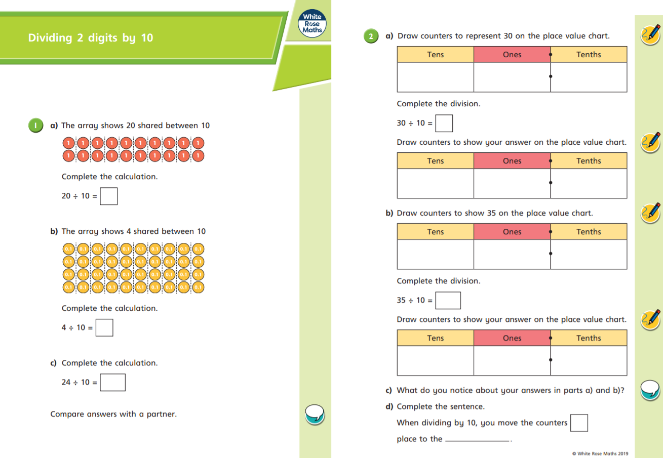
3.4.20 LO: Dividing two-digit numbers by 10. Page 2
