Thailand Easter Homework Grid
Happy Easter! During the Easter Holidays, complete as many activities as you can from the grid below. We look forward to seeing your learning
Watch the Easter Story:  https://www.youtube.com/watch?v=Wnbo2AmS3OI  Have a go at writing it down or explaining it to an adult. | Make a cross out of natural materials. | Write a prayer for people during this time. Use the structure below if you would like to:  Dear God,  Thank you for……………………………..  Help us to……………………………  Amen. | Design and make your own Garden of Gethsemane.
Using your amazing scale reading skills, bake your own Easter treats. | 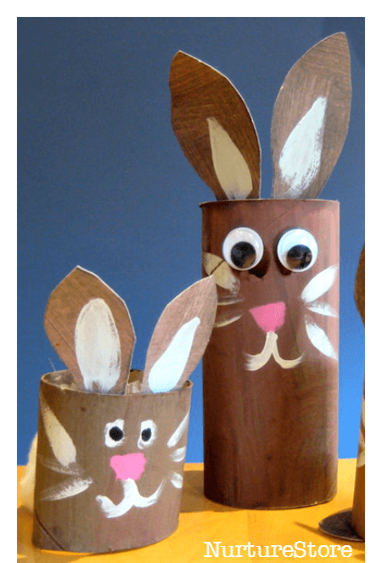  Use junk modelling to make an Easter flower or animal. | 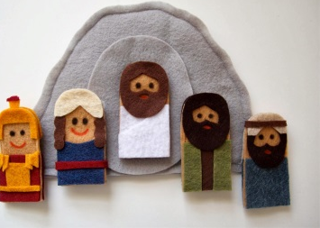  Make puppets and recreate part of The Easter Story. | Plant a seed and watch it grow! Record your observations each day.
Create a stained glass nature collage. | Sing along with the Easter song we all love, ‘I’m a Spring Chicken’.  https://www.youtube.com/watch?v=IEey4LZLeGw | 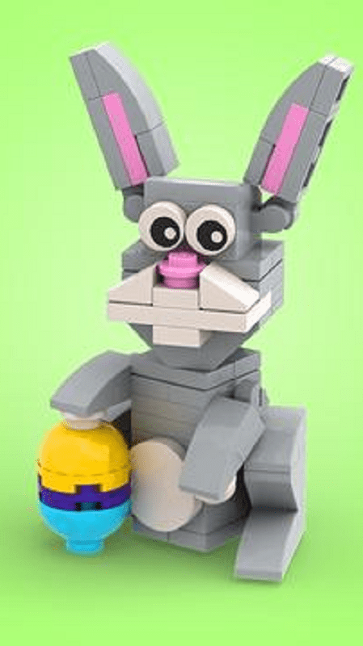  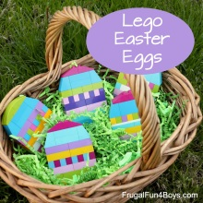  Use Lego or another building material to build your own Easter creation. | Research how Easter is celebrated around the World. Use the website below if you would like to.  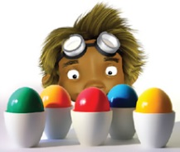  https://www.forteachersforstudents.com.au/site/themed-curriculum/easter-lp/facts/#world
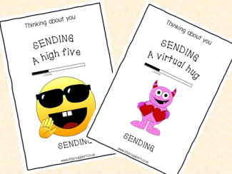  Write a ‘thinking of you’ card to one of your friends or family members. | Make an Emotions Wheel for 6 emotions eg. Happy, sad, angry, scared, disgusted, surprised. Think about the colours and drawings to represent each emotion. | 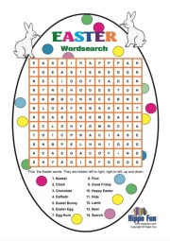  Create your own Easter Word search and ask a family member to complete it. | 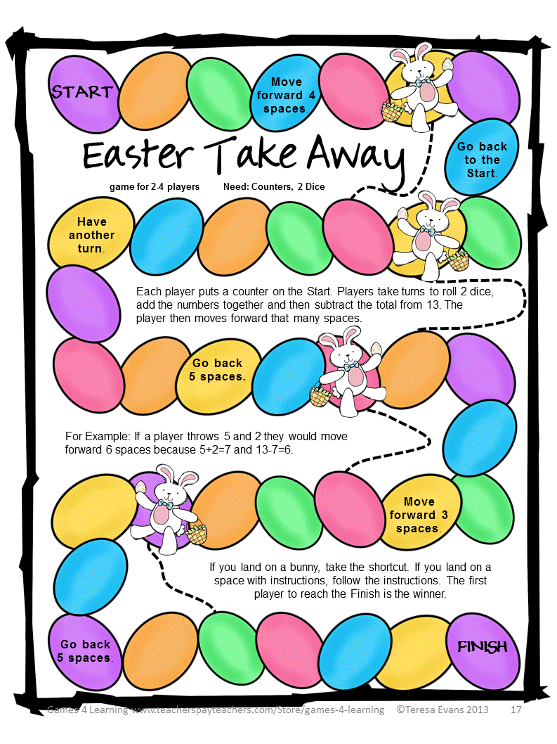  Make your own Maths game with an Easter theme.

