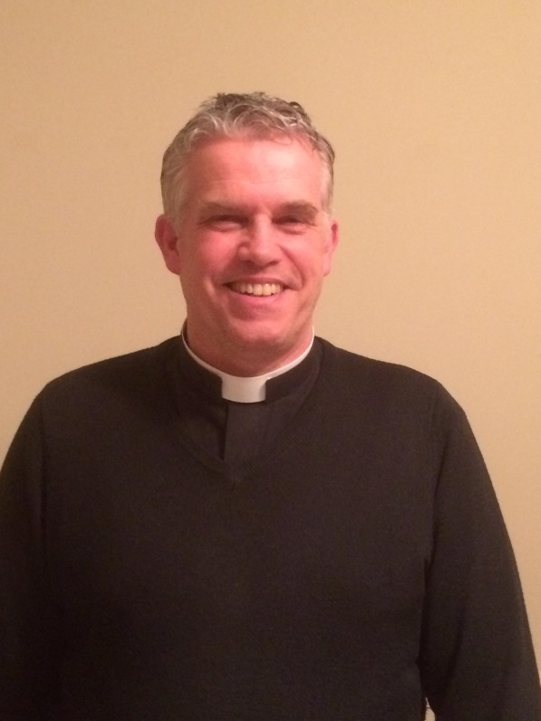

Father Paul Seaman
I became the new Rector of St Mary’s Pulborough on 19th September 2017 and by virtue of my office I became a governor of St Mary’s School. (Ex-officio) I join a group of committed and well motivated Foundation governors who particularly represent the interests of the wider church in our school.
I recently moved from East Grinstead where I was involved with another Church of England school in my role as Vicar of that parish. Before ordination I trained as a primary school teacher and taught for a short time before going to theological college.
I am very much looking forward to getting more involved in the life of the school and getting to know the children and staff as well as the parents and carers. My impression of the school so far is a very positive one and it will be good to build on the good work that has been done by so many over the years.

