New Zealand and Ireland class Easter Homework Grid
Happy Easter! During the Easter Holidays, complete as many activities as you can from the grid below. We look forward to seeing what you create.
Watch the below Easter story created from Lego.  https://www.youtube.com/watch?v=-M8Yesnt1V8  Then recreate your own scene using Lego or any other building materials. | Make a cross out of natural materials. | Write a prayer for people during this time. Remember the elements of prayer:  Forgiveness – saying sorry  Thankfulness  Please | Design your own Garden of Gethsemane.  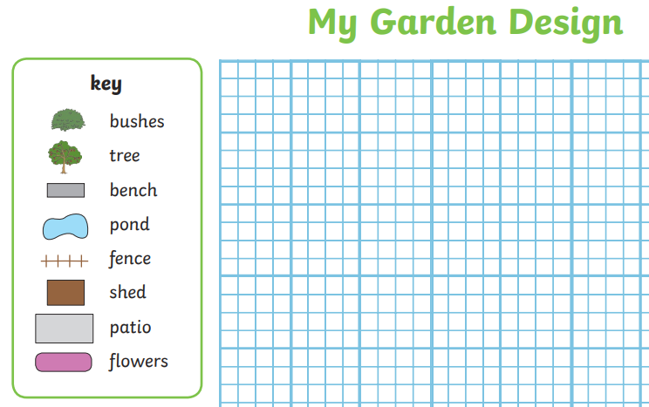
Bake your own Easter treats. Write out the recipe recording the measurements you use for the ingredients and listing the instructions. | 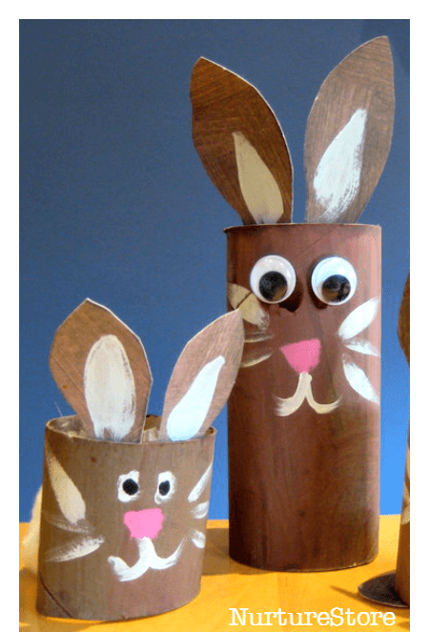  Use junk modelling to make an Easter flower or animal. | 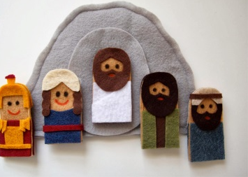  Make puppets and recreate part of The Easter Story. | Plant something and watch it grow! Take pictures and record daily observations which include room conditions e.g. light, water,  warmth etc.
Create a stained glass nature collage. | Sing along with the Easter song we all love, ‘I’m a Spring Chicken’ and teach your family the actions.  https://www.youtube.com/watch?v=IEey4LZLeGw | Create an Easter card and post it to a friend.  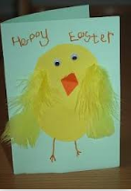 | Research how Easter is celebrated around the world. Use the website below if you would like to.  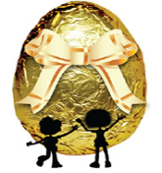  https://www.forteachersforstudents.com.au/site/themed-curriculum/easter-lp/facts/#world
Write a letter to your teacher telling them all about what you’re doing. Send it to school.  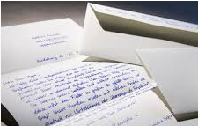 | Create an Easter bonnet and have a fashion parade.  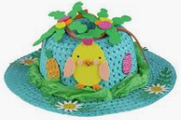 | 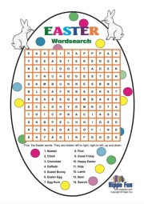  Create your own Easter word search and ask a family member to complete it. | 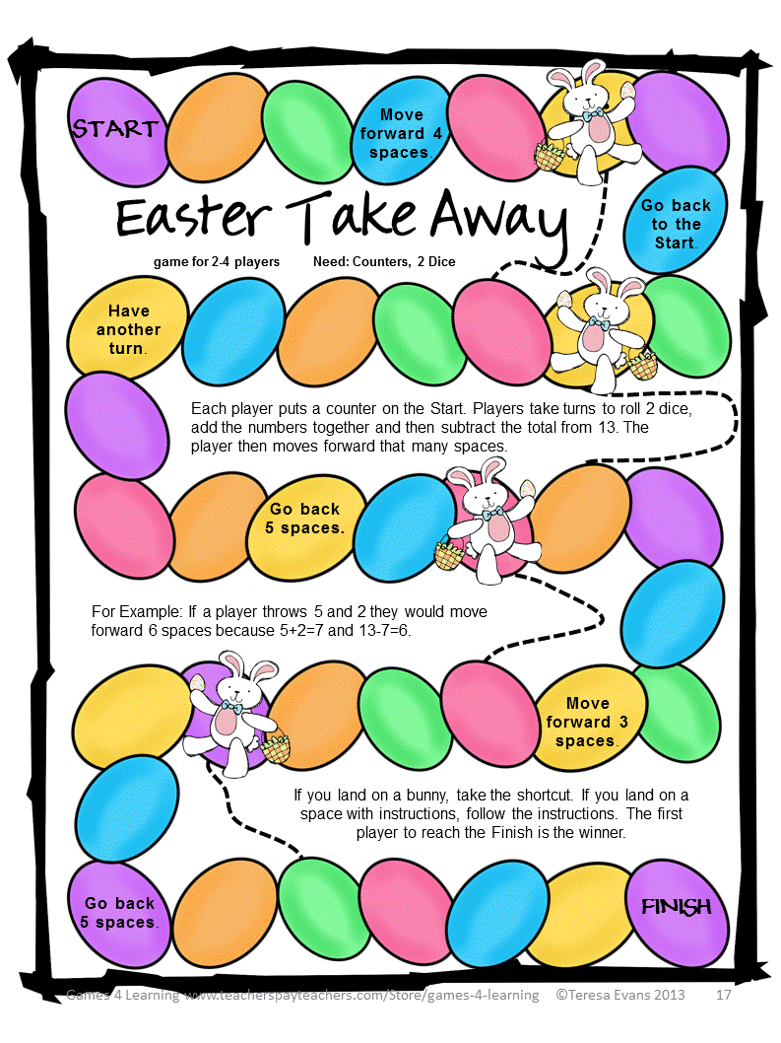  Make your own Maths game with an Easter theme.

