SUD AFRICA and JAPON CLASSES – YEAR 6
WEEK TWO
(Week One – Week beginning 23/03/20)
FOOD AND DRINK – ORDERING IN A CAFE
LO: I know polite words to use when ordering food and drink.
I can use verbs and speak in full sentences.
I can sequence a dialogue in Spanish.
Task:
Can you order and put into the right sequence with numbering, the cartoon “En la cafeteria”? Have a go and then look at the numbered solution attached for you.
Practise the dialogue on your own or have a go with someone at home. We have practised how to say most of these words in class already.

FUN ACTIVITY/EXTENSION
Use a Spanish dictionary online (or if you have one) to write a “MENU DEL DIA” – Menu of the Day in Spanish for a cafe or restaurant. You can use the VOCABULARIO sheet attached.
OR create a poster with different Spanish food names labelled with an illustration to help you remember the names.
*************

WEEK TWO – Week beginning 30/03/20
L.O. Translate a recipe.

During Lent, and before Easter, the Spanish have a special recipe for fried or baked bread, coated in milk and egg, with cinnamon, orange and lemon, and sometimes chocolate, honey or sugar on top!!
This is better used with stale bread, so if there is any at home, you could use it up.
MAKE SOME TORRIJAS IF YOU CAN WITH AN ADULT. Do not try to make these on your own.
If not, don't worry, just have a go at the translation task, and watch them being cooked on YouTube, with English and Spanish videos.
Links for YouTube:
https://youtu.be/iRaAEmyY6ig

Or type into the YouTube Search box: Spanish Bread Pudding (Torrijas) - Easy Spanish Dessert Recipe

https://youtu.be/-lrOCKoTg2I

Or type into the YouTube Search box: How to make Torrijas - Yolanda's Taste of Spain

Task: Translate the recipe instructions below from Spanish to English, using the word bank to fill in the gaps.
Las torrijas
Ingredientes: (Ingredients)
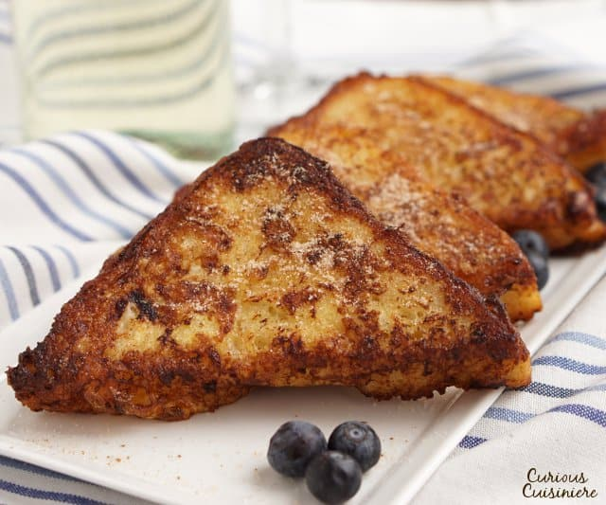
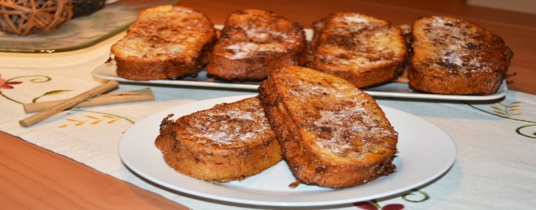
• Una barra de pan del día anterior, cortada en rebanadas de 1,5 cm aproximadamente. También se puede comprar pan especial para torrijas.
• 4 huevos - (4 eggs)
• 1 litro de leche. – (1 litre of milk)
• 1 taza de azúcar. – (1 cup of sugar)
• Un trozo de corteza de limón y otro de naranja. – (a piece of lemon rind and another of orange rind.)
• Una ramita de canela. – (a cinnamon stick)
• Una cucharada de canela en polvo. – (a spoonful of ground cinnamon.)
• Aceite para freír: ¾ de litro – (oil to fry: ¾ of a litre.)

(See below for English vocabulary and word banks.)
Banco de palabras: (Word Bank:)

Una barra de pan del día anterior, cortada en rebanadas de 1,5 cm aproximadamente. – A French stick or stale bread from the day before, cut into slices approximately 1.5cm thick.

se puede – you can de(l) – of/from cortada - cut
corteza – peel canela - cinnamon en – on/in
ramita – little stick para – for/to

Las instrucciones: (Method)

1- Poner a calentar la leche con dos cucharadas de azúcar, la corteza del limón y la ramita de canela hasta que empiece a hervir.
2- Dejar enfriar la leche y luego colarla para quitar los restos de la canela y del limón.
3- Mientras tanto, cortar las rebanadas de pan, aproximadamente de unos 2 centímetros cada una
4- Empapar, una a una, las rebanadas de pan en la leche fría y batir dos huevos para cada barra de pan. Luego, pasar las rebanadas de pan por el huevo batido y freírlas en abundante aceite caliente.
5- Cuando se enfríen, pasar las rebanadas por una mezcla de azúcar y canela.

Banco de palabras: (Word Bank for Method:)
calentar | to heat up
hasta que | Until
empiece | it begins
hervir | to boil
enfriar | to cool down
luego | then
los restos | the remains/what's left of
Mientras tanto | Meanwhile
fria | cold
batir | beat
caliente | hot
cuando | when
una mezcla | a mixture

1. Start to heat up the milk with two spoonfuls of sugar, the lemon peel and the cinnamon stick _________ it begins to _________.
2. Let the milk ____________ and _______ strain it to get rid of the _________ of the cinnamon and lemon.
3. ______________________, cut the slices of bread, approximately 2cm each.
4. Soak, one by one, the slices of bread in the ______ milk and ________ two eggs for each breadstick. Then, dip the slices of bread in the beaten egg and fry them in lots of _______ oil.
5. ___________ they have cooled, dip the slices in a ___________ of sugar and cinnamon.

