Year Five Easter Activities
Happy Easter! Below is a grid of activities to choose from over the holiday. We hope you have a lovely time with your families and look forward to hearing about what you get up to.
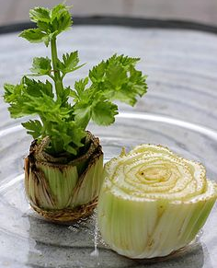  Plant some seeds or grow indoors using vegetable tops! Just place the top cut side down in a shallow saucer, add a little water and leave it on a windowsill. Change the water each day and after a while you will see some green sprouts. | Design and make your own Garden of Gethsemane. | Make a cross out of different materials you can find outside or around the house. | Write an acrostic poem for a word associated with Easter or the Easter story.  e.g. C  R  O  S  S  This could be a list of words beginning with each letter, a sentence for each line or even a rhyme.
Bake your own Easter treats such as chocolate nests, biscuits or hot cross buns. | Use junk modelling to make an Easter flower or animal.  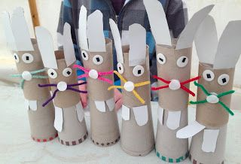 | Dance with Oti Mabuse or do some PE sessions with Joe Wicks.  https://www.youtube.com/channel/UC58aowNEXHHnflR_5YTtP4g  https://www.youtube.com/user/thebodycoach1/videos | 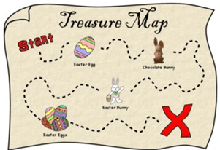  Make a map for your Easter egg hunt. Where did the Easter Bunny leave your eggs?
Setup an obstacle course around the garden, bedroom, lounge etc. Here are some everyday objects you could use.  Bridge – lay a scarf along the floor  Tunnel – large cardboard box to crawl through or a blanket to crawl under  Cones – tin cans  Bricks – books or tissue boxes | Sing along with the Easter song we all love, ‘I’m a Spring Chicken’.  https://www.youtube.com/watch?v=IEey4LZLeGw | Use Lego or another building material to build your own Easter creation.  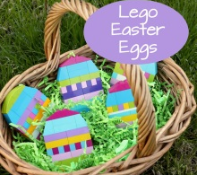 | Research how Easter is celebrated around the world. What different traditions does each country have?  https://www.forteachersforstudents.com.au/site/themed-curriculum/easter/facts/
Watch the Easter Story: https://www.youtube.com/watch?v=Wnbo2AmS3OI  Draw a comic strip or write a play script to re-tell the main events of the story. | 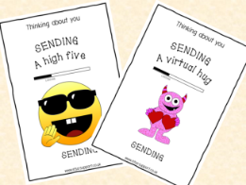  Write a thinking of you card to one of your friends or family members. | 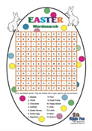  Create your own Easter Word search and ask a family member to complete it. | 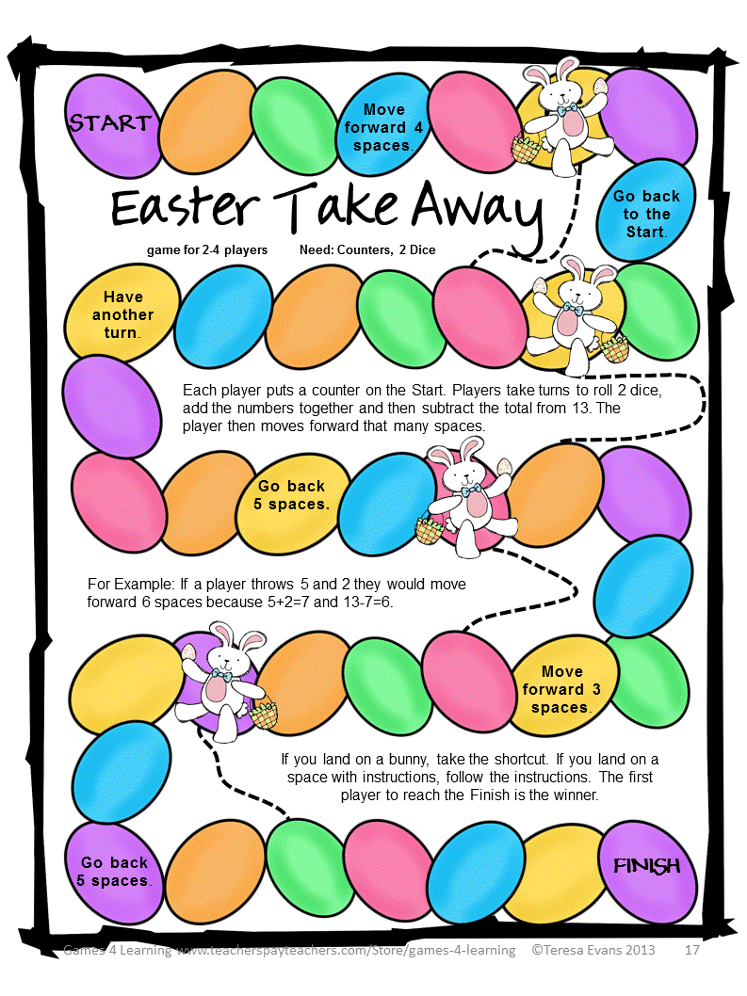  Make your own Maths game with an Easter theme. You can adapt one you know to give it an Easter twist!

