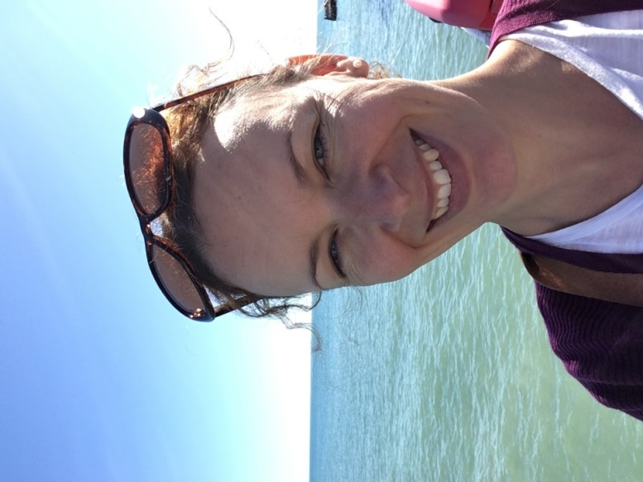

Charlotte Cargill

Hi, I’m Charlotte Cargill and I have lived in Pulborough with my husband Matt since 2009. We have two daughters who attend St Mary’s. I sit on the Teaching, Learning & Assessment Committee, Chair the Ethos & Worship Committee and have the Governors’ responsibility for RE. I have a Science background and am also keen to see that Art, Music and PE are fully supported at school so our children experience a really rounded education. Here I am enjoying the sunshine on the pier in Worthing where I work for the Environment Agency. I’ve just started training as a Legal Executive which probably won’t leave me much time for anything else but I like singing and also help organise family activities at St Mary’s Church.

