Tuesday 31st March 2020 Science: States of Matter – Water Consumption Diary
Task: To complete a water consumption diary over a one week period. Fill in the appropriate boxes with a tally chart.
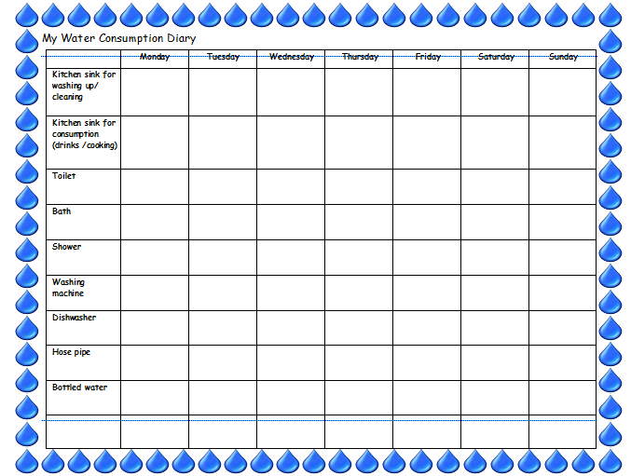

Challenge:
Can you find out how much water is used in each activity on your tally chart?
Eg. Flushing the toilet, having a shower/bath, drinking a bottle of water, using the washing machine/dishwasher.

