Wednesday 1st April 2020 LO: Using expanded noun phrases for description.
Starter:
Discuss similarities and differences in the poems that we have looked at so far.

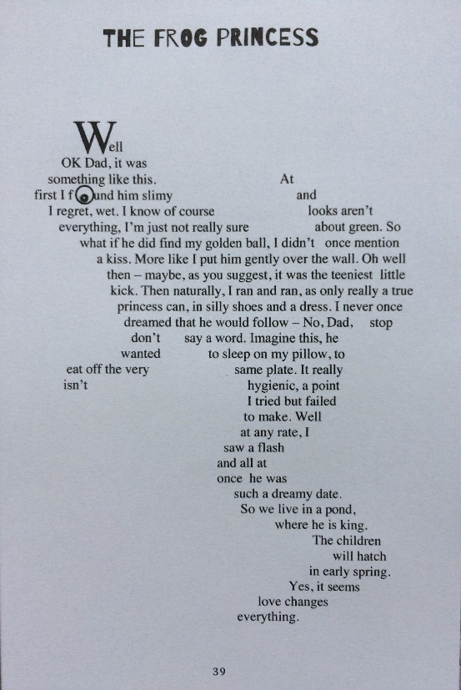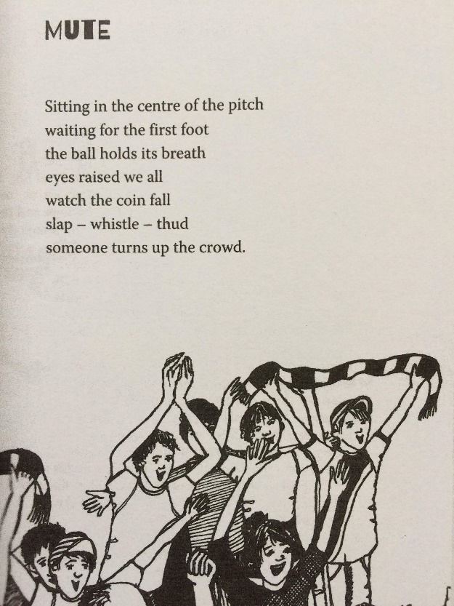
Recap on prior learning and key terminology for noun phrases.
Nouns – naming words – can refer to a person, place or thing
Simple noun phrases – groups of words, including a noun, that make up part of a sentence (the noun is the main word in the phrase and the other words supply information about it)
Determiner – words that come before a noun to introduce it and give the reader information about it (eg. the, a, an, his her, my, your)

Adjectives – descriptive vocabulary to provide more information about the noun being described

Use the Twinkl powerpoint to introduce expanded noun phrases and model how these can up-level a simple noun phrase.

Discuss how the adjectives we choose to expand a noun phrase can have very different effects.
Examples:
The dark, gloomy house with creaky, broken windows……
The new, brick house with a bright, colourful garden……
How does the description of each house change the picture in our mind’s eye?
Introduce main activity, show resources and produced some shared examples.
Ensure that children are recording full sentences which include a verb to describe the action being carried out. Refer to prior learning on synonyms and adverbs to produce interesting sentences.

Activity:
Children to have pictures of animals featured in poems from ‘Where Zebras Go’. Children to record sentences to describe these animals including an expanded noun phrase for each one, eg. The enormous, hungry owl with soft, tawny feathers swooped silently above the dark river.

Success Criteria:
- I can write a simple noun phrase.
- I can use adjectives to expand a simple noun phrase.
- I can select adjectives to describe a noun to create effects.

