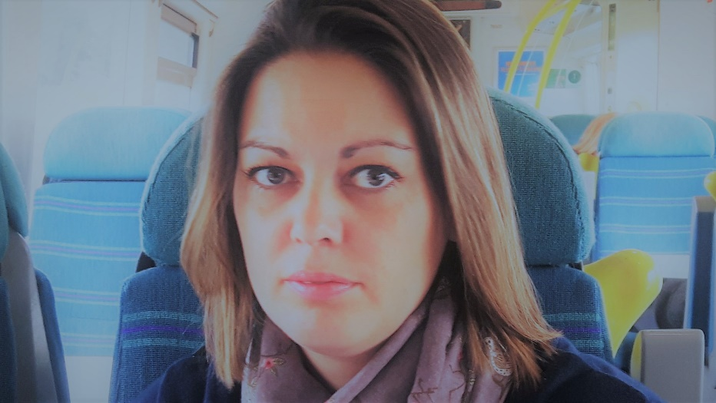

Claire Bridge

I am a mother of two children, a daughter who has moved up to secondary school, and boy who attends St Mary’s Primary. I started working as a teaching assistant at St Mary’s in 2016, and am currently studying for my BA (Honours) Primary Education Studies.
I became the Staff Governor in June 2017, and I sit on the ‘Teaching, Learning and Assessment’ and ‘Buildings, Health and Safety’ committees.

