03.04.20
LO to read, understand and use hundredths as decimals

Starter:
Recap of adding and subtracting fractions:
$$\frac{2}{10}+\frac{4}{10}=$$

$$\frac{3}{9}+\frac{6}{9}=$$

$$\frac{12}{5}-\frac{8}{5}=$$

$$1\frac{1}{4}-\frac{3}{4}=$$

Main:
https://whiterosemaths.com/homelearning/year-4/

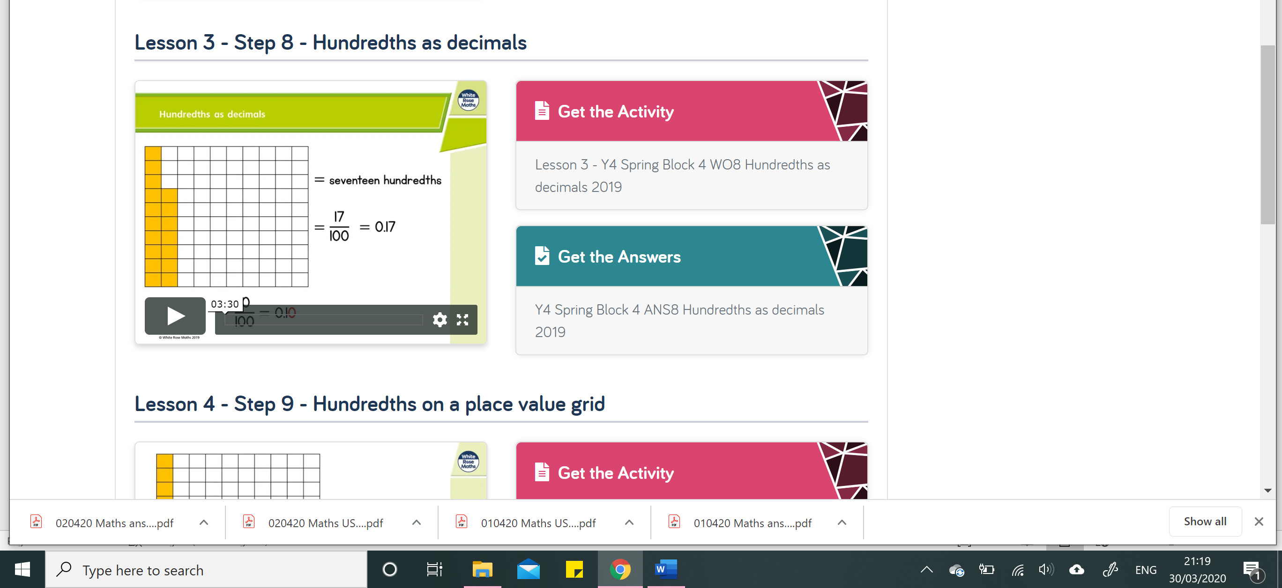

QUESTIONS ARE IN THIS DOCUMENT AS WELL AS ATTACHED AS A PDF

**If you can’t fill in the table for Q1 then just write the fractions and the decimals
Enjoy,

USA team

