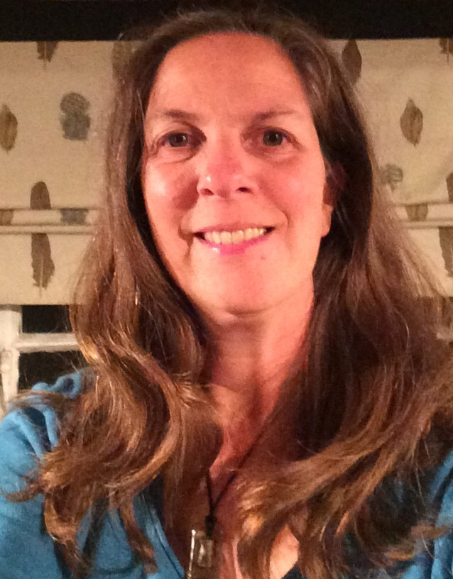
Laura Batchelor
I am a Diocesan Foundation Governor (appointed by the diocese because of my links with St Mary’s Church). My background is in education with a degree in Fine Art leading me into Art & Design teaching, head of department in a large secondary comprehensive and since moving to the Pulborough area I now teach children of all ages and in a variety of settings.
I have been involved on the PTA committee in the past and continue to be a Trustee of the Friends of St Mary’s (the charity aspect of the PTA). As a governor I chair the Teaching, Learning and Assessment committee and my special responsibility is in literacy and the creative arts.
All three of my boys have been through or still attend St Mary’s and have received an excellent start to their education. In my “spare” time I can usually be found driving the boys to their respective sporting fixtures – football, rugby and cricket or standing on the muddy side-lines trying not to be an embarrassingly over-enthusiastic supporter. You will often see me lurking in the playground, so please feel free to chat. I love a good cuppa (with cake, of course).

