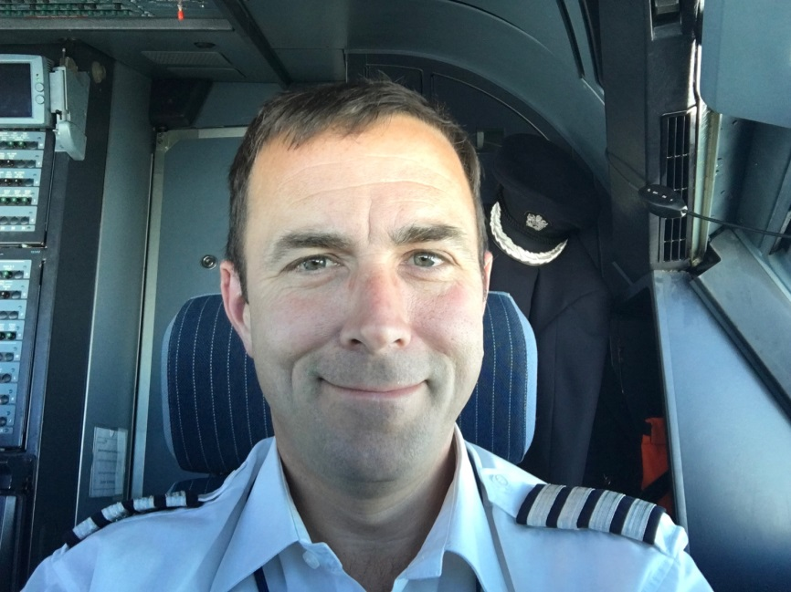

Julian Edge

Hi, My name is Julian and I'm a father of three girls, two of which attend St Mary's. I've been a governor for two years and sit on the Ethos and Teaching & Learning committees. I also hold the governor’s responsibility for the exceptionally able pupil policy. My day job is flying for an airline and my passion is horses which is why I often look like something the cat has dragged in at pick up.

