Monday 30th March 2020
Ireland & New Zealand class learning
Geography
LO: understanding volcanoes.
Explain to the children that volcanoes are mountains. Go through the key vocabulary on volcanoes.
Key Vocabulary.
- volcano
- crater
- lava
- vent
- smoke
- ash
Watch:
https://www.bbc.co.uk/bitesize/topics/z849q6f/articles/zd9cxyc
Find/research information about a volcano. Present your finding in whatever form you want to.
Also enclosed is the opportunity to draw and label a volcano.

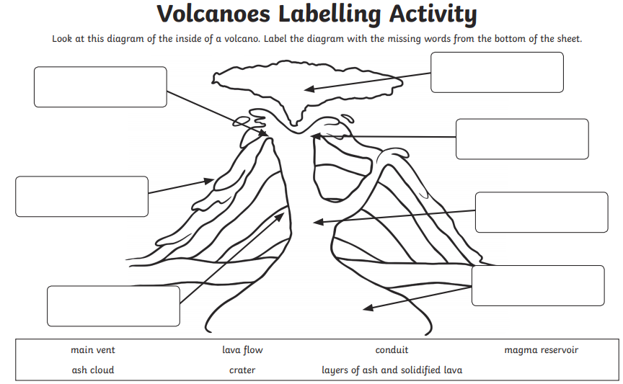
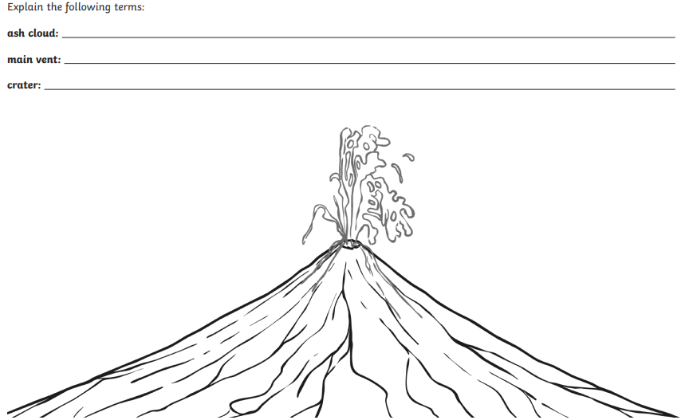
ANSWERS
