1.4.20 LO: Representing tenths on a number line. Page 1
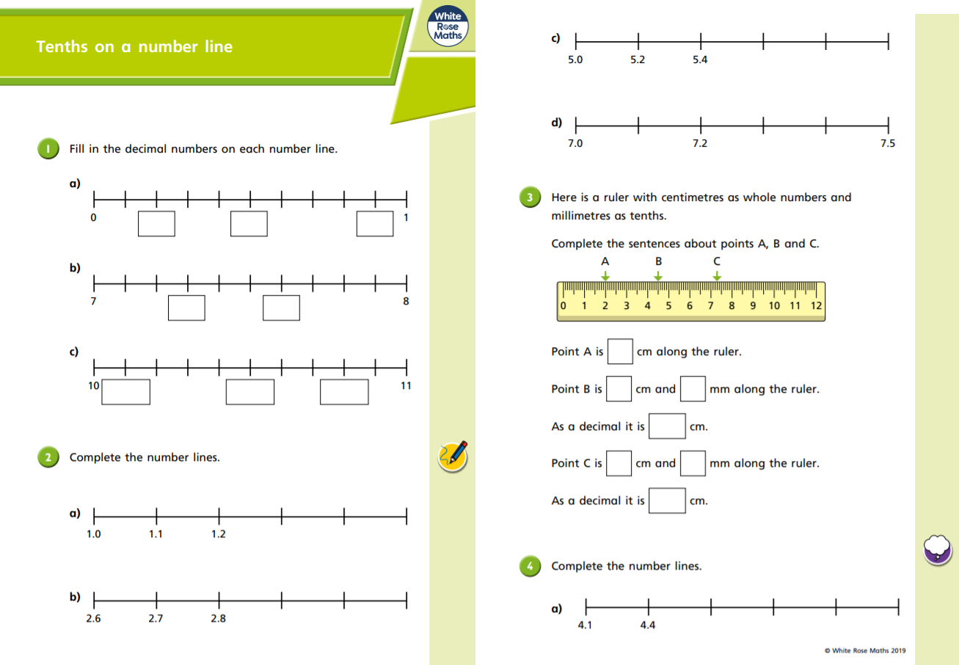
1.4.20 LO: Representing tenths on a number line. Page 2

