Topic | Year 6 Homework Grid – Spring 2020 Please make a booklet of all your work or take photos to email to Ms Frances/Mr Rogers |  |  |  |  | I AM GOING TO CHOSE…
Literacy and Communication | Write a newspaper report detailing an interview you did with a famous explorer.  This could an explorer from modern times like Bear Grylls or Ellen MacArthur or a historic explorer like James Cook  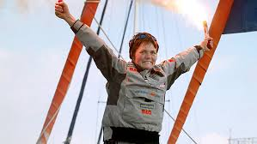 | You are writing a Biography about the life of Charles Darwin. Record an interview with him.  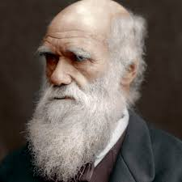 | Write a story detailing an adventure or exploration. Use one you have experienced or use your imagination | Postcards:  Produce a postcard for somewhere you have been either in the UK or abroad. Tell us what the place was like and what you did there focussing on geographical features and places of interest.  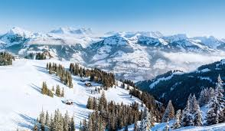 | Complete a character study Boris Johnson  *Describe his physical appearance.  *Discuss his background. *Write about his personality.  * Write about the famous things he has done.  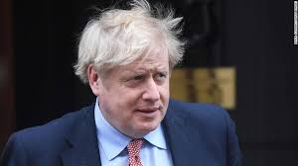 | 1.
 |  |  |  |  |  | 2.
 |  |  |  |  |  | 3.
 |  |  |  |  |  | 4.
Maths and Problem Solving | Create a record of the weather for the week, presenting your findings in a table and graph. Think about the temperature, the amount of rainfall and wind speed and direction. | Compile a table of information about the countries across the Tropic of Cancer. Note differences and similarities. | Create your own Tropic of Cancer themed top trumps cards.  You could use geographical features, populations etc and award points | Create a 3D model of a famous building in the world eg Big Ben, the Taj Mahal  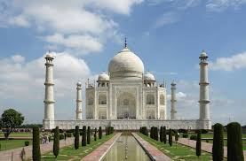 | Investigate tessellating shapes using hexagons and triangles. Explain/Record your findings.  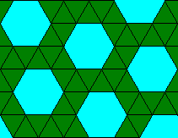 | 1.
 |  |  |  |  |  | 2.
 |  |  |  |  |  | 3.
 |  |  |  |  |  | 4.
Science and the outside environment | Investigate the theory of Evolution. Make a chart with key illustrations and bullet points.  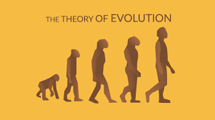 | Investigate famous scientific discoveries made in medicine. Explain what may have caused these momentous changes and the impact on health.  Eg the discovery of Penicillin | Conduct your own experiment at home using a food type. Make variables and things that are consistent eg all in plastic bags  Variable – where you put it. Record your findings. | Choose a sea creature. Investigate its habits, food source and habitat.  Present this information in a form of art.  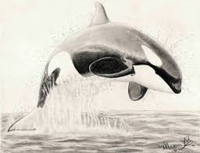 | Create a 3D model of a human cell. 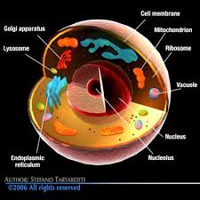 | 1.
 |  |  |  |  |  | 2.
RE and Citizenship | Write and draw a story board of the Easter story starting with Jesus’ arrival in Jerusalem and finishing with the resurrection. | Read your Easter Story board aloud or use family members to construct a script and drama | Bake shortbread with the sign of the cross on it for Good Friday.  https://www.bbc.co.uk/food/recipes/shortbread_1290 | Create the garden of Gethsemane in mini garden form from natural soil and moss from outside or use paints/art supplies/ recyclable materials to create your garden. | Write al prayer for all of those struggling in this difficult time during the Coronavirus pandemic | 1.
 |  |  |  |  |  | 2.

