Making inferences.
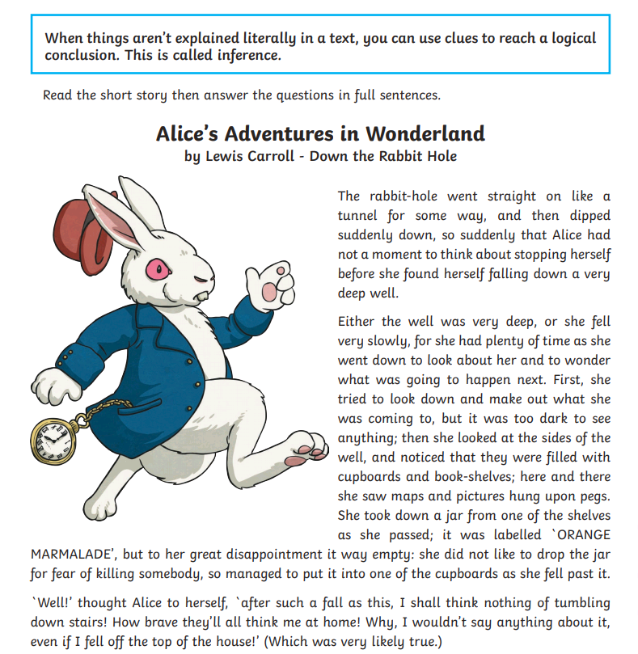

Answer the questions in your books - using full sentences
- If Alice couldn’t stop herself from falling down the hole, how do you think she felt as she began her fall?

- The author doesn’t say what Alice felt about the appearance of the well. If you were Alice, how would you describe her reaction when she saw cupboards and bookshelves on the walls?

- Why do you think Alice was disappointed that the jar of marmalade was empty?

- Alice says she wouldn’t hurt herself even if she fell from the top of her house. Why does she think this?

- How do you think Alice could get out of the well and back to the top?

