15.07.20
LO to describe position.
Starter: True or False.
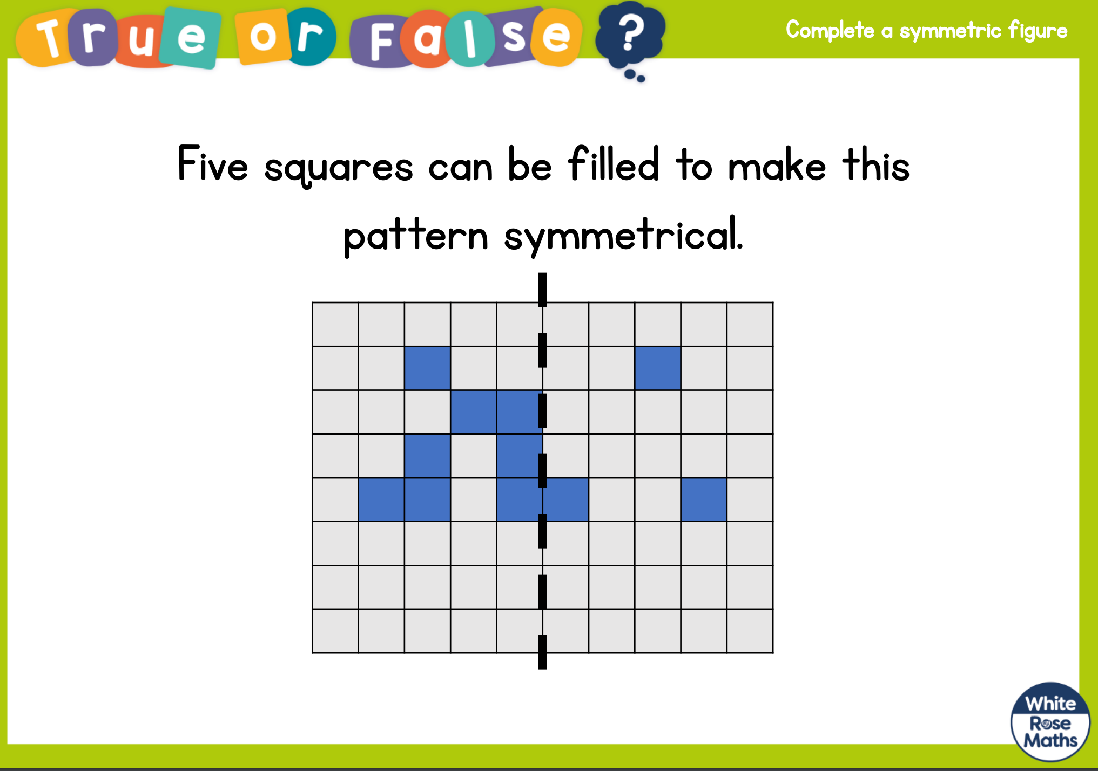

Main: Back to White Rose main site again: https://whiterosemaths.com/homelearning/year-4/

For this lesson remember: ALONG THE CORRIDOR (x), THEN UP THE STAIRS (y)
(x,y)

USA team

