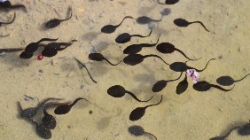

Wednesday 1st April
Good morning everyone. Pinch, punch, first day of the month! Please let the children know our tadpoles are thriving, Amy will be sending pictures out to you today. I would like to thank Max and Amy for looking after them so well. Mrs. HH reports that Austria’s are also doing well. Thank you for the Spring pictures/rainbows that I know some of you produced yesterday. Kate says please email them to her at Kate@rhymecare.co.uk

Reading: Today if possible visit Oxford Owl for free eBooks that link to your child’s book band. You can create a free account. We read books together from this site each week at school.

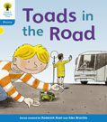
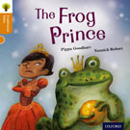
Read together Independent reading

Topic: The area you live in
The project this week aims to provide opportunities for your child to learn more about the area in which they live. Learning will focus on your local area.

Junk model your house -using old packaging – (shoe box, cereal box etc.) support your child to make a model of your house. Can they count how many windows there are and stick on the right amount? Can they write their house number on the front?

Use construction blocks to build your house – using lego, duplo or wooden blocks to make a model of your house. Write labels to match each room on pieces of paper.

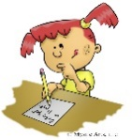
Writing

Use your phonics knowledge to label the rooms in your house – see activity above.

Singing

In U.K. and Austria we use a fantastic singing resource called ‘Sing-up’. This is free to you if you use the link below. I hope you enjoyed ‘Shake My Sillies Out’. Today try ‘Five Little Speckled Frogs’.
https://www.singup.org/home-schooling/eyfs-ks1/warm-ups-and-songs
Phonics- www.PhonicsPlay.co.uk
User name: March 20
Password: home
Today practice reading words with the sound that we learnt yesterday. Play ‘Dragon’s Den’ or ‘Picnic on Pluto’ reading words that contain ‘oa’ from phase three.

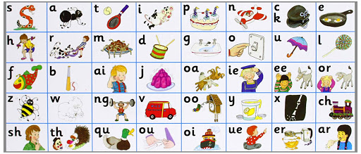

All the Jolly Phonics songs can be accessed via this link https://vimeo.com/106231366

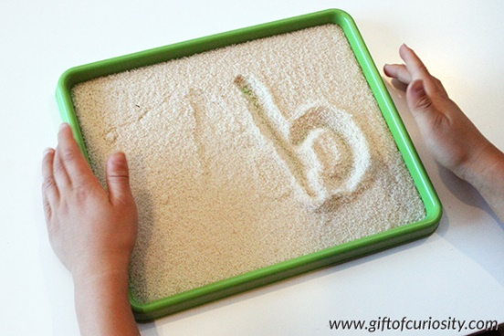
Handwriting

Please practice ‘One Armed Robot’ letters r,n,m,b,h,p – We have attached a poster and a power point to help you. Austria and U.K. are familiar with this terminology and using the ditty ‘down for his body and up for his one-arm’ helps with the formation of the letter. You could use the salt/flour tray that you used yesterday.

Maths

Choose one of the activities listed below, you can of course do all of them if you wish!!!

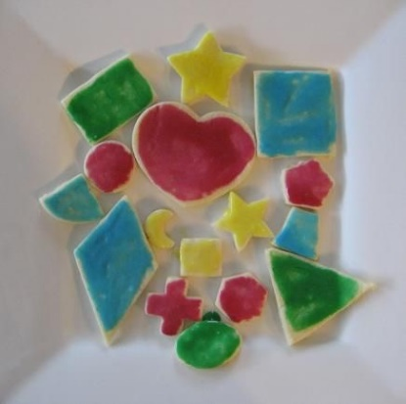
- Shape biscuits, using biscuit cutters or carefully cutting out the shapes with a blunt knife (perhaps cut out paper templates to place on the biscuit dough). The conversation can then continue whilst you decorate these and eat them!

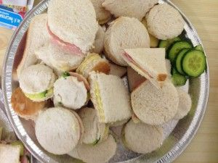
- At lunchtime use cutters/blunt knife to cut the sandwiches into different shapes.

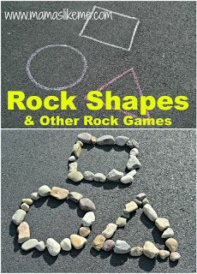

- Draw shapes on the ground using chalk, or use paper and pen, then place pebbles/coins/beads/other small objects around the edges of your shape.

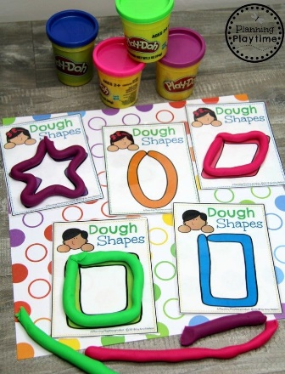

- Draw the shapes on paper. Roll play dough sausages and use them to follow around the edges of the shape,

Whichever activity you choose please focus on the following;
Shapes – square, rectangle, circle, triangle. When confident with the features of these introduce more shapes such as; diamond, hexagon, pentagon, octagon.
Vocabulary – throughout the activity model the correct vocabulary and encourage your child to use it to describe the shapes. Sides/edges, corners, straight, curved, longer, shorter, equal.

If you would need a simple biscuit or playdough recipe and don’t have any luck finding one online then please email us and we will send you one.

It has been great looking through the pictures and comments sent in so far. We are adding these into their 2Simple Profiles each day so please keep them coming.

