Thursday 2nd April 2020 LO: Reading and responding to a range of poetry.
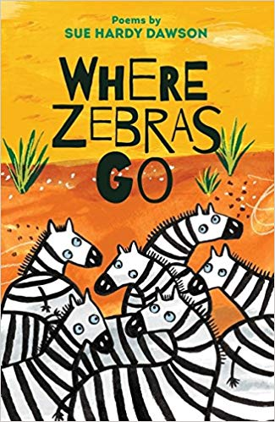
Show the front cover of ‘Where Zebras Go’ to the children.
Key questions:
What sort of book do you think this might be? How do you know?
What do you already know about poetry?
Can you recall the names of any features of poetry from our work in school last week? (similes, metaphors, alliteration, rhyme etc).
Activity 1:
Read the poem ‘Where Zebras Go’ – page 12. If possible, print it off and ask your child to stick it into their home learning book to annotate with their responses.
Use the following questions to guide discussion with your child:
What do you like about the poem? Is there anything you dislike about it?
Can you make connections with it? Do you have any questions about the poem?
What makes it a poem? What does it tell you about poetry?
Discuss how the poem is organised into lines and verses. Ask your child to think about the lack of punctuation and capital letters/look at the way the start of the line is repeated in the poem. Emphasise that although there are some examples of rhyme, not all poetry has to include rhyming vocabulary.

Activity 2:
Read ‘The Frog Princess’ – page 39. Children to annotate a copy of the poem with their personal responses – see questions above for guidance.
Does this poem remind you of any story that you know? Can poems tell stories? Is this poem like a story?
Discuss the layout of the poem: Does it look like the first one? Why/why not?
Discuss the poet’s use of shape, and how the poem looks on the page in relation to how it sounds when read aloud.

Activity 3:
Read ‘Mute’ – page 29. Share and record personal responses to the poem (as above).
What do you think the poem is about? How does it make you feel? What makes you feel like this? What words or phrases has the poet used that make the poem memorable/create atmosphere/evoke emotion? What pictures form in your mind as you read the poem? Does the illustration help your reading and response to the poem? What is in the poem that makes you visualise this?

