Tuesday 31st March

Good morning everyone. Thank you for the pictures you sent us yesterday especially the plan of your house. Apologies if we could not message you yesterday but dojo was temporarily shut down because of increased load.

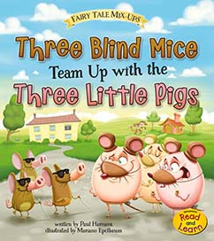
Reading:

MyOn
Today can you read this book?

Visit Oxford Owl for free eBooks that link to your child’s book band. You can create a free account. We read books together from this site at school.

Topic: The area you live in
The project this week aims to provide opportunities for your child to learn more about the area in which they live. Learning will focus on your local area.

Read the story of ‘The Three Little Pigs’ (or watch on youtube)- Discuss the choices the little pigs make about the materials they use to build their houses. Can children figure out the material their own house is made from?

Find your house on google maps-
○ Explore using google maps to look at your house from above and on street view. Use the arrows to move up and down the road and around your area. Can you find key places e.g. the corner shop, their school, grandparents houses?
○ Search for a house in a different part of the world and discuss how it is similar or different to your own. You could use places you have visited on holiday or search places that are significantly different.

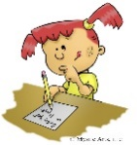

Writing
Today please can you draw a Spring picture to send to the residents of The Anchorage Care Home. I have told Kate that we are going to do this. I know it would cheer up their day as they are not receiving any visitors at the moment. It would also be lovely if you could use your phonics knowledge to label your picture.

Singing

In U.K. and Austria we use a fantastic singing resource called ‘Sing-up’. This is free to you if you use the link below. Sing one of our favourites which the children love ‘Shake My Sillies Out’ a fun action song which we were going to sing to you at our class assembly.

https://www.singup.org/home-schooling/eyfs-ks1/warm-ups-and-songs

Phonics- www.PhonicsPlay.co.uk
User name: March 20
Password: home

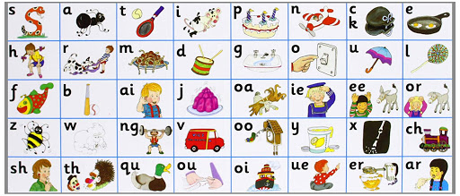

All the Jolly Phonics songs can be accessed via this link https://vimeo.com/106231366

Today we would like you to log on to Jolly Phonics see link above and sing the song to help learn the digraph ‘oa’. ‘Oh, did you see the Billy Goat’. After revisiting the sounds covered so far in the purple book, introduce the new sound and sing the song. Use the salt tray to write the words.

Todays words are:

goat
soap
road
load

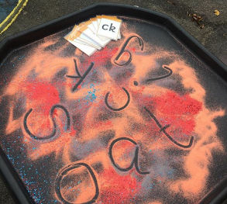
Try using the salt or flour that you used yesterday to practice todays sound.
You will need simple kitchen ingredients, we use corn flour, salt or sugar. Pour a small amount onto a tray , call out the words, can your child write the word in the flour/salt?

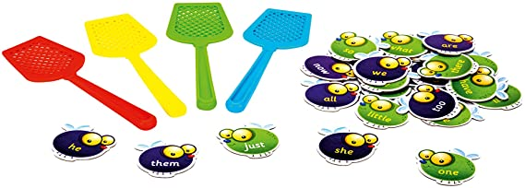

Another favourite activity of ours is ‘splat’ – write the tricky words out onto pieces of paper, call out the word and your child can ‘splat’ them with their hand, a spatula, a pastry brush or fly swatter if you have one!!
Maths
Remember to support natural language development by modelling back to your child, take this opportunity to extend vocabulary introducing the following terms into your descriptions – sides, edges, corners, curved, straight, longer, shorter, length

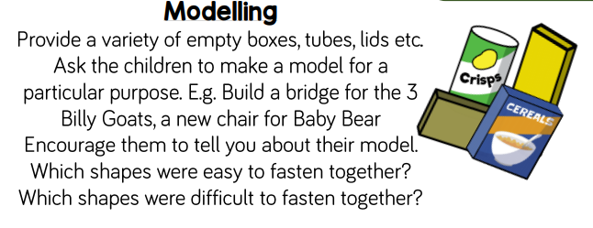

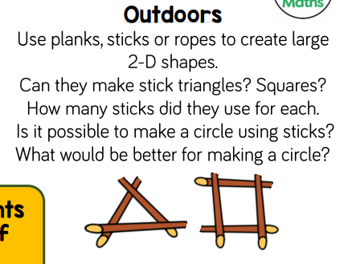

It has been great looking through the pictures and comments sent in so far. We are adding these into their 2Simple Profiles each day so please keep them coming.

