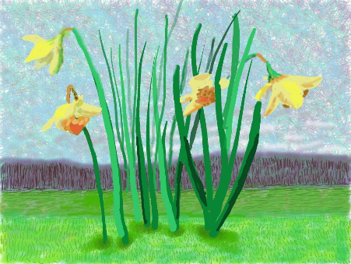

Thursday 2nd April

We are amazed at the wonderful things you are all doing at home. We are enjoying looking at the shape pictures, house plans, labels you are writing and of course the Spring pictures. Thank you for your feedback it helps us inform our daily activities.

Lee and Emma

Please continue to send your Spring pictures to Kate@rhymecare.co.uk

Reading: Today visit Oxford Owl for free eBooks that link to your child’s book band. You can create a free account. We read books together from this site each week at school.
Simply reading a book with a child is one of the most important ways you can help a child learn to read. If they get stuck on a word, encourage them to ‘sound talk’ the word and then blend the sounds together to make the word.

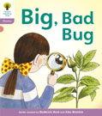
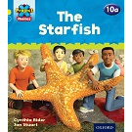
Read together Independent reading

Topic: Exploring with your senses-
○ Gather a collection of household objects e.g. fork, cup, toothbrush, teddy bear, book
and show your child. Use a scarf/ material as a blindfold and pass your child one of
the objects. Can they figure out what it is through touch alone? Give clues if they are
struggling. Swap roles and ask your child to give you an object to figure out.

○ Explore the textures around your house. Can children find something rough, smooth,
bumpy.They could take a wax rubbing of each texture (Lay a piece of paper over the
top and rub over with the side of a crayon). You could continue this into the garden.

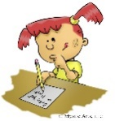
Writing

Design your dream house. What rooms would you like to have in your house?
Encourage children to be as imaginative as they can (e.g. a cinema room, a chocolate room). Can they label their house using their phonics knowledge?

Singing

In U.K. and Austria we use a fantastic singing resource called ‘Sing-up’. This is free to you if you use the link below. Try joining in with ‘Hey Little Frog’.
https://www.singup.org/home-schooling/eyfs-ks1/warm-ups-and-songs

Phonics-
Daily phonics - Practice the sounds your child is working on in their purple book and blend words. This can be oral blending (e.g. spoken out loud c-a-t) or written if appropriate.

www.PhonicsPlay.co.uk
User name: March 20
Password: home
Today practice reading words - click on ‘Pick a Picture’. Choose from phase two or phase three.

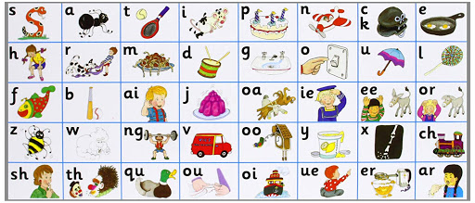

All the Jolly Phonics songs can be accessed via this link https://vimeo.com/106231366

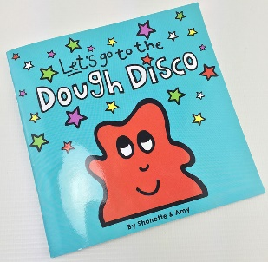

Playdough An old classic! There are many recipes available, this is our favourite.

2 cups of plain flour
Half a cup of salt
2 tablespoons of cooking oil
2 tablespoons of cream of tartar
1 to 1.5 cups boiling water
A few drops of food colouring.

Mix the flour, salt, oil and food colouring in a bowl. Slowly add the water (you may not need it all) Allow to cool then knead and join Shonette Bassett-Wood who leads the children in playdough disco.

This is a fun activity which combines the use of playdough with a series of hand and fingers exercises which combines the use of playdough with a series of hand and finger exercises.

Shonette Bassett Wood can be found at - https://www.youtube.com/playlist?list=PLtw-7Jf06an1IfIIonfs44FpzuCv7g1ZB&fbclid=IwAR2N7UYt-_WteDtohKZAU-J3yyfCGc0qnBC_WTRR-yqcu0FmHX22Ahd3Qo4

Maths – We are not changing the maths activities today as we do not want to overload you!!

Choose one of the activities listed below, you can of course do all of them if you wish!!!

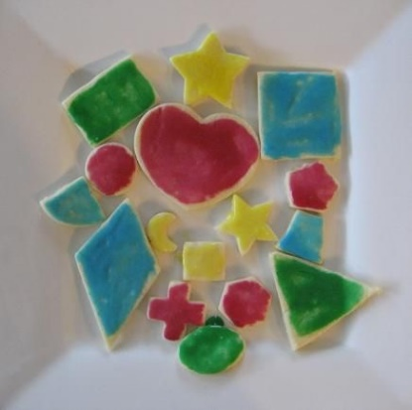
- Shape biscuits, using biscuit cutters or carefully cutting out the shapes with a blunt knife (perhaps cut out paper templates to place on the biscuit dough). The conversation can then continue whilst you decorate these and eat them!

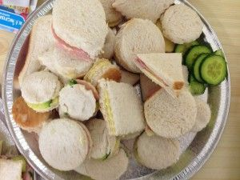
- At lunchtime use cutters/blunt knife to cut the sandwiches into different shapes.

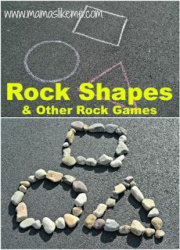

- Draw shapes on the ground using chalk, or use paper and pen, then place pebbles/coins/beads/other small objects around the edges of your shape.

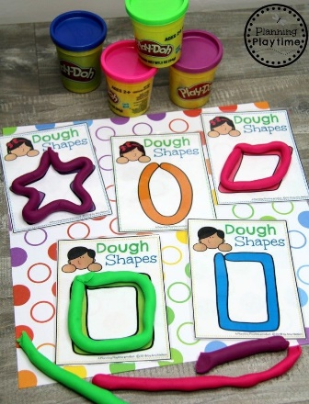

- Draw the shapes on paper. Roll play dough sausages and use them to follow around the edges of the shape,

Whichever activity you choose please focus on the following;
Shapes – square, rectangle, circle, triangle. When confident with the features of these introduce more shapes such as; diamond, hexagon, pentagon, octagon.
Vocabulary – throughout the activity model the correct vocabulary and encourage your child to use it to describe the shapes. Sides/edges, corners, straight, curved, longer, shorter, equal.

If you would need a simple biscuit or playdough recipe and don’t have any luck finding one online then please email us and we will send you one.

It has been great looking through the pictures and comments sent in so far. We are adding these into their 2Simple Profiles each day so please keep them coming.

