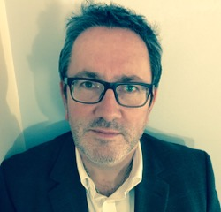

David Shepherd

Hello! My name is David Shepherd (spelling as in sheep) and my daughter is in Year 5 at St Mary's. After 4 years of service, I am currently Vice Chairman of Governors, which is a challenging but rewarding role. I have specific responsibility for overseeing the science aspect of the curriculum at school. I also sit on the Finance and Buildings (Health & Safety) sub-committees, chairing Buildings, largely given the experiences I bring from my day job in housing development.
I devote what spare time I have to photography and trying to keep the garden tidy, and am a passionate supporter of a certain football team (which, in the interests of impartiality, I won’t name!).

