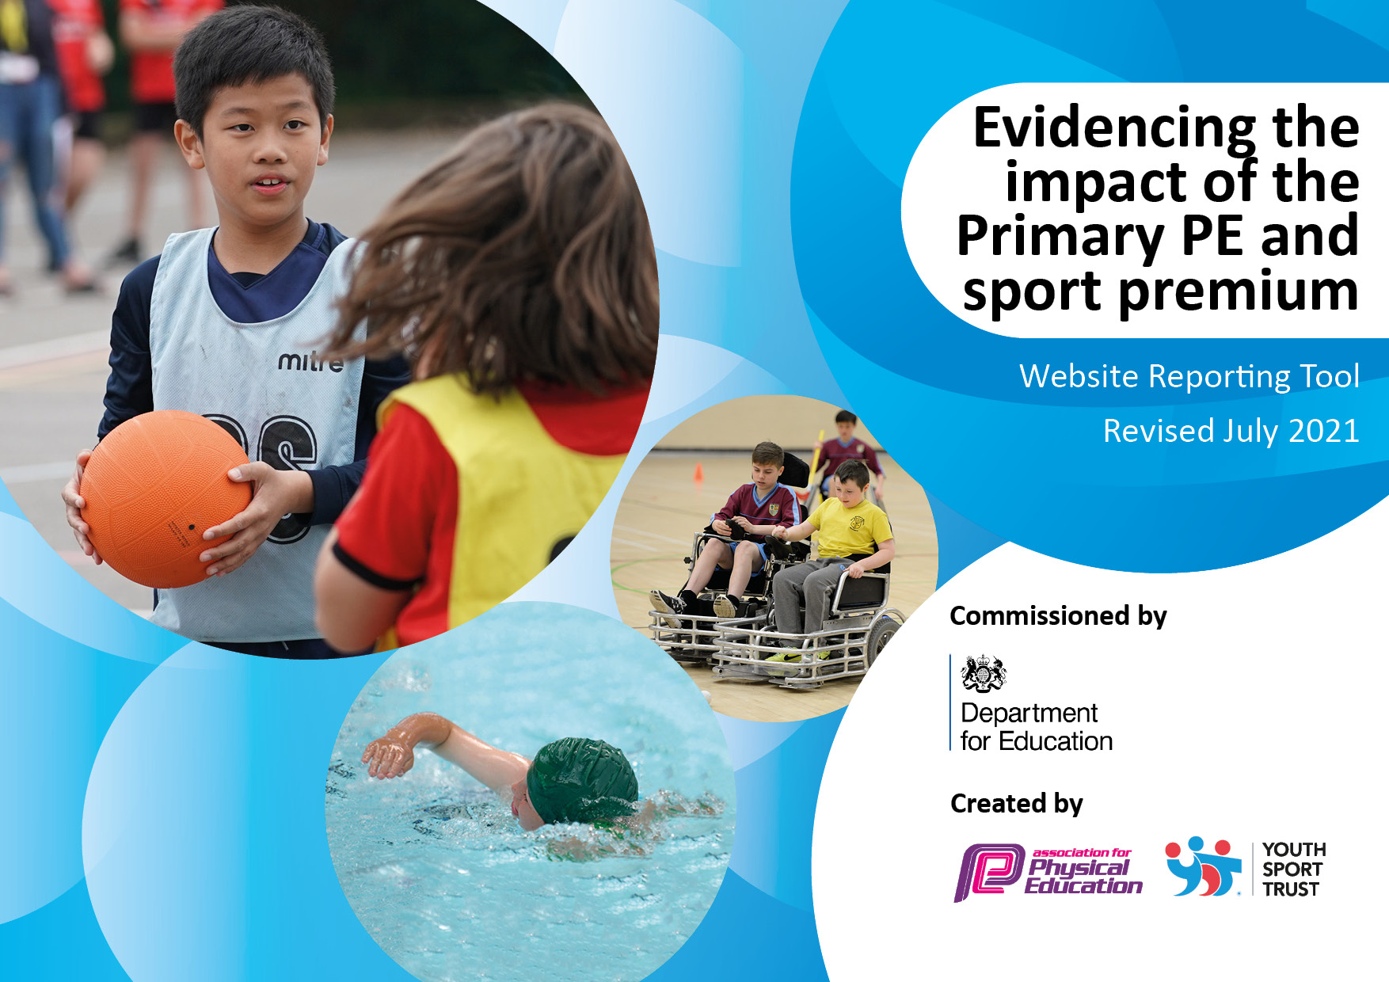
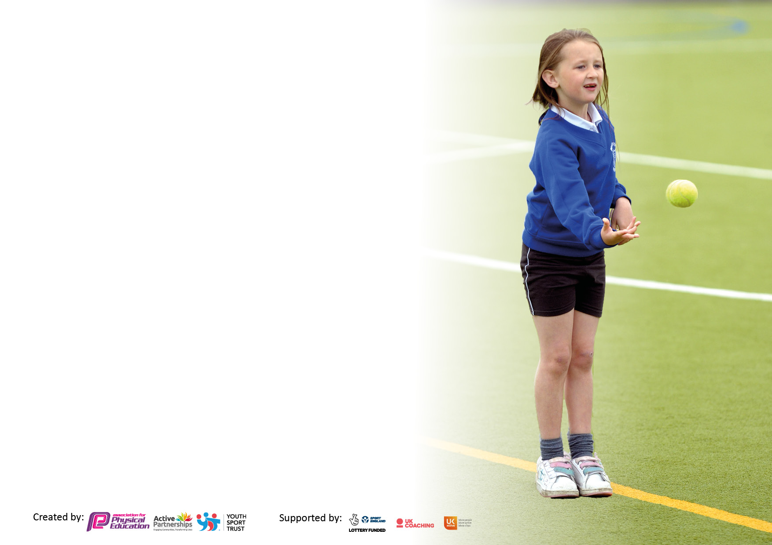

It is important that your grant is used effectively and based on school need. The Education Inspection Framework makes clear there will be a focus on ‘whether leaders and those responsible for governors all understand their respective roles and perform these in a way that enhances the effectiveness of the school’.

Under the Quality of Education Ofsted inspectors consider:
Intent - Curriculum design, coverage and appropriateness
Implementation - Curriculum delivery, Teaching (pedagogy) and Assessment
Impact - Attainment and progress

To assist schools with common transferable language this template has been developed to utilise the same three headings which should make your plans easily transferable between working documents.

Schools must use the funding to make additional and sustainable improvements to the quality of Physical Education, School Sport and Physical Activity (PESSPA) they offer. This means that you should use the Primary PE and sport premium to:

- Develop or add to the PESSPA activities that your school already offer
- Build capacity and capability within the school to ensure that improvements made now will benefit pupils joining the school in future years
- The Primary PE and sport premium should not be used to fund capital spend projects; the school’s budget should fund these.

Pleasevisitgov.ukfortherevisedDfEguidanceincludingthe5keyindicatorsacrosswhichschoolsshoulddemonstrate animprovement.Thisdocumentwillhelpyoutoreviewyourprovisionandtoreportyourspend.DfEencouragesschools to use this template as an effective way of meeting the reporting requirements of the Primary PE and sport premium.

We recommend you start by reflecting on the impact of current provision and reviewing the previous spend.

Schools are required to publish details of how they spend this funding, including any under-spend from 2019/2020, as well as on the impact it has on pupils’ PE and sport participation and attainment. All funding must be spent by 31st July 2022.

We recommend regularly updating the table and publishing it on your website throughout the year. This evidences your ongoing self-evaluation of how you are using the funding to secure maximum, sustainable impact. Final copy must be posted on your website by the end of the academic year and no later than the 31st July 2021. To see an example of how to complete the table please click HERE.

Details with regard to funding
Please complete the table below.

Total amount carried over from 2019/20 | £13,495.00
Total amount allocated for 2020/21 | £18,870.00
How much (if any) do you intend to carry over from this total fund into 2021/22? | £19,900.00
Total amount allocated for 2021/22 | £18,854.00
Total amount of funding for 2021/22. To be spent and reported on by 31st July 2022. | £38,754.00
Swimming Data
Please report on your Swimming Data below.

Meeting national curriculum requirements for swimming and water safety.  N.B. Complete this section to your best ability. For example you might have practised safe self-rescue techniques on dry land which you can then transfer to the pool when school swimming restarts.  Due to exceptional circumstances priority should be given to ensuring that pupils can perform safe self rescue even if they do not fully meet the first two requirements of the NC programme of study | 72%
What percentage of your current Year 6 cohort swim competently, confidently and proficiently over a distance of at least 25 metres?  N.B. Even though your pupils may swim in another year please report on their attainment on leaving primary school at the end of the summer term 2020.  Please see note above | 72%
What percentage of your current Year 6 cohort use a range of strokes effectively [for example, front crawl, backstroke and breaststroke]?  Please see note above | 72%
What percentage of your current Year 6 cohort perform safe self-rescue in different water-based situations? | 65%
Schools can choose to use the Primary PE and sport premium to provide additional provision for swimming but this must be for activity over and above the national curriculum requirements. Have you used it in this way? | No

Action Plan and Budget Tracking
Capture your intended annual spend against the 5 key indicators. Clarify the success criteria and evidence of impact that you intend to measure to evaluate for pupils today and for the future.

Academic Year: 2020/21 | Total fund allocated: | Date Updated:
Key indicator 1: The engagement of all pupils in regular physical activity – Chief Medical Officers guidelines recommend that primary school pupils undertake at least 30 minutes of physical activity a day in school |  |  |  | Percentage of total allocation:
 |  |  |  | %
Intent | Implementation |  | Impact
Your school focus should be clear what you want the pupils to know and be able to do and about  what they need to learn and to  consolidate through practice: | Make sure your actions to achieve are linked to your intentions: | Funding allocated: | Evidence of impact: what do pupils now know and what can they now do? What has changed?: | Sustainability and suggested next steps:
Encourage more children to be healthier, fitter and more knowledgeable about the importance of exercise and leading a healthy lifestyle | Healthy living week  Daily Mile  Jump Start Johnny  KS2 PE starts with cross country run | £269.00 | Participation in the Daily Mile across the school.  Jump Start Johnny to allow brain breaks and increased exercise through raising the heart rates | Daily Mile to continue  PE TA to support Gifted and Talented and those not engaging in PE/Physical exercise.
Encourage the children to be more active in their lunch and break times with a new trim trail – designed and implemented for the children to use and have increased exercise. | Purchase resources to support the playtimes,  Trim Trail to go in for all pupils to use | £903.89 | Trim trail delayed but due in June 2022. | Continue to train staff in play activities during lunch and break times  Ensure all children are accessing the trim trail across the week.
Maximise physical activity during lessons.  Forest Schools for Y1 and Y2 half a day a week. | PE Teaching assistant employed for the spring term | £5,369.39 | Children in KS2  More talent spotted and used within lessons  More physical activity evident in lessons  Pupil voice discusses the enjoyment in cross country and running activities  Two children whose behaviour has improved due to the running  Forest Schools for Y1 and Y2 half a day a week to allow more physical exercise outside. | PE TA to be employed in the next financial year to improve outcomes from sport and to ensure extra-curricular activities and participation at intersport competitions.
Ensure children can swim to the National Curriculum level | Pool to be opened at Easter and Y3 – Y6 to swim – 45-minute lessons in groups of 8 – 10. |  | Progress in swimming progression from 90% of the children in Y3 – Y6.  The children talk about improved water confidence, refined stroke development and time challenges improved ability in the water. | Swimming pool open in the holidays and after school provision especially for those not obtaining the 25 metres.
Key indicator 2: The profile of PESSPA being raised across the school as a tool for whole school improvement |  |  |  | Percentage of total allocation:
 |  |  |  | %
Intent | Implementation |  | Impact
Your school focus should be clear what you want the pupils to know and be able to do and about  what they need to learn and to  consolidate through practice: | Make sure your actions to achieve are linked to your intentions: | Funding allocated: | Evidence of impact: what do pupils now know and what can they now do? What has changed?: | Sustainability and suggested next steps:
Celebration articles in the newsletter for all sports activities so that the whole school is aware of the importance and PE/Sport and this will encourage more children to participate | Children are noted on the newsletter to celebrate successes  Inform staff of competitions  PE display board to show events coming up  Sports Award for each term in each year group to celebrate participation and successes. | £ | Children feel valued and want to participate.  Children like to be on the PE board and in the newsletter for the sense of achievements.  We have entered more than one team to competitions due to the amount of children wanting to participate and showing skills. | PE board to be updated and show participation.  Record participating in extracurricular activities and events  Sports Awards to be handed out to show how important participation is in different sports.  Virtual challenges to be looked at, advertised and record pupil participation.
Curriculum development | Ensure that whole school curriculum is fully inclusive and meets the needs of all learners |  | Children have had a wider range of exposure to a variety of sports including badminton, volleyball and ultimate Frisbee as well as the usual cricket, netball and basketball, athletics.  Topics and sports are linked in a cyclical curriculum so revisited ensuring progression of skills.  Lesson format allows the children to warm up, look at skills and practise those skills in game situations allowing the children to refine those skills. | Continue to look at the activities being offered for PE and ensure all-inclusive and engaging for boys and girls.  EYFS and starting points to be recorded and expectations by the end of Y6.
Gymnastics scheme of work  Swimming progression for Key Stage Two.  Cricket skills for staff | Staff to deliver a new scheme of work for Gymnastics that shows transition to KS3 curriculum with skills and knowledge.  Swimming weekly for all children in Key Stage Two  Cricket coach to come and deliver sessions for staff |  | Improved confidence in teachers teaching Gymnastics.  Progression of skills so children are building and trying more complex moves.  Swimming awards which are gained every half term showing a progression of skills  Improved confidence in the pool  More children in Y6 achieving 15 metres by the end of the summer term.  Lifesaving skills and time trials developed to add competition to swimming.  All children making progress in swimming in Key Stage Two. | Gymnastics scheme of work embedded across the school and staff confident in the delivery.  Swimming life saving skills – specific session run.  Cricket competitions in school across year groups.
Participating in Horsham Schools, Weald locality and other events to improve participation in school sport across the school. | Attend weekly events  Join in with all intersport competitions allowing children to excel in a variety of sports. | £2000.00 | Attendance at badminton, hockey, football, netball, multiskills, swimming, cross country, tag rugby.  Children keen to talk about their achievements  Increased confidence allowing the children to go through to semi-finals and finals. | Attendance at these and increase further with basketball, dance etc.
Increase links to external clubs to offer a wide range that meets the needs from pupil questionnaire | Implementation of clubs across all age ranges in a variety of sports both before and after school. |  | Parents have access to a variety of clubs to allow children to develop the sports Netball, karate, Street Dance, contemporary Dance, Football, Multiskills | Increase even further with some supplied by staff and some by outside providers

Key indicator 3: Increased confidence, knowledge and skills of all staff in teaching PE and sport |  |  |  | Percentage of total allocation:
 |  |  |  | %
Intent | Implementation |  | Impact
Your school focus should be clear | Make sure your actions to | Funding | Evidence of impact: what do | Sustainability and suggested
what you want the pupils to know | achieve are linked to your | allocated: | pupils now know and what | next steps:
and be able to do and about | intentions: |  | can they now do? What has
what they need to learn and to |  |  | changed?:
consolidate through practice:
Ofsted Deep Dive in to PE for PE coordinator  PE conference for PE lead  CPD sessions for newer staff in Gymnastics and Games to develop confidence.  PE TA Badminton sessions | HB and RG to lead part of INSET Day and a staff meeting on what is needed for PE.  Training attended to look at the national picture for PE  Develop curriculum knowledge and developing aspects of PE | £180.00 | PE lead is aware of what is needed in a deep dive for PE and feels more confident with the curriculum offer for PE.  Newer staff are more confident in the delivery and have had opportunities to work with experienced staff. | Employ sports coach to continue the good work by PE TA.  Look for further courses to support need of the staff.  HB to have leadership time to action this.
PE coordinator to link EYFS, KS1 and KS2 together and ensure cyclical curriculum with progression of skills. | Look at what has been developed and add to the successes  Allow KS1 cyclical curriculum to revisit and develop skills.  Planning developed by PE coordinator with staff |  | Curriculum linked with new gymnastics curriculum to ensure progression.  PE coordinator has good overview. | Focus on EYFS into KS1 to show the link and what EYFS are experiencing. Know the starting point for EYFS.
Continue to work with Weald locality and Horsham Schools | Attend local PE coordinator meetings  Access training for staff  Collaborate with other schools to allow the children the opportunity to participate. |  | Attended sessions allocated  Participation for all year groups in a range of different activities including swimming, multiskills, athletics, cross-country, hockey, basketball, badminton.  Triathlons outside of school as well. | Triathlon running on the school site to encourage village participation  Colour run at school fete  Participate in as many organised sporting events as possible
Ensure we have the resources to develop the curriculum and staff to be confident due to having the right resources. | Resource audit against the curriculum  Ensure children have the correct resources and therefore curriculum area is fully inclusive for all. |  | Resources arrived for the curriculum across the school. Tennis balls, netballs, volleyballs, new nets, variety of balls for KS1 and EYFS. Playground equipment to encourage increased participation.
Key indicator 4: Broader experience of a range of sports and activities offered to all pupils |  |  |  | Percentage of total allocation:
Intent | Implementation |  | Impact
Your school focus should be clear | Make sure your actions to | Funding | Evidence of impact: what do | Sustainability and suggested
what you want the pupils to know | achieve are linked to your | allocated: | pupils now know and what | next steps:
and be able to do and about | intentions: |  | can they now do? What has
what they need to learn and to |  |  | changed?:
consolidate through practice:
Additional achievements:  Employ PE TA to ensure a wider range of extra-curricular activities and participation in competitions. | PE TA to look at Gifted and Talented and encouraging participation from those who find PE challenging. | £1,968.38 | Strong teams in to cross country, swimming, hockey, badminton and football. | Sustainability of PE TA for the next academic year to ensure participation and clubs before and after school.
Involvement of outside providers to ensure children experience other sports | Ian Ford for Archery  Residentials offer a wider range of outdoor activities such as (fencing, shooting, kayaking, sailing, canoeing)  Cross Country sessions  Swimming – area and district | £483.75 | Archery – we have children who have developed their confidence and are doing this outside of school.  Cross country team and went on to Brighton Sussex finals with three children coming in the top 10.  Swimming at The Pavillions and now swimming in Guildford at the finals with a team of four. | Swimming developed further.  Look for providers of other sports so that children get to experience them (Le Crosse)

Key indicator 5: Increased participation in competitive sport |  |  |  | Percentage of total allocation:
 |  |  |  | %
Intent | Implementation |  | Impact
Your school focus should be clear | Make sure your actions to | Funding | Evidence of impact: what do | Sustainability and suggested
what you want the pupils to know | achieve are linked to your | allocated: | pupils now know and what | next steps:
and be able to do and about | intentions: |  | can they now do? What has
what they need to learn and to |  |  | changed?:
consolidate through practice:
Increased competitive opportunities to ensure participation increases. | Keep records and photo board of events attended and report on newsletter how we got on.  Celebrate in the newsletter and photographs and match reports.  Talented Athletes to participate at The Weald  Get to Sussex finals with strong teams  Keep records of who is attending clubs to support the children | £500.00 | Finals of cross Country  Finals of swimming at Guildford  Weekly football participation at Tanbridge  Football and Netball for Y2  Increased involvement with KS1 multiskills  Hockey tournament  Netball competitions and our own team now due to the skills we saw

Signed off by
Head Teacher: | S Copus
Date: | 6.5.22
Subject Leader: | R Gowland
Date: | 6.5.22
Governor: | S Ansell
Date: | 6.5.22

