Thursday 2nd April 2020

Home Learning – Maths: exploring related facts (introduction to inverse operations) through problem solving
Ask the following questions:
What is the same? What is different? If we know 12 + 1 = 13 what else do we know?

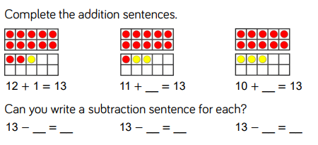

Why not go onto Maths Shed (EdShed) to play some fun maths games?
The portal is free for the duration of school closures!

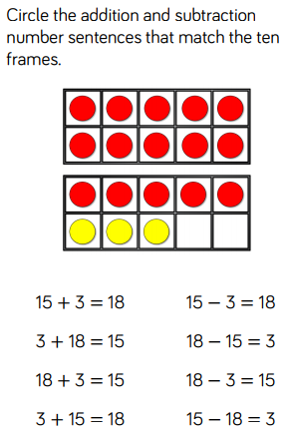

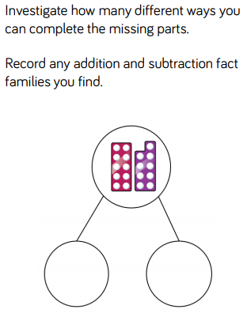

The following words may help you if you want to write sentences:
Nine Nineteen Subtract Add
Ten is equal to

