‘Journeys’ Homework Grid- Autumn 2
India and Italy
Please complete one activity from the grid below each week. We can’t wait to see your learning.
RE/ DT  Make a Nativity Diorama to show the journey that was made by the Wise Men in the Christmas Story.  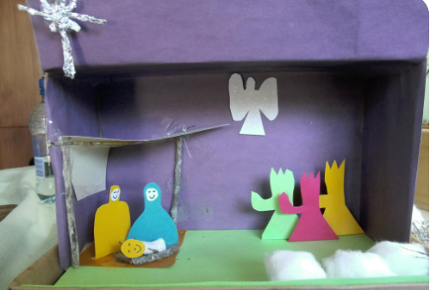 | English  Watch ‘The Way Back Home’. Retell the story in your own words. Use the sentence stems if you would like to:  Once upon a time,  One day,  Unfortunately,  Luckily,  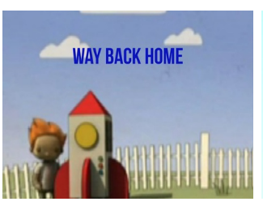  Finally, | Maths  Make a poster to display the times tables and division facts for 10s, 5s or 2s… or all three!  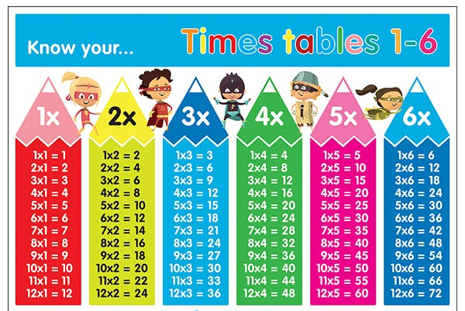
Music  Rehearse the songs for our Christmas Production, ‘The Bethlehem Bake Off!’ We will share the songs and lyrics on Google Classroom  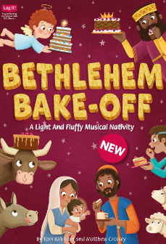 | Geography  Make a map of your home! Can you include a key?  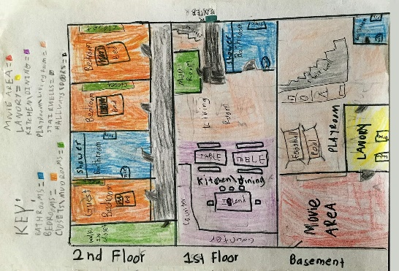 | Science  Seasonal Selfies / Four o clock photograph  Take a selfie or photograph at the same time everyday. Try doing this at 4 o’clock in the afternoon. What do you think will happen as we get into December?

