MEXICO and CHINA CLASSES – YEAR 5
WEEK BEGINNING 23/03/20
L.O. describing our town or village
Write some sentences in Spanish about the shops which are in Pulborough, and what buildings or shops are not in Pulborough.
For example:
En Pulborough hay ... In Pulborough there is / there are ...
dos farmacias (two chemists.)
En Pulborough no hay ... In Pulborough there isn’t / there aren’t ... un estadio (a stadium.)
(You can print out the scanned writing sheet or write on some paper at home.)
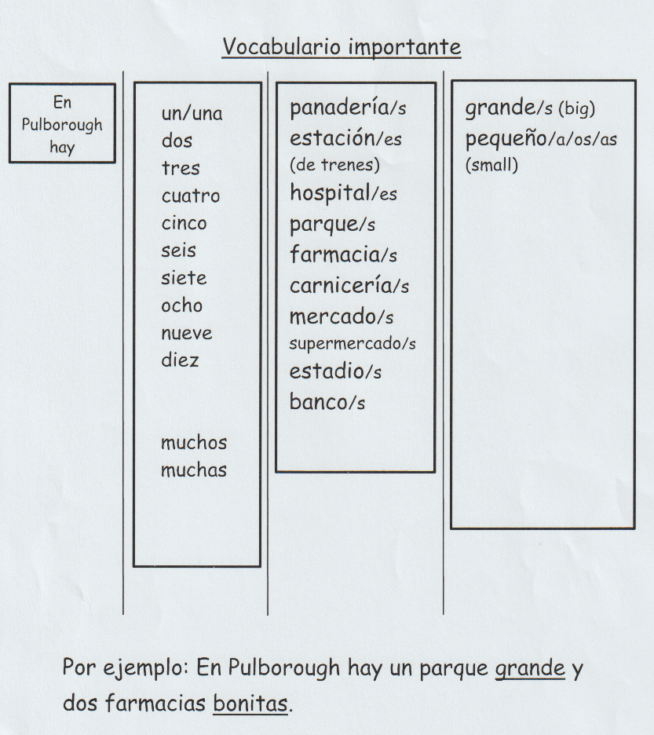
EXTENSION/FUN ACTIVITY:
Draw a map of Pulborough showing the different shops and buildings and label in Spanish, using the vocabulary list or search online Spanish dictionary for other shop/building names. Colour and illustrate with pictures or drawings.
