YEAR 4 – ACTIVITIES FOR LEARNING TIMES TABLES
Please see the following ideas for practicing your times tables at home:
- Use Times Table Rockstars for 20 minutes each day. Use the ‘studio’ area to try and improve your speed (and rock status!) or the ‘garage’ area to have a go at a timed challenge. TT Rockstars is currently set to ‘training mode’ which means that the tables will build on the children’s previous achievements and be presented in a progressive order.

- Log on to MyMaths and complete the times table activities that have been set.

- Times table flashcards. The children all brought home a yellow sheet of card last week. This is to be used to make their own times table cards. They will be able to show you the strategies that we have been learning in class to improve speed of recall, accuracy and fluency. Ask your child to pick a times table of their choice – then test them on the calculations using the flashcards, first in the correct order, then in a random order.

- Hit the Button: Use the following website to practice recall of multiplication and division facts: https://www.topmarks.co.uk/maths-games/hit-the-button

- Explore the website: http://www.transum.org/Tables/Times_Tables.asp and have a go at some of the activities on there to learn a new times table of your choice.

- Play a game of times table connect 4. Draw yourself a 5x5 grid and fill with times tables questions. Take it in turns to answer a question and then mark off with your initial or a colour. If you get 4 questions correct in a row then you win!

- Go on to You Tube and learn a times table song of your choice – there are lots to choose from. Percy Parker has been very popular with the children recently! An alternative website to use is: https://musicalmaths.com/category/teacher-resources/ You could also make up your own times table song.

- Look at this website to set yourself timed challenges and develop knowledge of factors and multiples. http://www.bbc.co.uk/skillswise/game/ma13tabl-game-tables-grid-find

- Have a go at times table dominoes. Place the dominoes face down in a pile, take it in turns to turn one over and multiply the numbers on each end together. The player with the highest score wins!

- Try the times table ‘Tic Tac Toe’ game. Choose a times table to focus on. Draw a grid and write the numbers 1-9 in the corner of each square. On your turn, choose a square and multiply the number in the square by the times table. The first player to get three answers in a row wins.
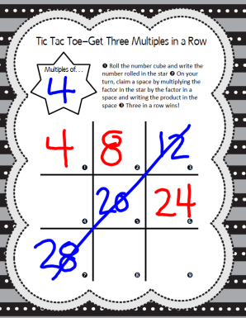
11. Outdoor learning ideas: Take a football/rugby ball/tennis ball outside and practice your passing whilst learning a times table. Count in different steps whilst kicking/passing the ball or take it in turns to ask a times table question for your partner to answer whilst throwing and catching.
12. Use the following website to answer times table questions in the style of the Year 4 Multiplication Check. There are lots of other games to choose from. https://mathsframe.co.uk/en/resources/category/7/multiplication-and-division

