03.04.20
LO to read, understand and use hundredths.

Starter:
Practise a times tables of your choice using your flashcards or play a couple of games on TTRockstars.

Main:
https://whiterosemaths.com/homelearning/year-4/

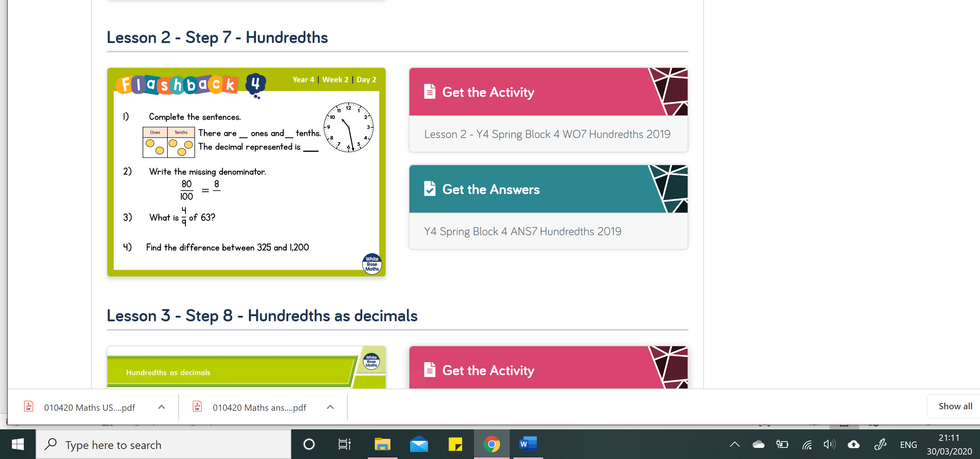

QUESTIONS ARE IN THIS DOCUMENT AS WELL AS ATTACHED AS A PDF
Enjoy,

USA team

