KS1 Homework Grid
Choose one of the activities below to complete each week. We cannot wait to see your learning!
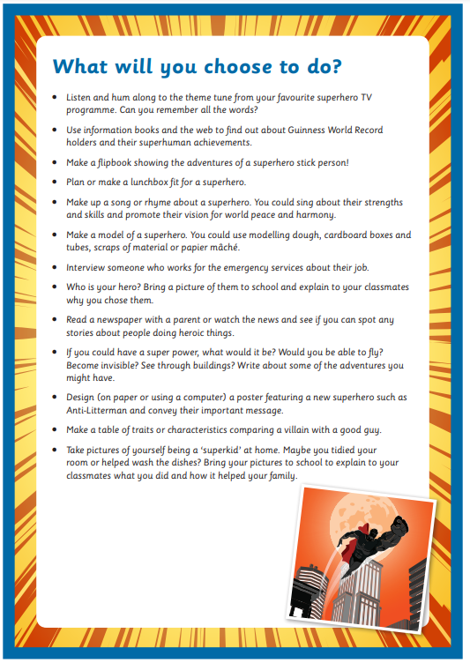

- Write a story about a child that gains super powers. What are their powers? How did they gain their powers? (eg. Did they drink a special potion or eat something special?) What do they use their powers for?

