L.O. to understand that every story has structure and a plan resulting in a beginning, build up, problem and resolution.
Story Mountain for: ________________________________________________________________________________________________________
Problem
________________________________________________________________________________________________________________________________________
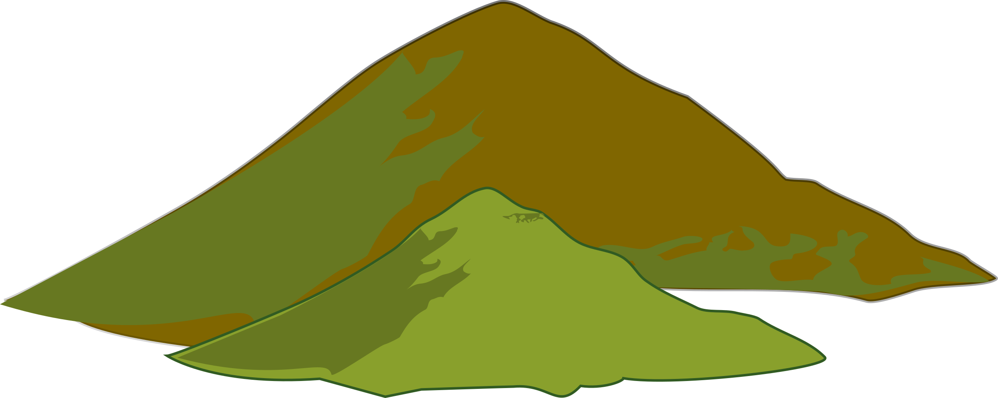
Story Mountain
Build Up
________________________________________________________________________________________________________________________________________
Characters

Settings

Resolution
________________________________________________________________________________________________________________________________________
Ending
________________________________________________________________________________________________________________________________________
Introduction
________________________________________________________________________________________________________________________________________

