16.07.20
LO to draw coordinates on a grid.
Starter: True or False.
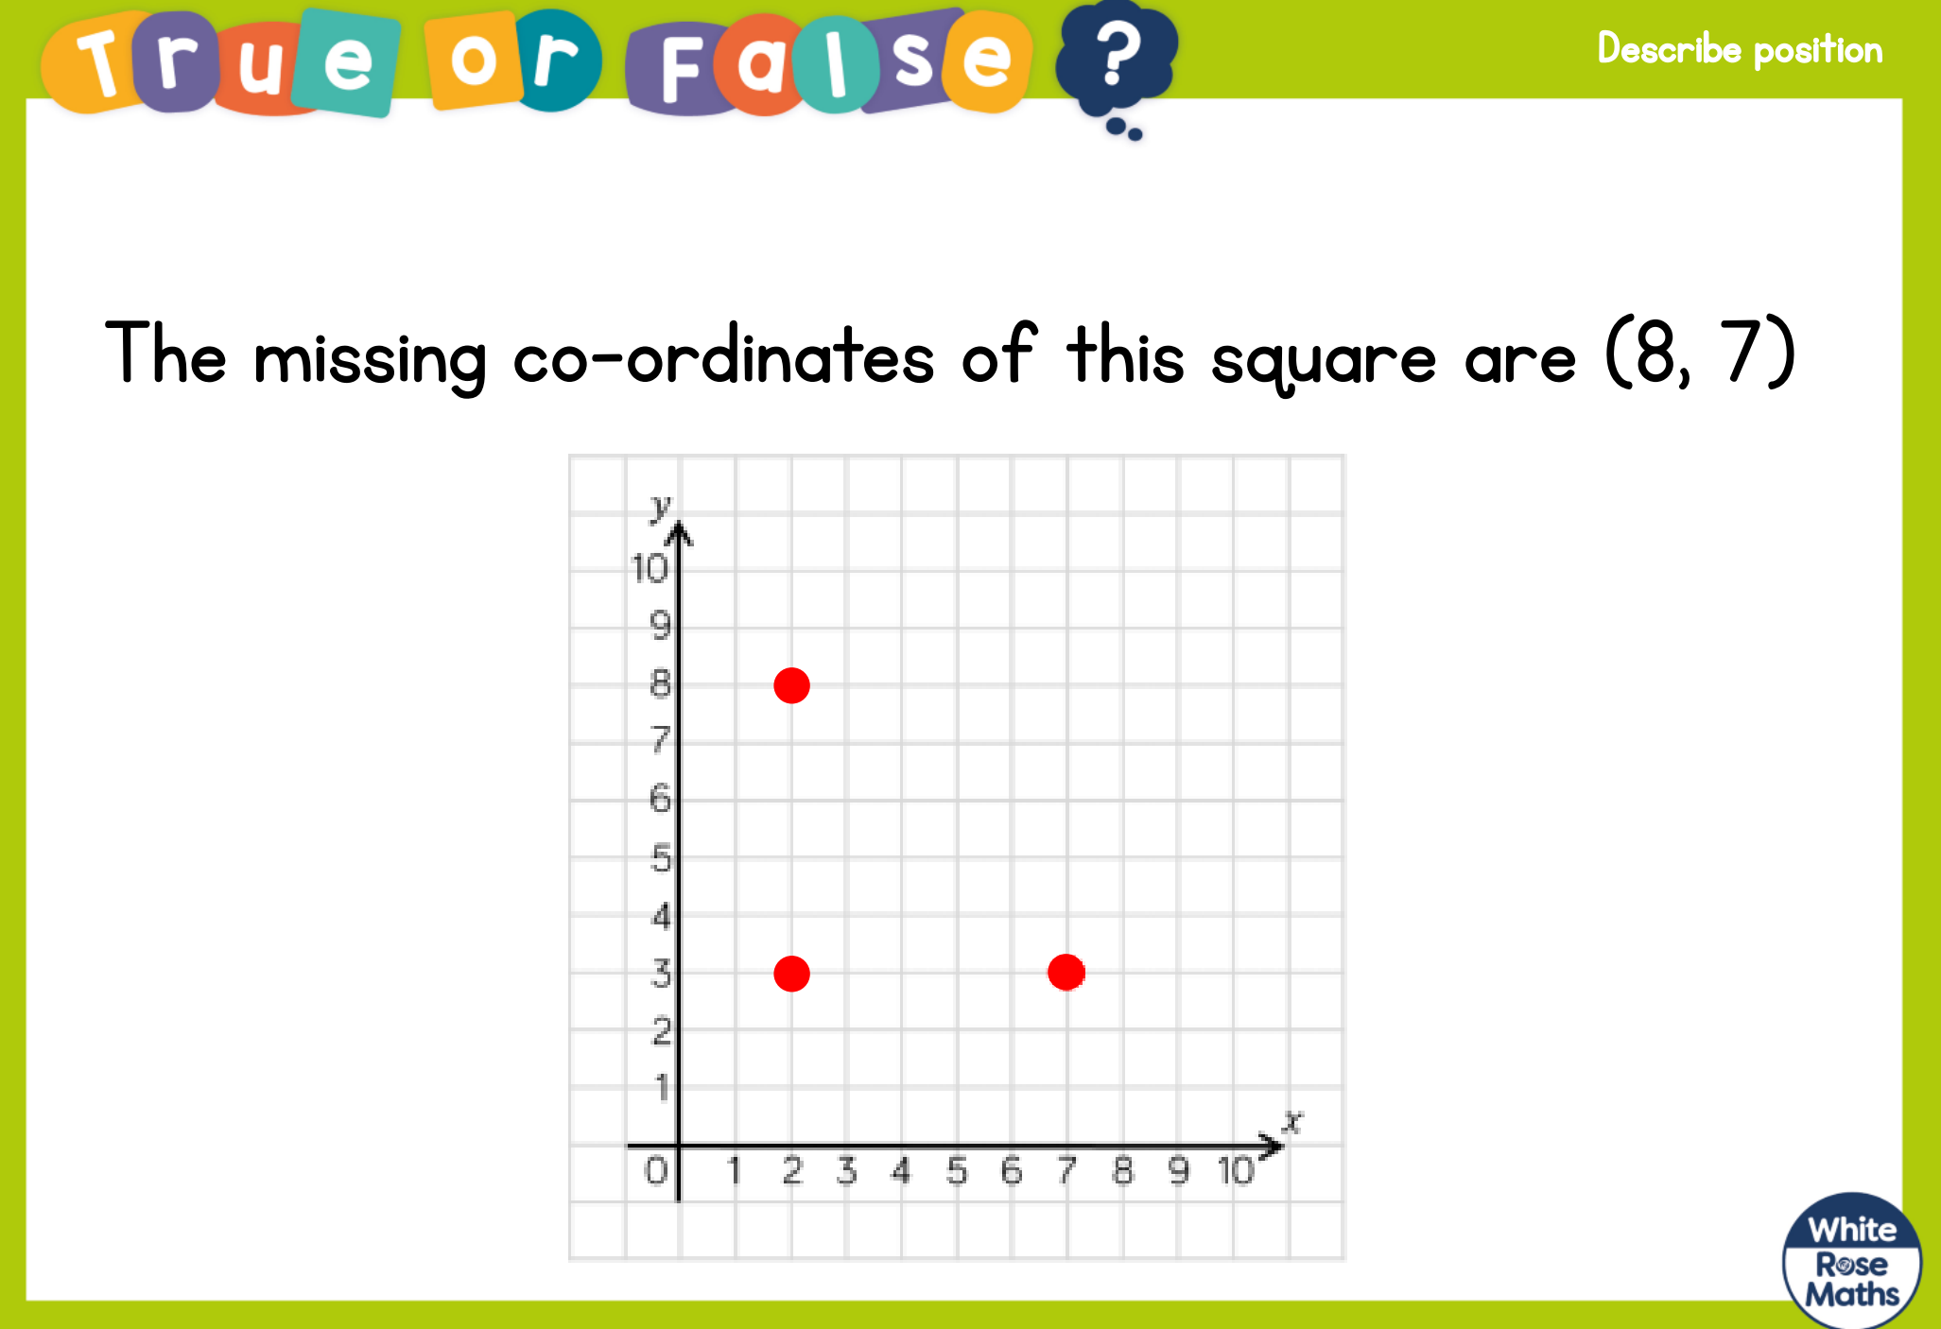

Main: Back to White Rose main site again: https://whiterosemaths.com/homelearning/year-4/

Again, for this lesson remember: ALONG THE CORRIDOR (x), THEN UP THE STAIRS (y)
(x,y)

CONGRATULATIONS on completing all of the White Rose Maths set for you. Tomorrow there is a number trail for you to enjoy! You deserve it! Very well done.
USA team

