01.04.20
LO to divide 2 digit numbers by 10.

Starter:
Hit the button divide by 10: https://www.topmarks.co.uk/maths-games/hit-the-button

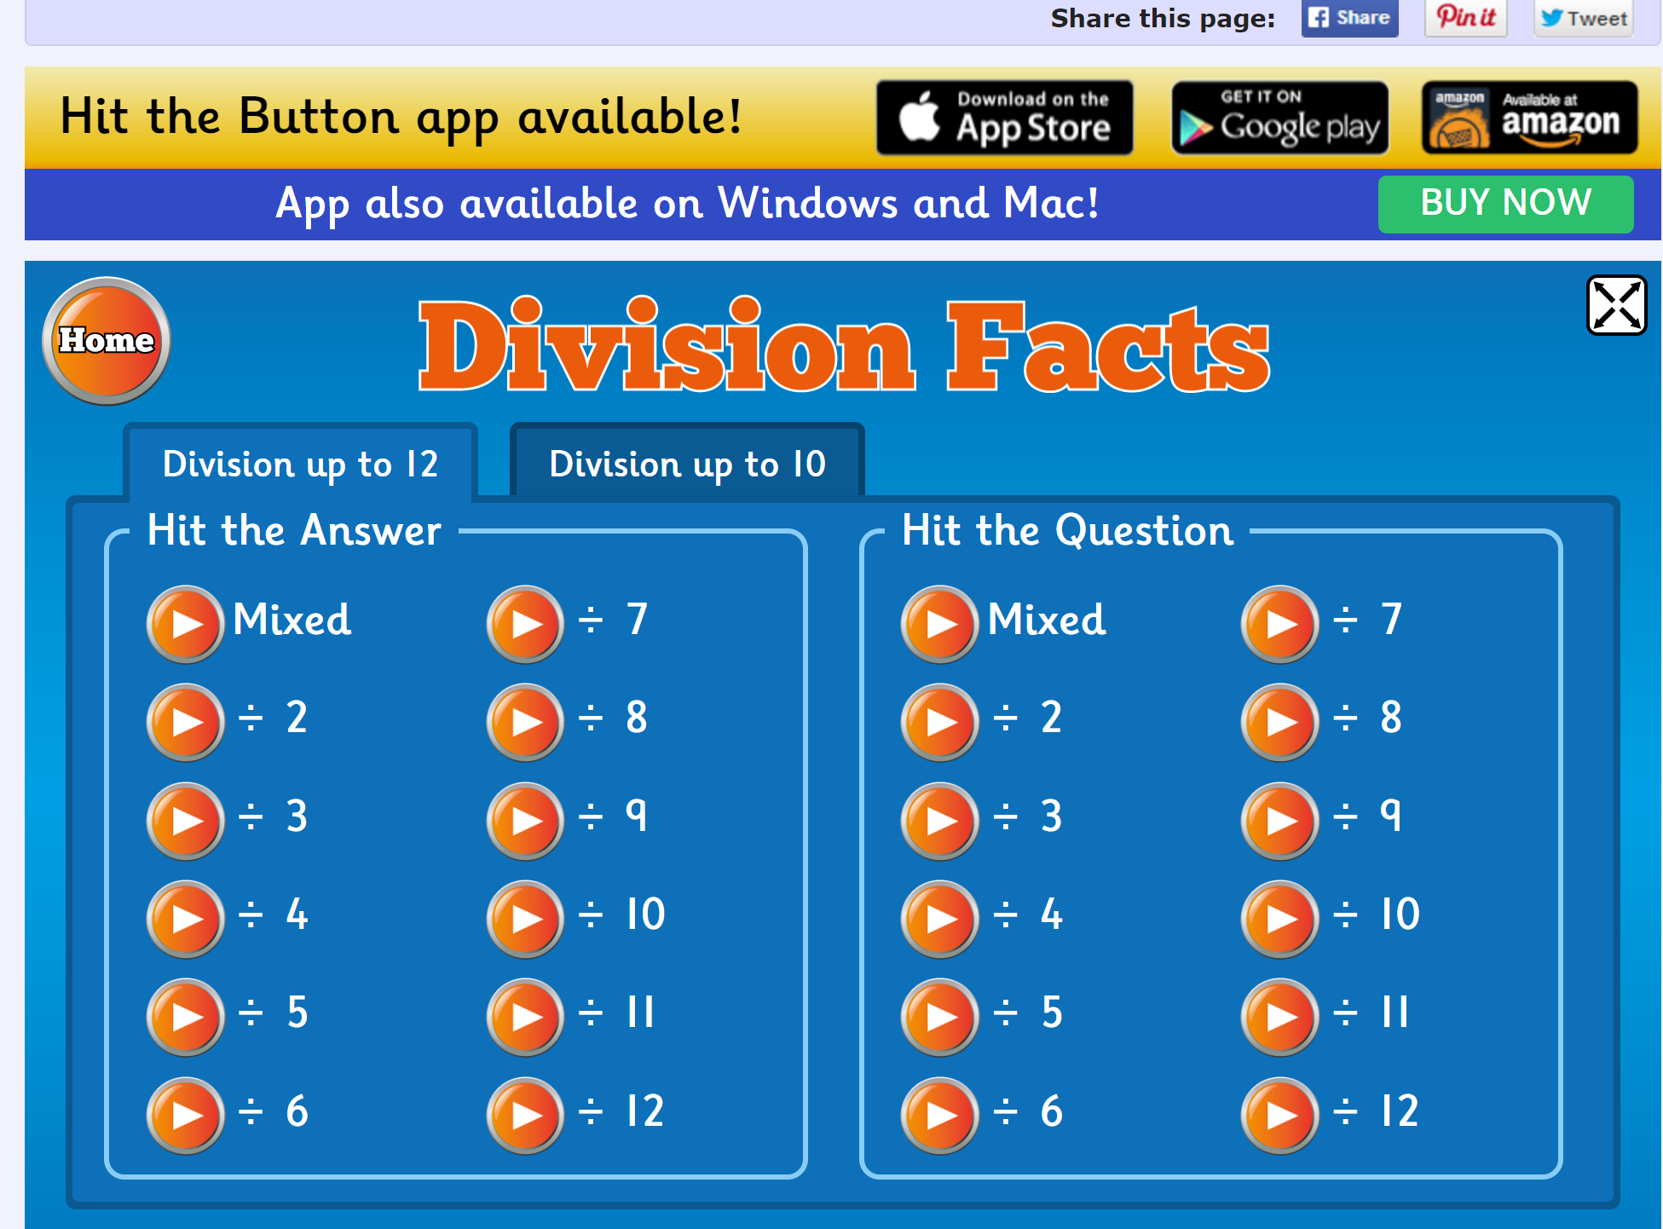
Main:
https://whiterosemaths.com/homelearning/year-4/

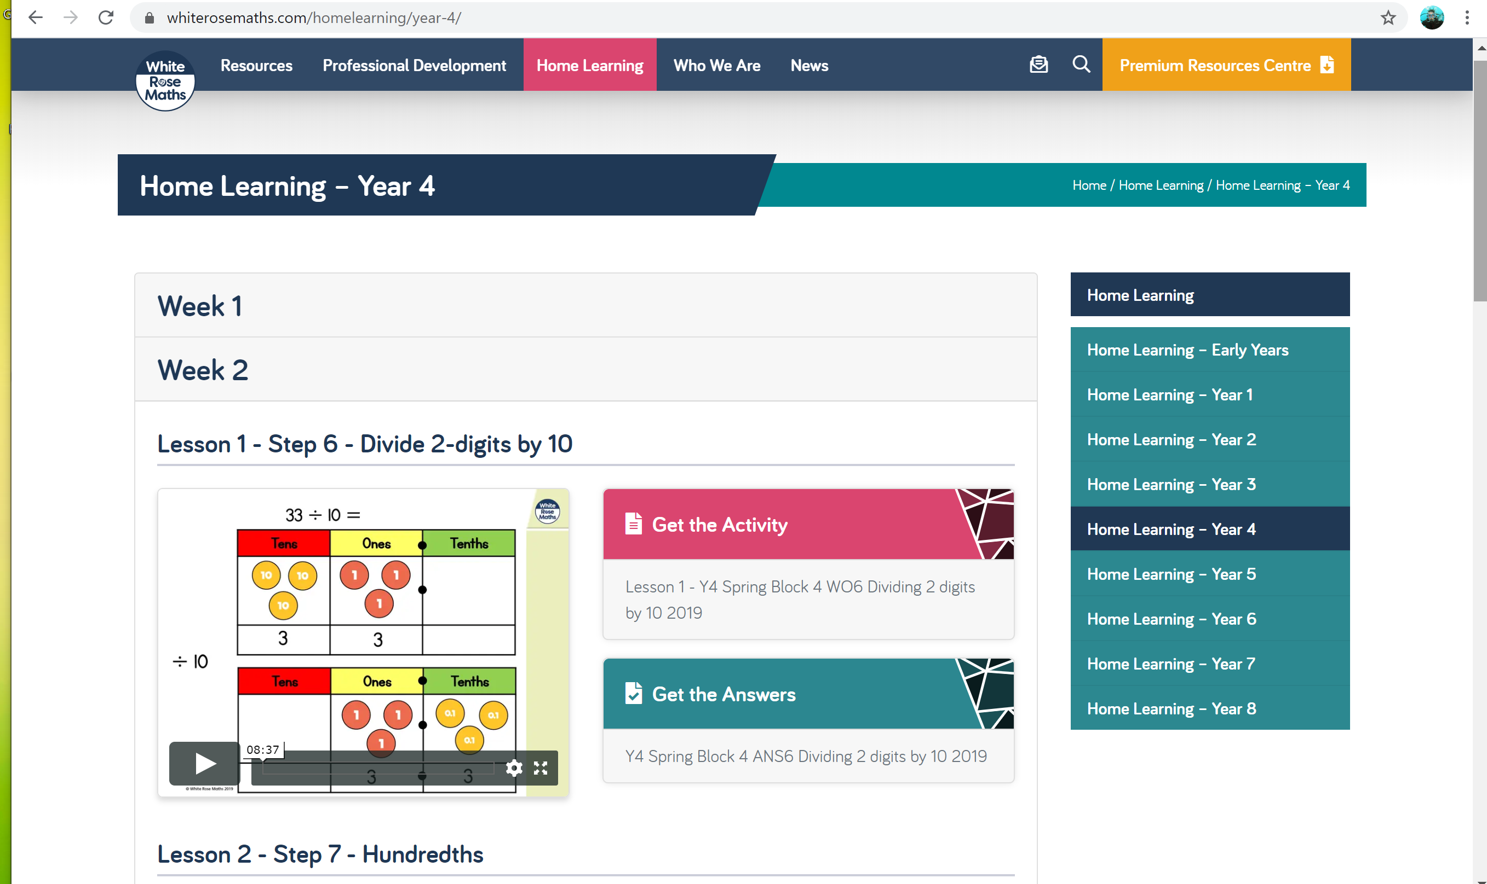

QUESTIONS ARE IN THIS DOCUMENT AS WELL AS ATTACHED AS A PDF
Enjoy,

USA team

