Monday 30th March 2020 RE
LO: Making links between Bible stories and the importance of love and life in the world today.

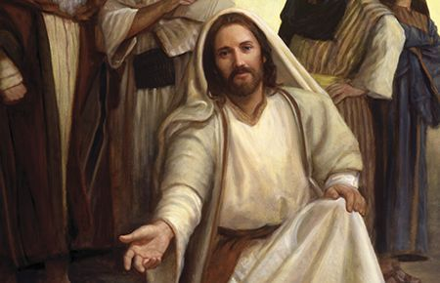

Starter:
Recap on discussion from last week’s home learning task – what kind of world would Jesus have wanted? Encourage children to give clear examples of how Jesus would want Christians to behave and provide reasons for them.
Activity 1:
Children to reflect upon what they think the world should be like today.
Using the globe template, (see resources document) on one side record words/phrases describing what they believe the world is like; on the other side record words/phrases showing what they would like it to be like.
Activity 2:
Children to write a paragraph describing what sort of world they think Jesus would have wanted. This could include; a world where people follow Jesus and his example, a world where followers spread the word so that others who want to follow Jesus are all included.
Challenge:
Children to look at a selection of images showing the world in a state that Jesus would not have wanted, eg. a homeless person with others passing by, bullying someone, not forgiving someone who is truly sorry, etc.
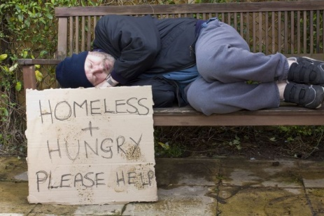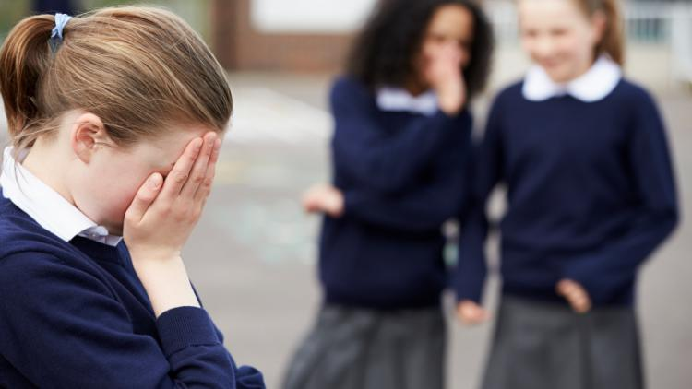
Children to draw/record:
- What a Christian who lives as Jesus would want them to might do in each situation.
- What the children themselves would choose to do in each situation if they were trying to be really good and kind – it does not have to be the same as the Christian.

