Wednesday 1st April 2020

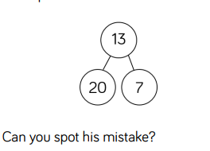
Home Learning – Maths
Revision of Number – number bonds, addition, subtraction
Good morning children and families!

Please complete the White Rose revision strips, ensuring that you have access to practical equipment as needed, including a ruler/number line.
Ten frames can be hand-drawn or printed from Twinkl for free.
