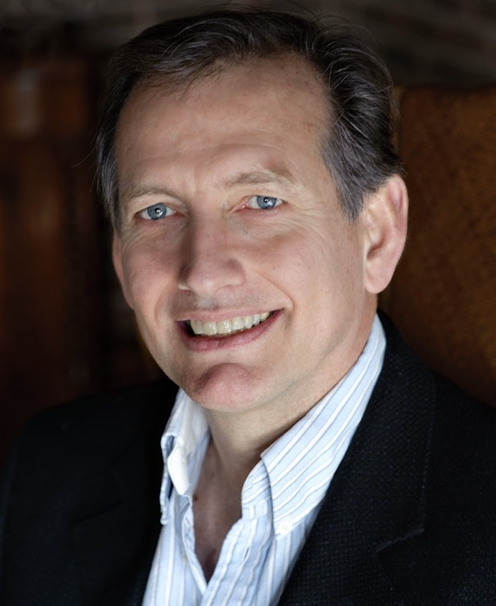

Richard Cordy

Hi, my name is Richard Cordy and I have a son at St Mary's, and my daughter has just moved on to the Weald from St Mary’s. I've been a foundation governor for two years and sit on both the Ethos and Worship committee and the Premises/ Health & Safety Committee. I am also Treasurer for the Governing Body and chair the Finance Committee.
Following a career in Leisure, and Residential Development, I am now a Property Consultant, and when I can find time I enjoy playing tennis and badminton.

