Monday 30th March
Good morning everyone. Mrs. Huntley-Hart and I hope you all had a good family weekend even though it was a bit chilly. It’s worth remembering that these are extraordinary times and nothing feels normal at the moment. We’ve all got plenty of things on our minds on top of our children’s learning. Now is the time to be kind to each other, to our families, and to strangers. Perhaps even more importantly, it’s the time to be kind to ourselves. Everyone has lots to juggle and we’re all doing our best in an unprecedented situation.

Reading: We have emailed some Jolly Phonics books to those who have sent back permission not to copy them. More are on their way.

MyOn
Today can you read this books from the ‘Community’ section.

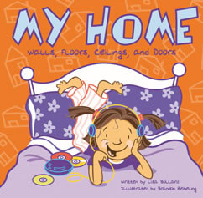

Visit Oxford Owl for free eBooks that link to your child’s book band. You can create a free account. We read books together from this site at school.

Topic: The area you live in
The project this week aims to provide opportunities for your child to learn more about the area in which they live. Learning will focus on your local area.

Read the story Hansel and Gretel, retell it from memory or even watch it on youtube - What makes the house appealing to the children?

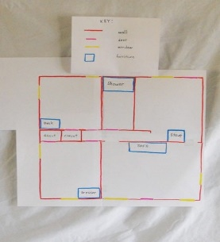
The rooms in my house-
○ Support your child to create a map or cross section of their home. Can they name all of the rooms? An adult could hide an object in a room and mark where it is on the child’s map. Can they use their map to find the hidden object? Label each room using phonics knowledge.
○ Gather an object from each room and challenge your child to return them to the appropriate room e.g. toothbrush from the bathroom, teddy from their bedroom.
○ Hide objects around the room and describe where it is e.g. “it’s under something red” Can your child hide an object and describe where it is for you to find?

We look forward to seeing pictures of this activity!

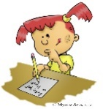

Writing
See the tricky words in the phonics section below.

Singing

Sing Nursery Rhymes and songs together. Add in actions and change the words. Can children think of different rhyming words to add in? Repeat old favourites and learn new rhymes, this is something U.K. and Austria do everyday.

Phonics- www.PhonicsPlay.co.uk
User name: March 20
Password: home

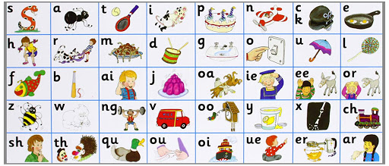

All the Jolly Phonics songs can be accessed via this link https://vimeo.com/106231366

Today we would like you to practice the tricky words we have been working on in class. Here are some super but simple activities that your children can do at home to practice their tricky word recognition and spelling.

Todays tricky words are:

the | he | be
to | she | was
no | we | my
go | me | you

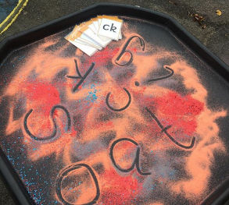
You will need simple kitchen ingredients, we use corn flour, salt or sugar. Pour a small amount onto a tray , call out the words, can your child write the word in the flour/salt? If thy find the whole word tricky can they record the initial sound?

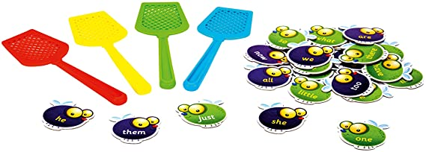

Another favourite activity of ours is ‘splat’ – write the tricky words out onto pieces of paper, call out the word and your child can ‘splat’ them with their hand, a spatula, a pastry brush or fly swatter if you have one!!

Maths
Investigating properties of 3D shapes. Look through the bits and pieces you managed to save over the last week. Try to pick something which reflects the properties of; a sphere, a cube, a cuboid, a cylinder, a cone and a pyramid (realise these last two may be tricky).
Explore the activity trying out each of the different shapes.
Vocabulary – edges, corners, sides
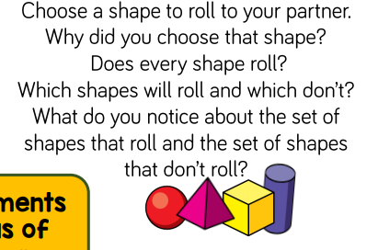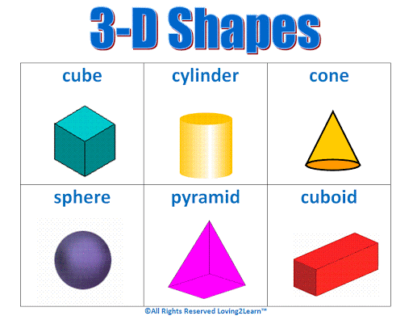

Recognising 2D shapes - we would normally go for a hunt around school to spot different shapes. Please explore your house, and garden if you have one, what shapes can your child spot? Link this back to the shape hunt that was sent home earlier in the school year.

Challenge your child to explain their thinking, for example; ‘the table is a circle because it has no corners and one edge that goes all the way round’, or ‘the window is a square because it has 4 corners and 4 sides that are all the same size’.

Remember to support natural language development by modelling back to your child, take this opportunity to extend vocabulary introducing the following terms into your descriptions – sides, edges, corners, curved, straight, longer, shorter, length
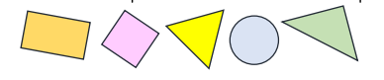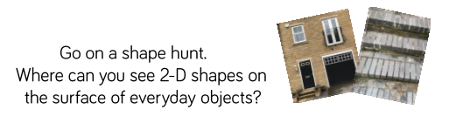

It has been great looking through the pictures and comments sent in so far. We are adding these into their 2Simple Profiles each day so please keep them coming.

