U.K. and Austria Homework Grid
Happy Easter! During the Easter Holidays, complete as many activities as you can from the grid below. We look forward to seeing your learning
Do not forget the National Trust things to do –see below. There might be a few your children can attempt.
Watch the Easter Story:  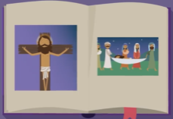  https://www.youtube.com/watch?v=Wnbo2AmS3OI  Have a go at writing it down or explaining it to an adult. | Make a cross out of natural materials.  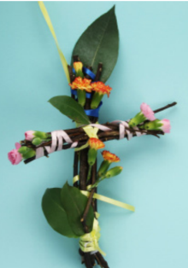 | 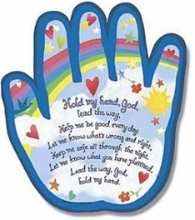  Write a prayer for people during this time. Use the structure below if you would like to:  Dear God,  Thank you for……………………………..  Help us to……………………………  Amen. | 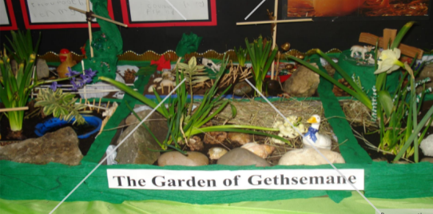  Design and make your own Garden of Gethsemane.
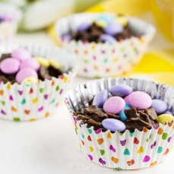  Using your amazing scale reading skills, bake your own Easter treats. | 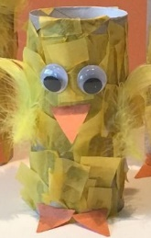  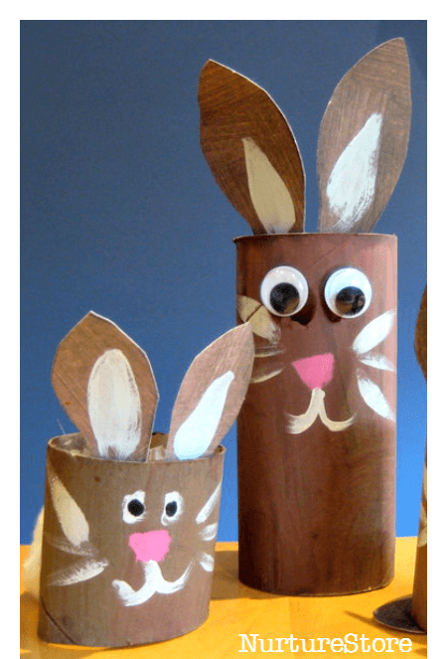  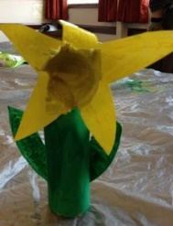  Use junk modelling to make an Easter flower or animal. | 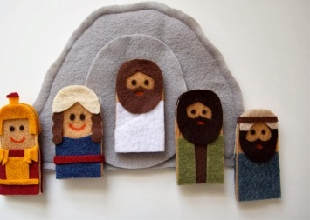  Make puppets and recreate part of The Easter Story. | 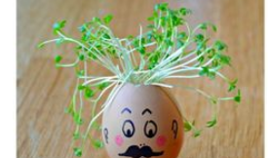  Plant a seed and watch it grow! Record your observations each day.
Create a stained glass nature collage.  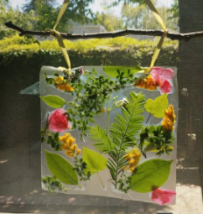 | 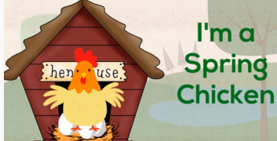  Sing along with the Easter song we all love, ‘I’m a Spring Chicken’.  https://www.youtube.com/watch?v=IEey4LZLeGw | 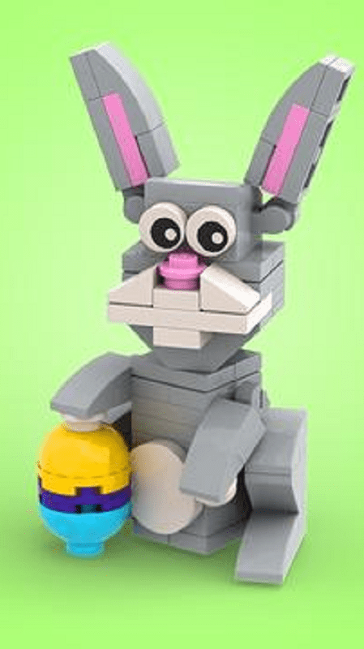  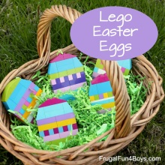  Use Lego or another building material to build your own Easter creation. | Talk with your children about different Easter traditions around the world.  https://www.forteachersforstudents.com.au/site/themed-curriculum/easter-lp/facts/#world
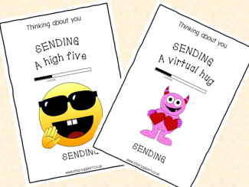  Write a ‘thinking of you’ card to one of your friends or family members. | An Easter egg hunt may be difficult this year. How about setting one up in your house? We have attached some printable Easter eggs that you can enjoy colouring in and hiding around the house.  See below | 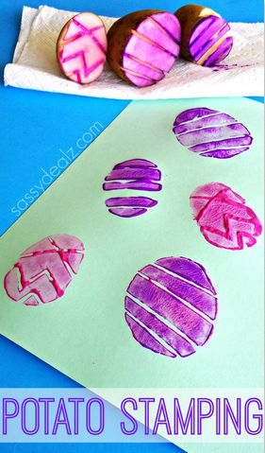 | We asked you to try this at the beginning if you did not manage it then have a go.  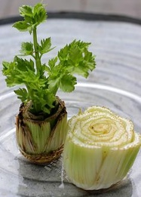

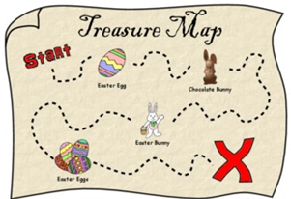
Make a map for your Easter egg hunt with the eggs below. Where did the Easter Bunny leave your eggs?

Special Message from Mrs Copus St Mary’s Easter Tradition – Easter Eggstravaganza – Every year we have an Easter Eggstravaganza and we are hoping this year won’t be any different. This involves making an Easter Bonnet, Decorating an Egg, or BOTH!! If your child would like to make one, or both, of these then send us a picture to head@stmarysprimarypulborough.co.uk or message through the Facebook page and we will post them on our next newsletter and on the PTA Facebook page. It would be lovely to see some of the children’s faces and see what they have made. Please start sending these whenever they are ready.
