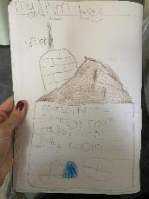
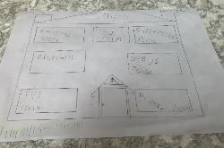

Friday 3rd April

Good morning everyone, the dream houses you created were so imaginative. So many of you are approaching home learning with enthusiasm and your children are lucky to have you. We will not be sending out daily activities over the Easter period but will be providing a grid with ideas for things to do. Please do contact us if you have any problems. We are not going anywhere! Please keep sending all the wonderful pictures.

Lee and Emma

Reading: Today visit Oxford Owl for free eBooks that link to your child’s book band. You can create a free account. We read books together from this site each week at school.
Simply reading a book with a child is one of the most important ways you can help a child learn to read. If they get stuck on a word, encourage them to ‘sound talk’ the word and then blend the sounds together to make the word.

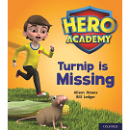
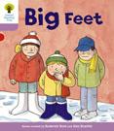
Read together Independent reading

Topic: Today we aim to provide opportunities for your child to learn more about different
viewpoints. Learning may focus on physical viewpoints in terms of what you can see outside
of the window at home, what others can see looking into your home and then progress onto
personal viewpoints and of others. This will continue after Easter.

What can you see out of your window?-
○ Ask your child to look out of a window in the house and draw what they can see. Look
out of a different window (e.g. back or side of the house), draw what they can see.
Look at the two pictures together and discuss what is the same in both pictures (e.g.
the sky) and what is different.

Record how many cars/ people walk past your house-
○ Set a timer for 5 minutes on your phone or tablet. Draw out a simple grid (as below)
and ask your child to put a tick in the right place every time a person or car goes past.

When complete, can they count up the ticks and write the matching numeral? Were there more people or cars?
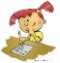

Writing

Ask your child to help plan a movie night/afternoon. Select two films from a streaming service or DVD’s you have in the house. Ask them to draw a picture to represent each film or write out the title.
Ask them to speak to each member of the house to find out their view on which film
they would like to watch. Ask your child to write each person’s name under their chosen film.

Singing

In U.K. and Austria we use a fantastic singing resource called ‘Sing-up’. This is free to you if you use the link below. Try joining in with ‘Alice the Camel’ a finger rhyme we know by copying and pasting the link below.
https://www.singup.org/home-schooling/eyfs-ks1/warm-ups-and-songs

Phonics-
Daily phonics - Practice the sounds your child is working on in their purple book and blend words. This can be oral blending (e.g. spoken out loud c-a-t) or written if appropriate.

www.PhonicsPlay.co.uk
User name: March 20
Password: home

Today we would like you to play:
Play I-spy with things you can see out of the window. You could alternate between the initial sound in the word e.g. “I spy with my little eye something beginning with t”. Or with oral blendinge.g. “I spy with my little eye a t-r-ee”
● Play a listening game- Gather a selection of objects that make sounds from around the house. Cover your child’s eyes with a blindfold and make sounds with theobjects collected. Can they figure out what the object is without looking at it?
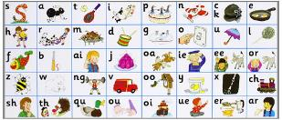

All the Jolly Phonics songs can be accessed via this link https://vimeo.com/106231366

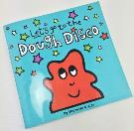

Playdough An old classic! There are many recipes available, this is our favourite.

2 cups of plain flour
Half a cup of salt
2 tablespoons of cooking oil
2 tablespoons of cream of tartar
1 to 1.5 cups boiling water
A few drops of food colouring.

Mix the flour, salt, oil and food colouring in a bowl. Slowly add the water (you may not need it all) Allow to cool then knead and join Shonette Bassett-Wood who leads the children in playdough disco.

This is a fun activity which combines the use of playdough with a series of hand and fingers exercises.

Shonette Bassett Wood can be found at - https://www.youtube.com/playlist?list=PLtw-7Jf06an1IfIIonfs44FpzuCv7g1ZB&fbclid=IwAR2N7UYt-_WteDtohKZAU-J3yyfCGc0qnBC_WTRR-yqcu0FmHX22Ahd3Qo4

Maths

For today we have chosen an activity from nrich.maths.org, this refers to using wooden blocks but we thought you could try this with the packaging you have been collecting? Have fun.
