Monday 13th July 2020
Ireland & New Zealand class learning
Science
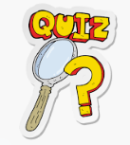
You have learnt so much in Science through-out Year 3.
Have a go at any of the below quizzes to see how much you can remember.
https://www.educationquizzes.com/ks2/science/rocks/
https://www.educationquizzes.com/ks2/science/magnets/
https://www.educationquizzes.com/ks2/science/skeletons/
https://www.educationquizzes.com/ks2/science/healthy-eating/
https://www.educationquizzes.com/ks2/science/the-parts-of-a-plant/
https://www.educationquizzes.com/ks2/science/shadows-and-reflections/

