Thursday 2nd April 2020
Home Learning – English
Well done to everyone who has been showing me their homework via the thailand@ email address. Keep them coming…I love to see what you have been doing and I love to give you dojos for your efforts! It is also good for me to see the outcome as this is like feedback for me, which helps me to reflect on how well I am doing my job!

Today in English, I would like your child to watch a short video from Literacy Shed and answer lots of questions about it. This is a comprehension activity but instead of reading they will be speaking and listening. Please refer to the Vipers poster to understand the skills your child will be practising.
Here is the link to the film:
https://www.literacyshed.com/bubbles.html
Bubbles Recommended age 4 – 7
https://www.literacyshed.com/the-fantasy-shed.html
(This is the web link for the following instructions, should you prefer to print that out).

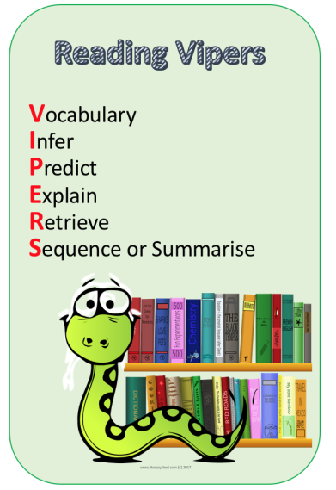

Before watching the film
Play a sound track of seaside sounds. Ask the children what they can hear. V R
Play the film ‘Bubbles’

Pause the film just after she picks up the bubbles at 14 seconds.
• Ask how is she feeling? I
• How does she feel when she finds the bubbles? I

Pause the film after she pulls down her hood and looks at the bubbles.
• How is she feeling now? I R
• What do you think she might say to herself? P
• What colours can you see in this scene? S
• What mood do these colours make you think of? E

Pause the film as she sees the yellow fish under the water 1 min 05 secs
• What can you see?
o Can you describe it? V R
o What is it doing? V R
o How is it doing it? V R
o Where is it doing it? V R
• Can you put all of this information into one sentence? V
e.g. The yellow fish is swimming slowly through the seaweed

Pause the film once she is in space. 1 min 17
• What can she see?
o Can you describe it? V R
o What colour is it? V R
o What is it doing? V R
o How is it doing it? V R
• Can you put it all into a sentence?
• What else may she be able to see that we can’t see in the scene? (moon etc) E

Pause after she lands on the bubble in the next scene after the big yellow star. 1 min 21 secs.
• How is she feeling now? I

Pause after she spots the girl on the beach?
• How is the girl on the beach feeling? I
• What could have made her feel like this? I E
• How could the little girl in our story cheer her up? P

Watch the film until the end.
• How do you think the new little girl feels when she finds the bubbles? I E
• How does this make the original little girl feel? I E
• Where do you think the second little girl goes on her bubble? P

If you could go anywhere on your bubble where would you go and why?
How many ways can we think of to describe the girl moving on the bubble?
• Floating, drifting, bouncing, sinking etc V
• What do all these words have in common? V
• What type of words are they? V

© 2017 The Literacy Shed Ltd

