USA and Sierra Leone Easter Homework Grid
Happy Easter! During the Easter Holidays, complete as many activities as you can from the grid below. We look forward to seeing your learning.
Watch the Easter Story:  https://www.youtube.com/watch?v=Wnbo2AmS3OI  Can you retell it by making a puppet show or retelling using a storyboard? | Make an Easter cross out of natural materials in the garden. | Write a prayer for people during this time. Use the structure below if you would like to:  Dear God,  Thank you for……………………………..  Help us to……………………………  Amen. | Design and make your own Garden of Gethsemane.
Using your amazing scale reading skills, bake your own Easter treats. | 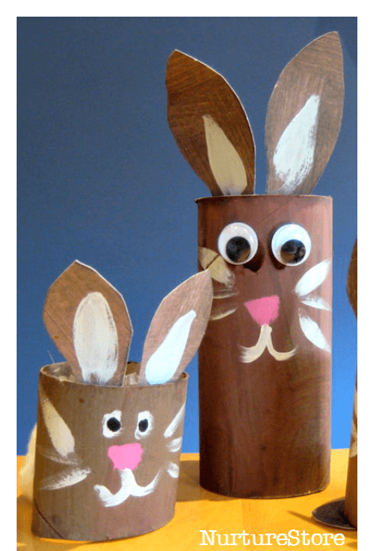  Use junk modelling to make an Easter flower or animal. | Have a discussion about key parts of the Easter Story. Use the discussion cards in this document.  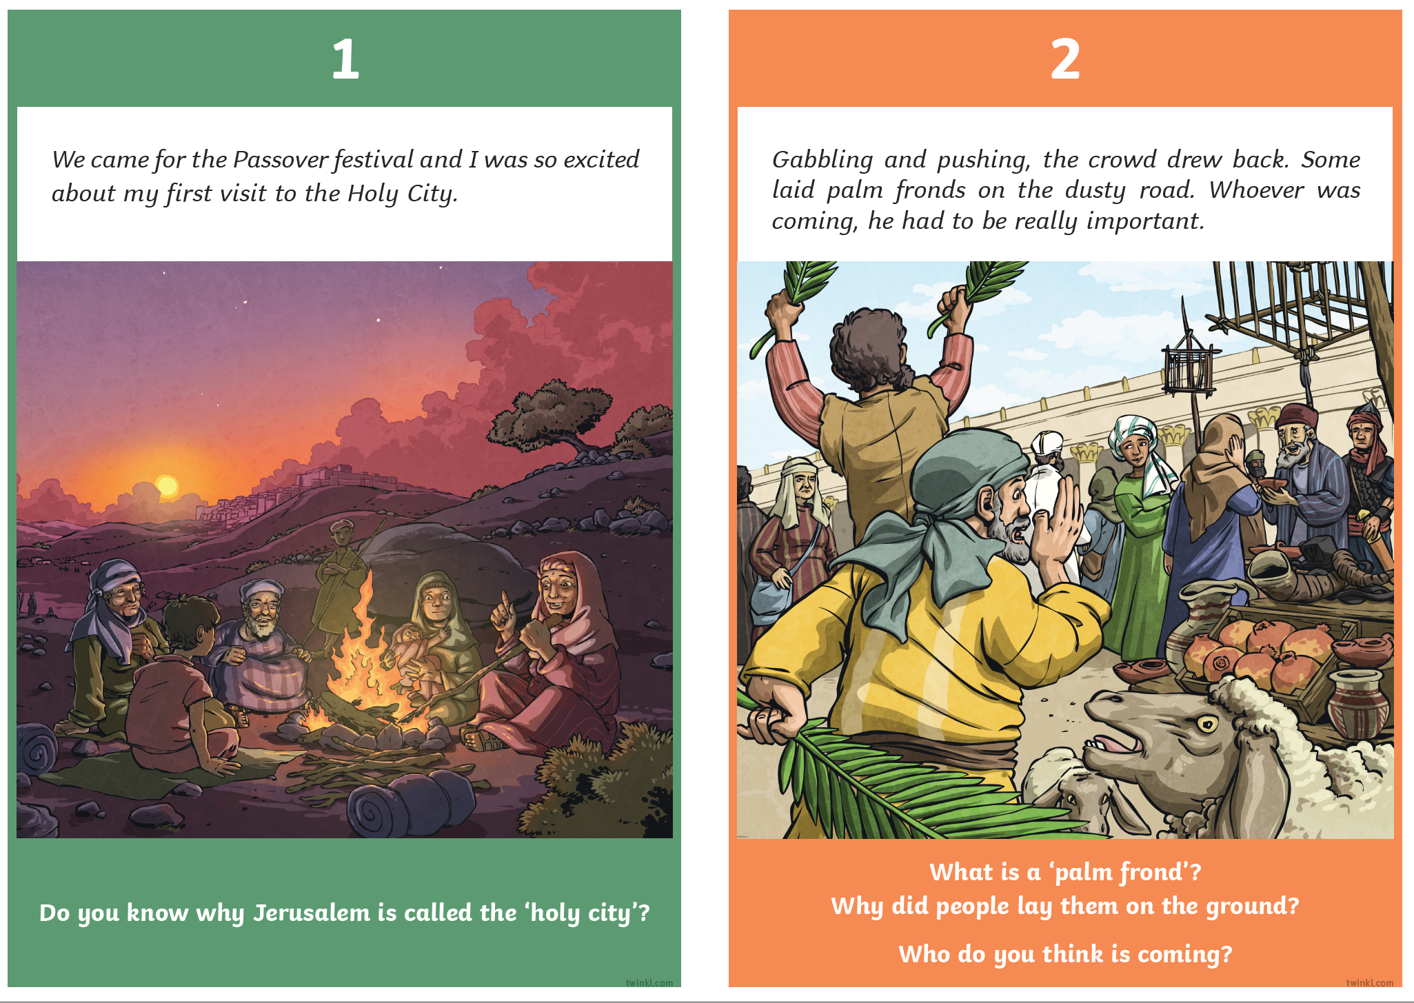 | Plant a seed and watch it grow! Record your observations each day.
Create a stained glass nature collage. | Sing along with the Easter song we all love, ‘Spring Chicken’.  https://www.youtube.com/watch?v=IEey4LZLeGw | Use Lego or another building material to build your own Easter creation.  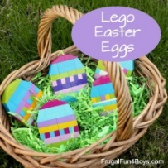  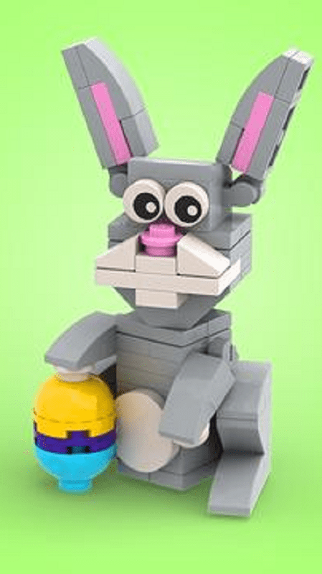 | 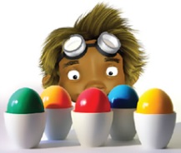  Research how Easter is celebrated around the world. Use the website below to help you. https://www.forteachersforstudents.com.au/site/themed-curriculum/easter-lp/facts/#world
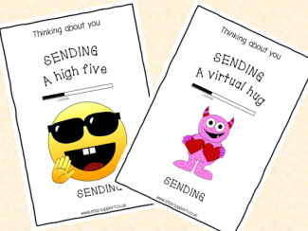  Write a ‘thinking of you’ card to one of your friends or family members. | 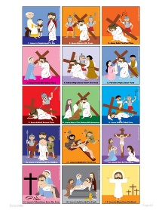  Create your own stations of the cross around your home. https://www.reallifeathome.com/14-stations-of-the-cross-list/ | 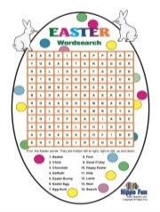  Create your own Easter Word search and ask a family member to complete it. | Solve the Mystery of the Easter Bunny Costume – Maths activities (attached to this document below – answers on the last page)

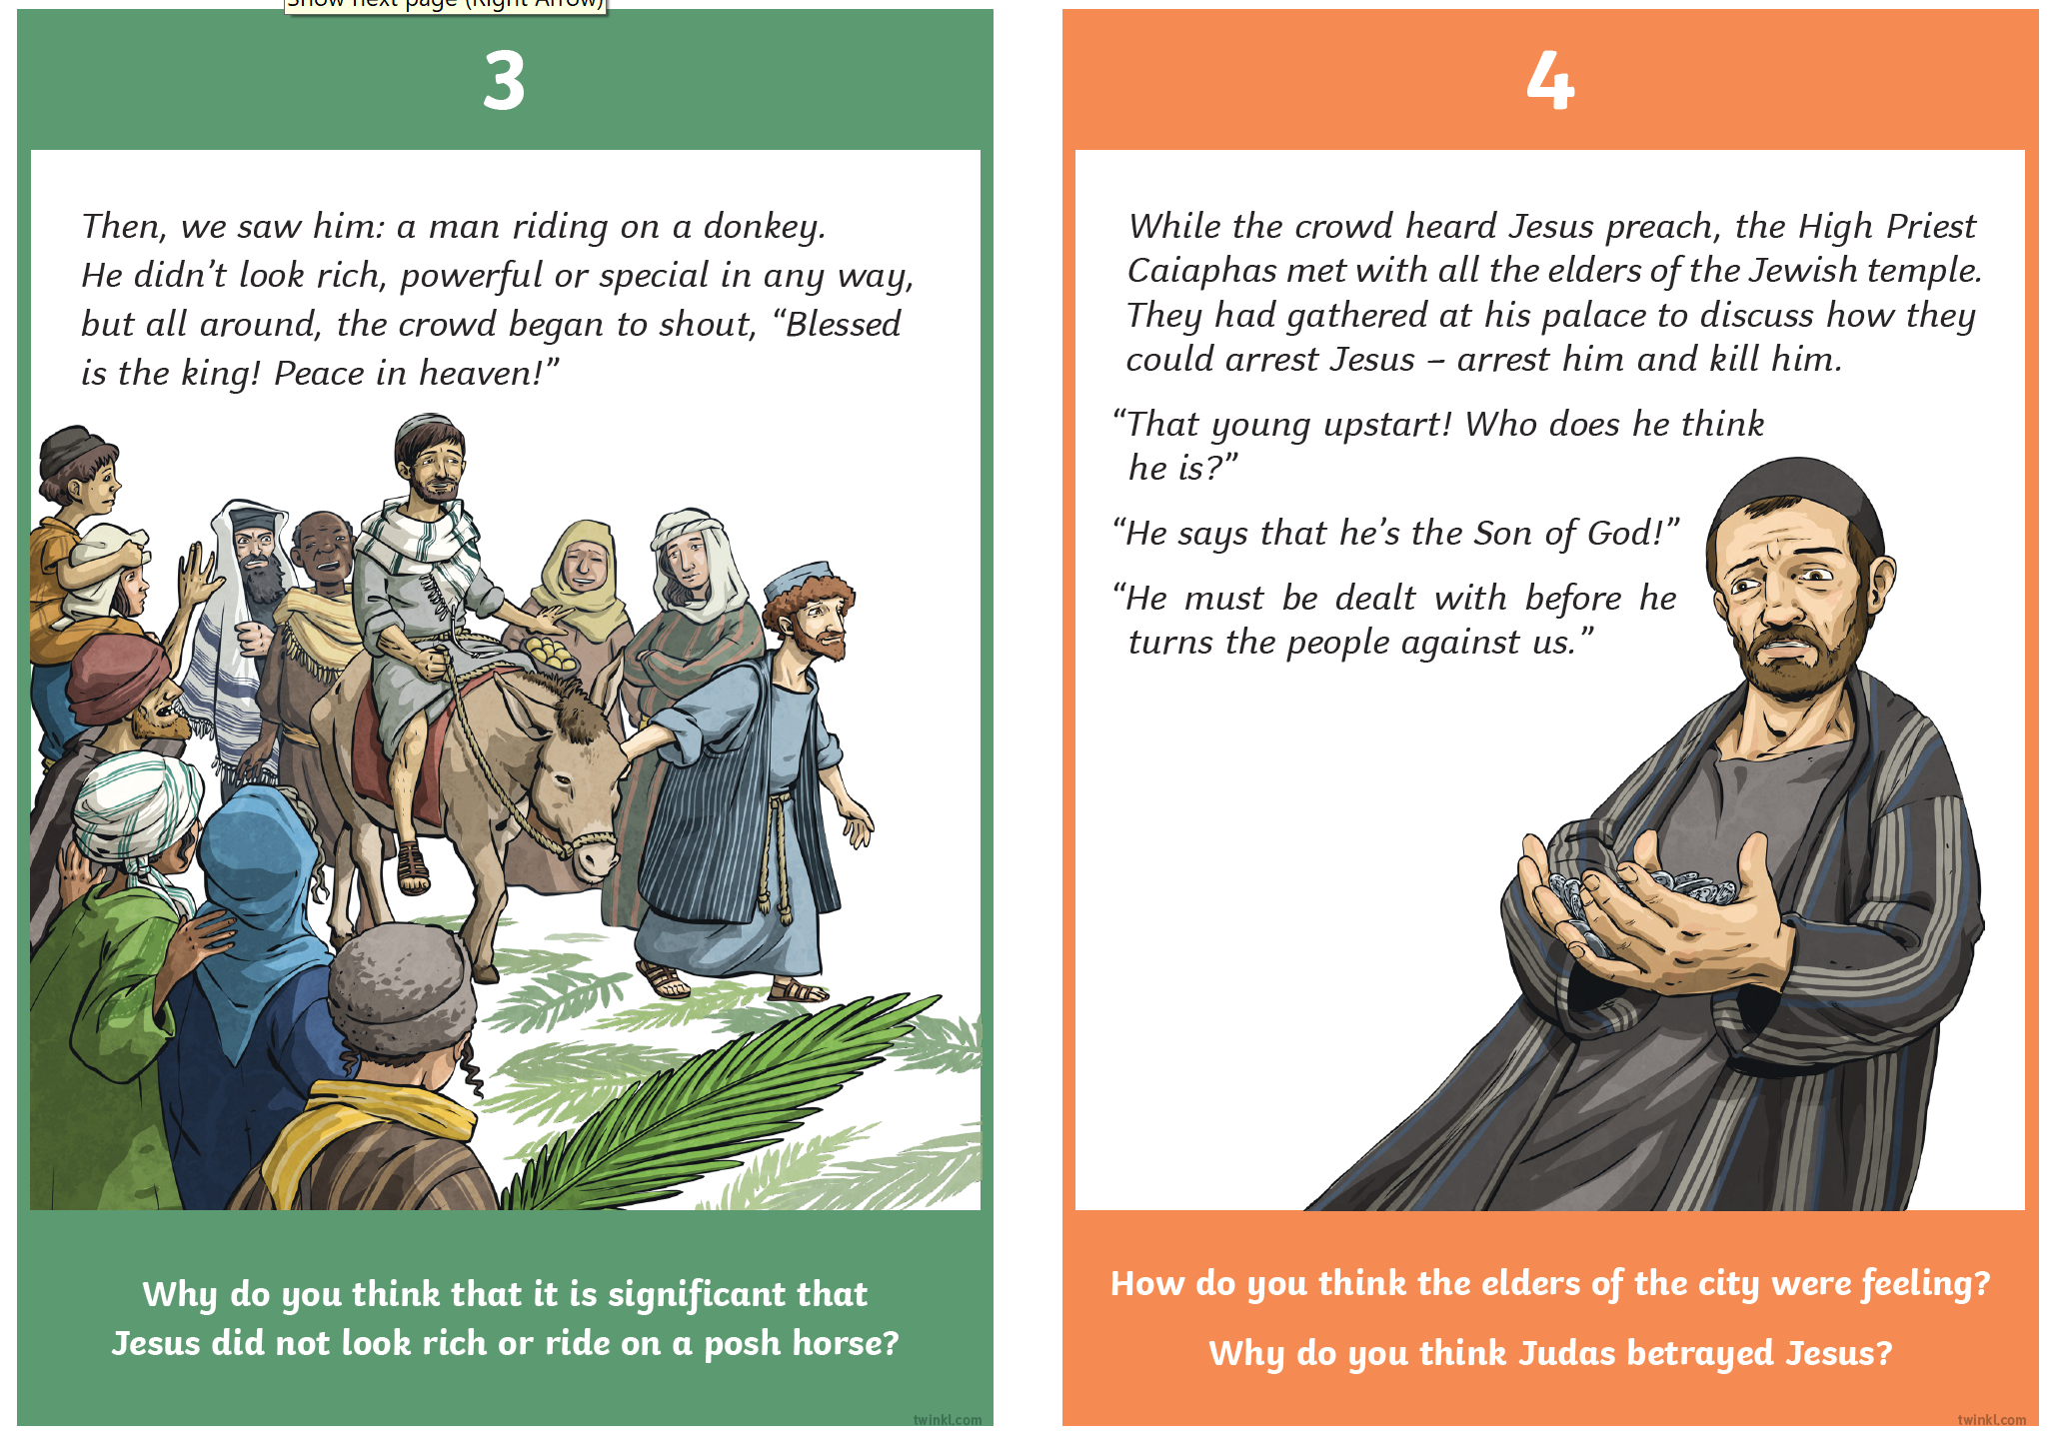
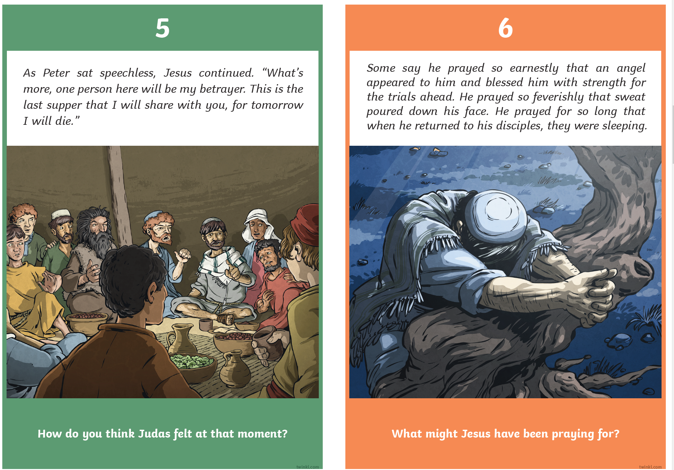
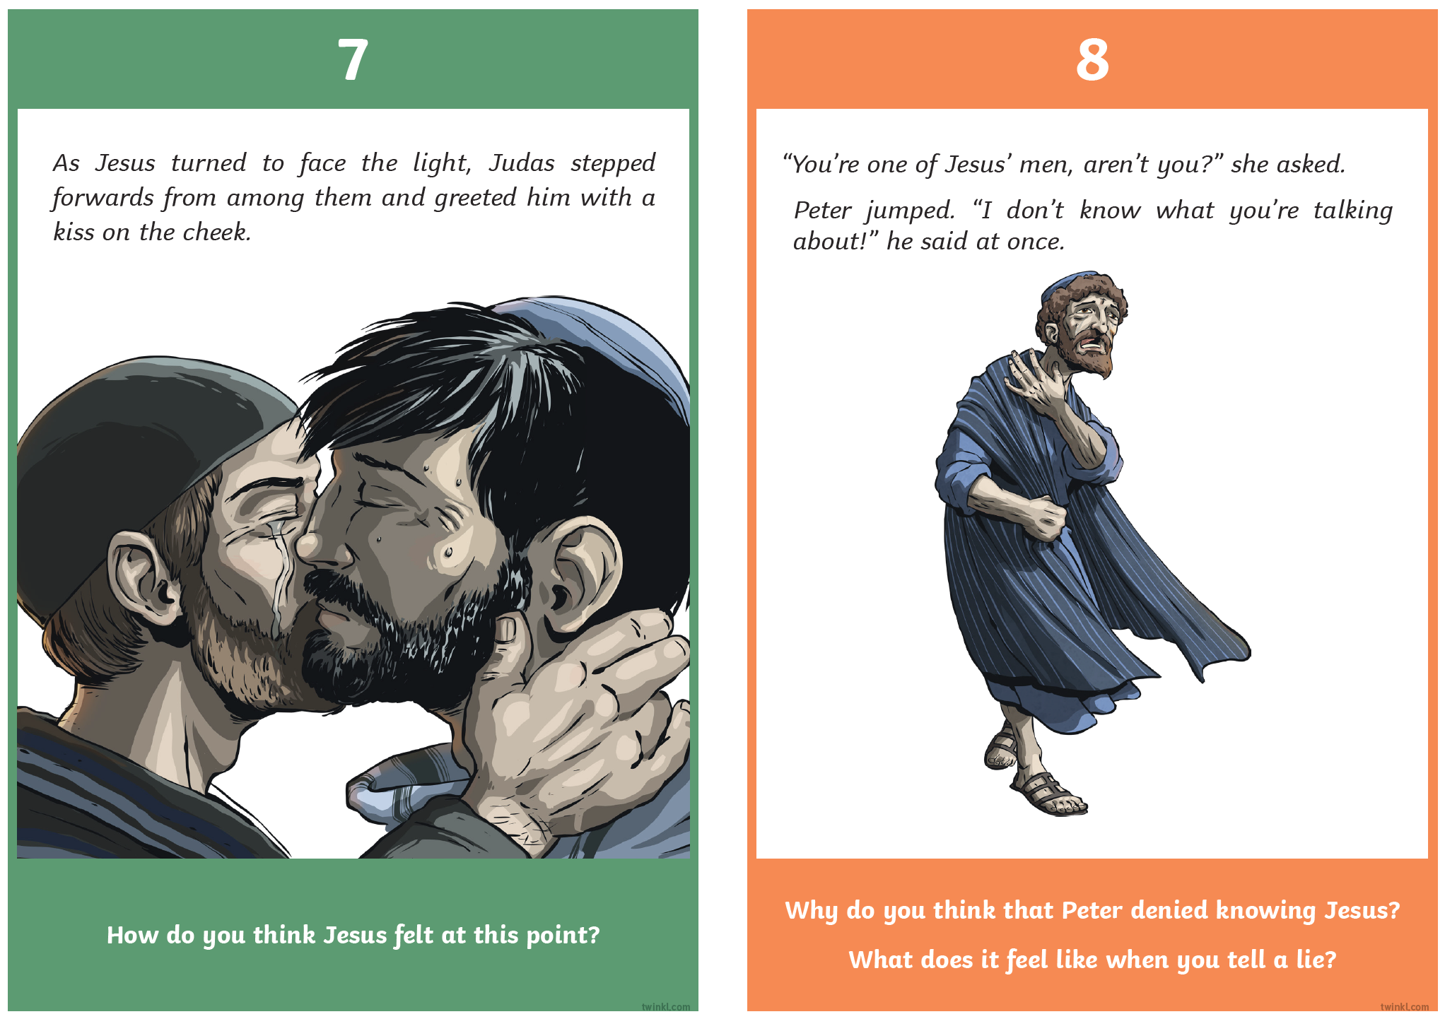
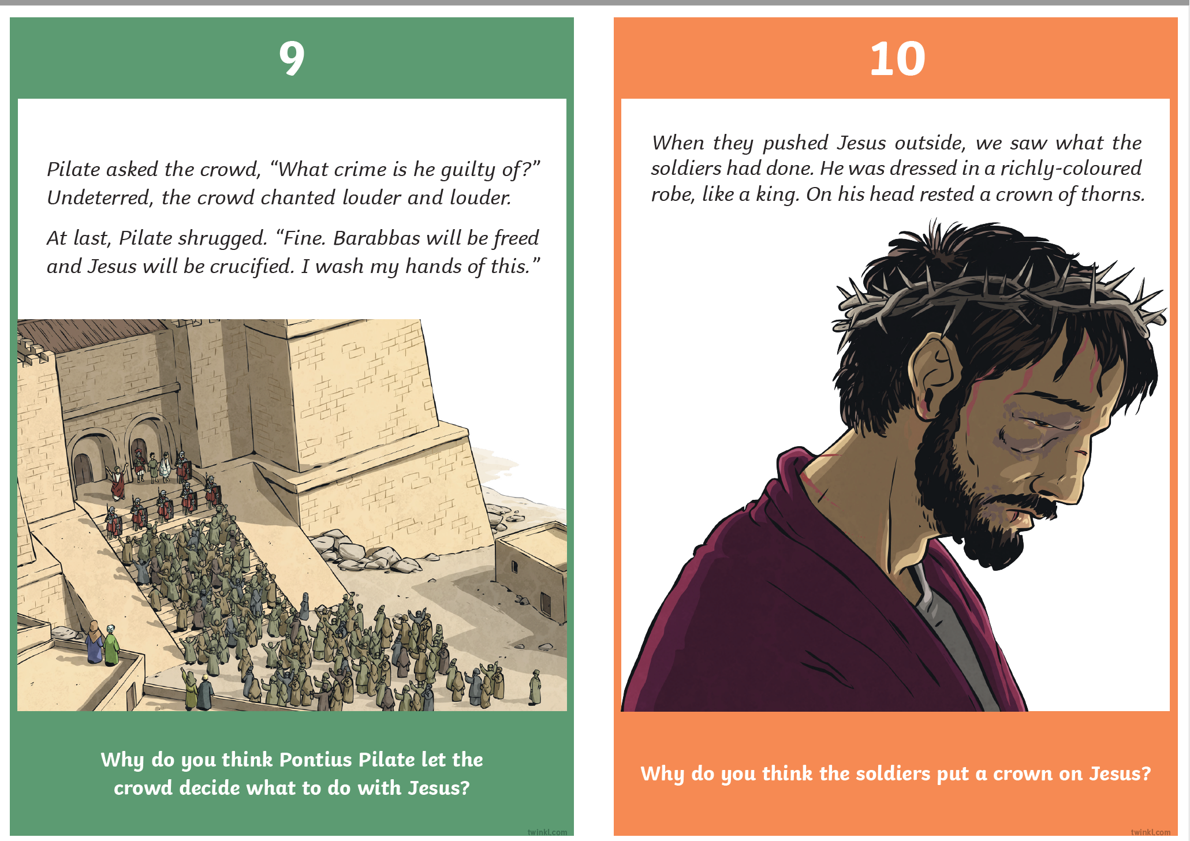
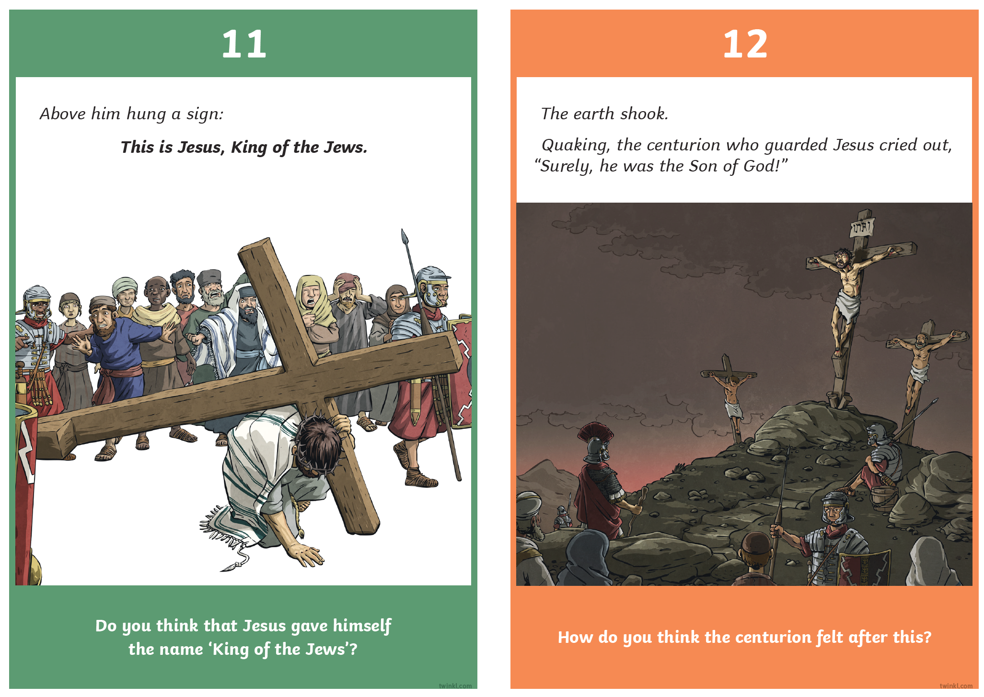
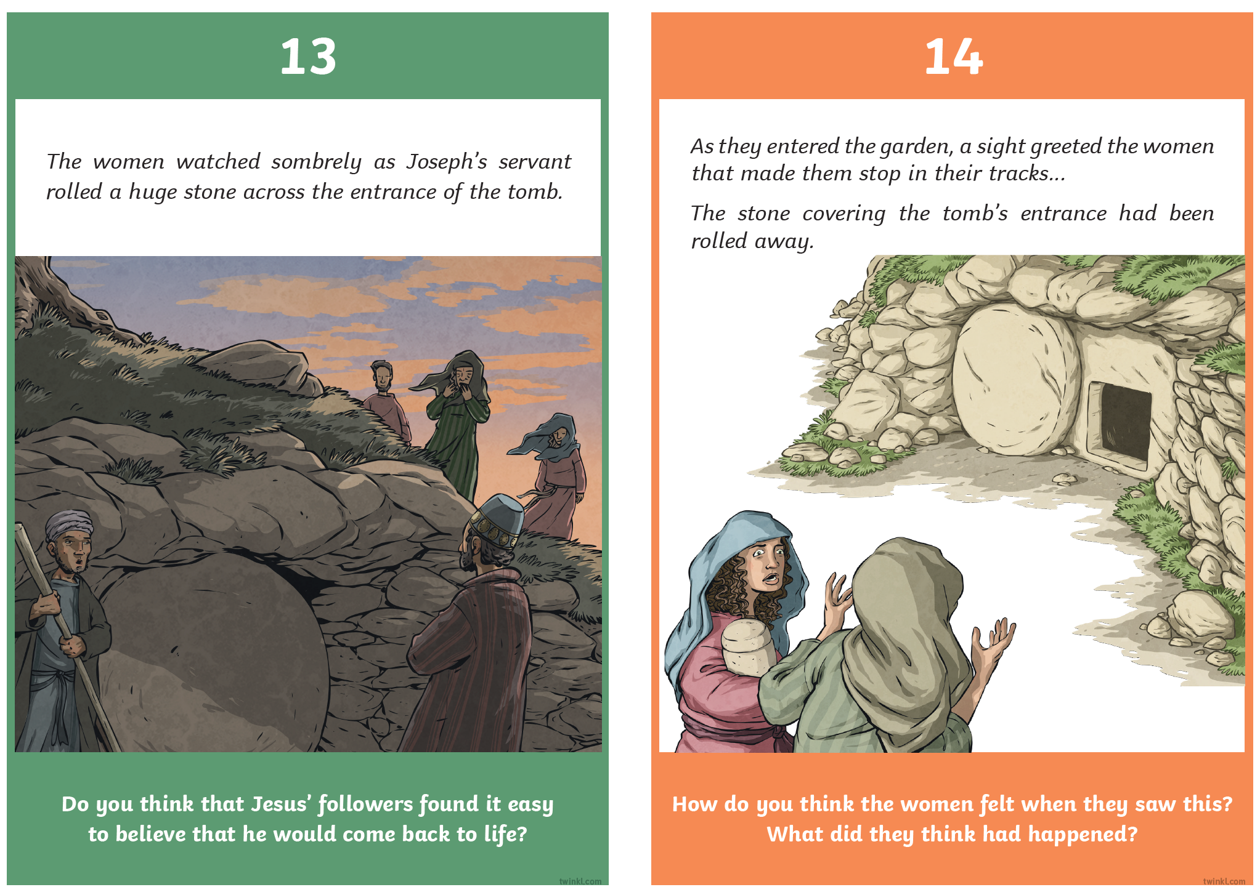

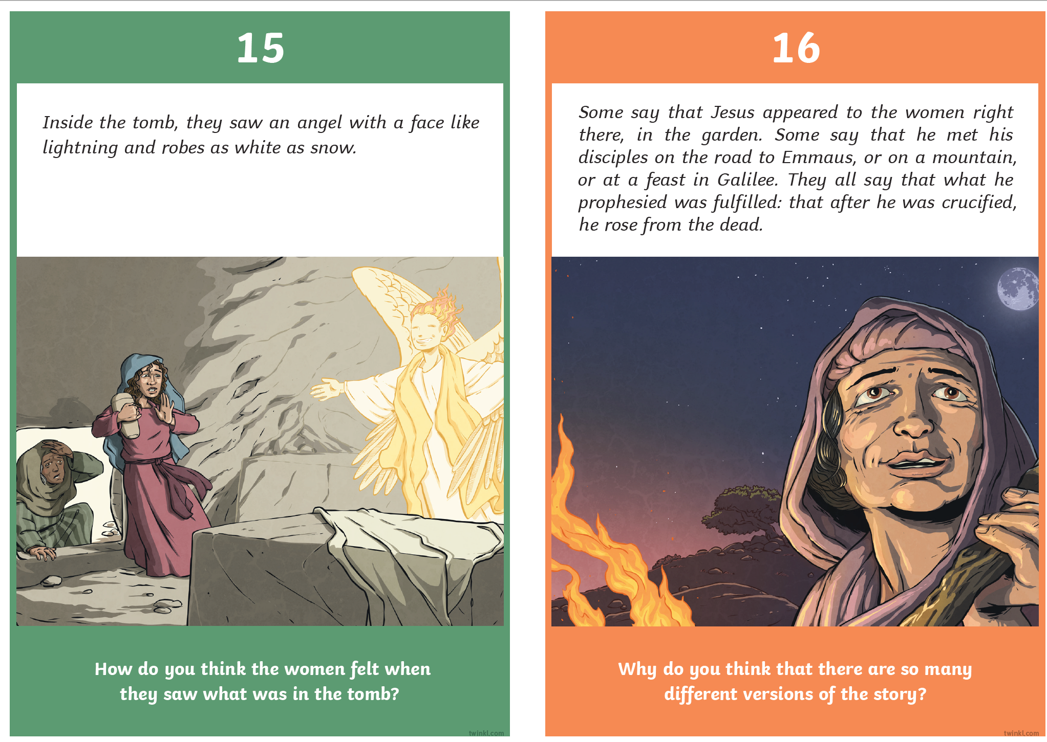

ANSWERS:

