Thursday 2nd April – Science
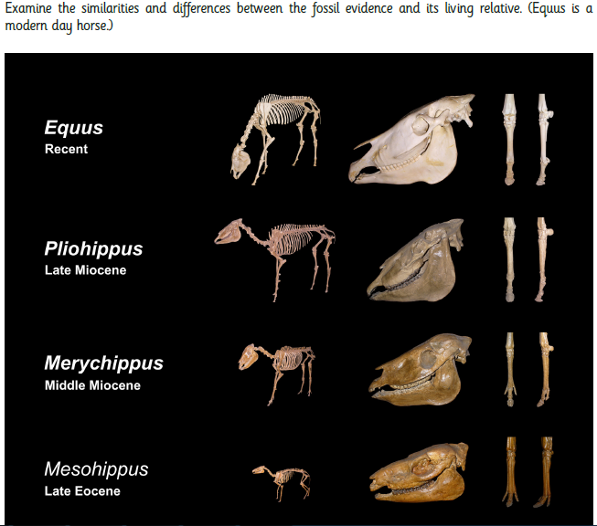
Watch the powerpoint on presentation mode (press f5) before completing this work.

*As a Church Of England School, St Mary’s would like to remind children that the ‘Theory of Evolution’ is a theory and not 100% proven. ‘Adaptation’ as a process shows how many scientists believe living creatures can develop over many thousands of years.*

