‘Journeys’ Homework Grid - Autumn 2
Australia

Please complete one activity from the grid below each week. We can’t wait to see your learning.

Geography  Think of a journey you have been on. It could be a walk around the village or a holiday. Draw a picture to represent this journey and label key parts – remember to include your senses!  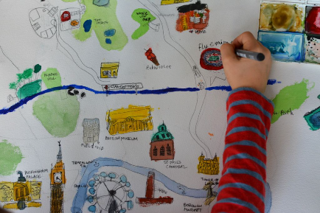 | English  If you could travel anywhere in the world, where world it be? Research your chosen place and create a fact file.  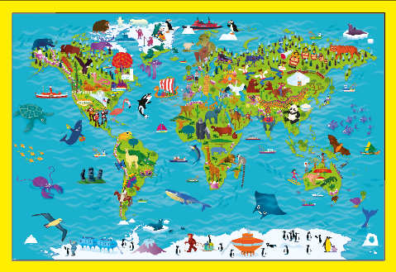 | Maths  Create a ‘First, then, now’ story at home and draw a picture to represent this. For example: First, there were 5 children on the bus, then 4 more joined. Now, there are 9 children on the bus.  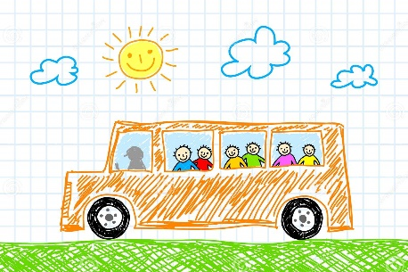
Science  Go on an autumnal walk. What can you see, hear, smell, touch and taste?  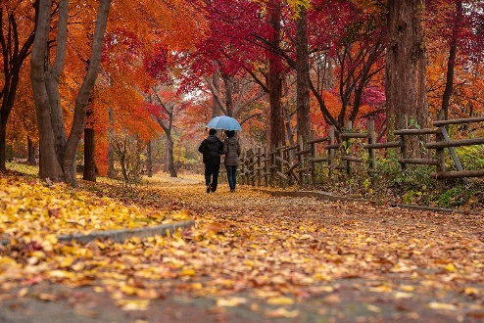 | Art  Draw a picture to represent the 4 seasons – you could do this using paint, collage, or pencils – be creative!  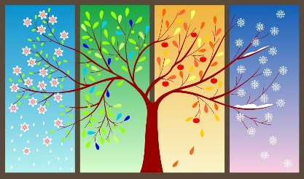 | DT/RE  Make a Christmas treat for your family – you could choose anything from mince pies and Christmas pudding to a gingerbread house or a yule log!  

