St Mary’s CE (Aided) Primary School Pulborough
Governors three-year Strategic Action Plan 2026 - 2029

What is the Governors Strategic Action Plan?

The governing body is engaged with setting and defining the school’s strategic direction, including its vision in line with its mission and strategic priorities alongside setting and modelling the school’s culture, values and ethos. Governors should be connected and responsive to pupils, staff, parents and carers, and the community through effective engagement.

This strategic plan has been produced by the Strategic Plan Task Group (Sept 2024 - Jan 2025) and revised in Sept. 2026, in close consultation with the full governing body and the headteacher, Mrs S Copus. The action plan, which sets out how the school will achieve its strategic objectives, is to be developed at committee level to include initiatives and timescales and approved by the Full Governing Body.
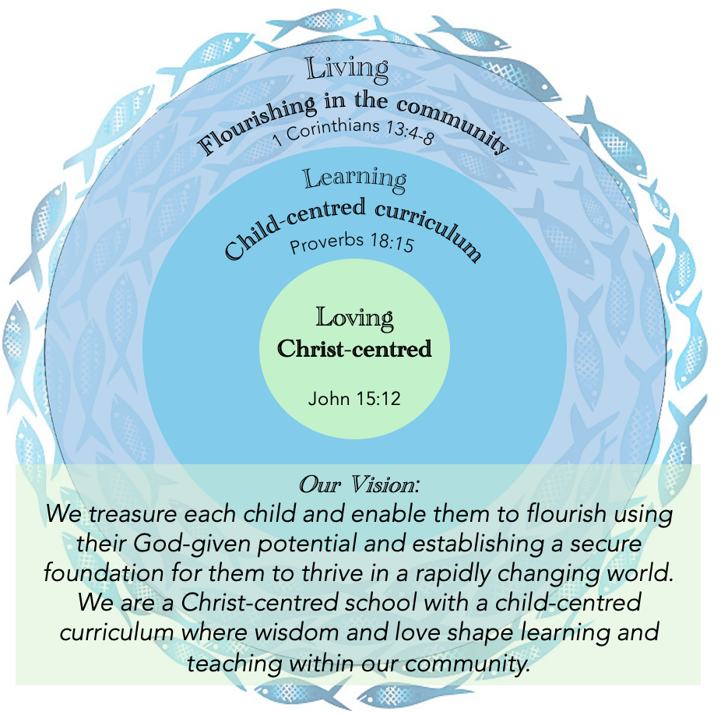
The strategic priorities and outcomes which are linked to the SIP are outlined below. Each of the priorities will be broken down into actions which can be seen reflected on the SIP. The priorities are divided into three categories and broadly come under the three headings: Loving, Living and Learning. These categories are each assigned to a committee of the governing body for oversight and form the basis of their meeting agenda programme and monitoring. The progress of each aspect is monitored by governors and progress reported on by the SLT on a regular basis.
Loving:
These strategic objectives will be owned/discussed by the Ethos & Worship Committee.
CORE FUNCTION: 1 - ENSURE CLARITY OF VISION, ETHOS & STRATEGIC DIRECTION
Living:
These strategic objectives will be owned/discussed by the Resources Committee.
CORE FUNCTION 3 - OVERSEEING FINANCIAL PERFORMANCE
Learning:
These strategic objectives will be owned/discussed by the Children & Learning Committee.
CORE FUNCTION 2 : HOLDING THE HEADTEACHER & SENIOR LEADERS TO ACCOUNT
Succession Planning:
In order to deliver its strategic aims, the governing body strives to have a robust and clear understanding of succession planning. A yearly skills matrix is used to identify gaps in skills or knowledge and governors are appointed to ensure a breadth of experience.

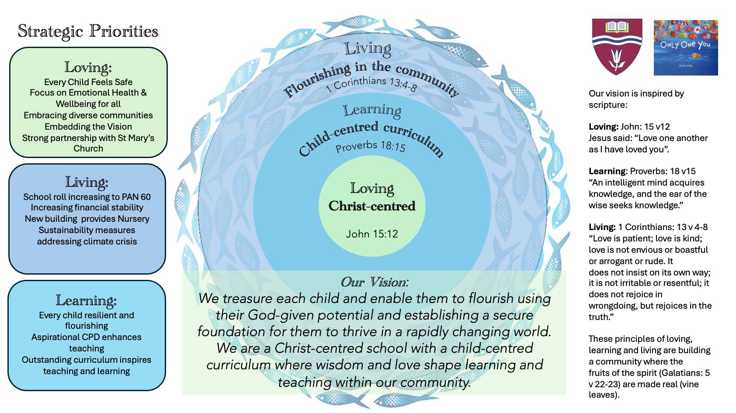
Strategic Priorities
Loving: Ethos & Worship Committee
- Every child feels safe.
- Focus on emotional health & wellbeing for all. Children and adults have the confidence to talk about their emotional health and well-being.
- Embracing diverse communities: St Marys to further develop its visibility within the wider community and for the children to have an awareness of their role as global citizens.
- Embedding the vision: All stakeholders will be prepared for a SIAMS inspection with the school’s vision embedded into all areas of school and wider community life.
- Continue to strengthen the school's links with St Mary’s Church (Growing Partnerships).
Living: Resources Committee
- School roll increased to PAN 60. St. Mary’s will become the school of choice within the local community.
- The school has financial stability which will allow all children (including SEND) to have access to the best possible resources, facilities and learning environment.
- New school building provides purpose built nursery/pre-school and community spaces.
- St Mary’s will move towards meeting the government's requirements within sustainability and climate change supporting children and young people who
- are passionate about the natural world
- want to do their best to protect it
- can influence their wider communities
Learning: Children & Learning Committee.
- Ensure that all children achieve the best they can and become resilient and independent learners. Children’s attainment is “in line” with or “better than” national data.
- Staff will have access to high quality CPD to ensure that teaching throughout the school will be good or better.
- The school has a well-planned, relevant and aspirational curriculum which gives all pupils the opportunity to achieve and develop their creativity.

Outcomes
St Marys’ Governors are committed to securing or maintaining the following outcomes for the school by continually revisiting the school’s vision, values and ethos and via monitoring progress towards the Key Priorities in the annual School Improvement Plan.
Loving
- Children will build up good mental health and procedures and practice to ensure all children are safe, feel safe and are happy, resilient and confident, displaying good behaviour at all times.
- Children/staff will have strategies to look after their own emotional health and well-being
- Children will develop their understanding of what it is to live in a world of diverse communities, showing respect and love for those who are different to themselves.
- The school will achieve a successful SIAMS inspection. All stakeholders will know the school vision and will be guided by it.
- St Mary’s is a happy, vibrant and welcoming school at the heart of its village community, where positive relationships are fostered between all adults and all children. All stakeholders (Children, staff, parents, governors, Church members) are respected and valued. (Fruits of the Spirit)
Living
- The school will move towards being a two-form entry (PAN 60). The total school budget will increase.
- Rigorous monitoring of the school budget, ensuring money is targeted and well spent, which will allow the school to flourish in all areas.
- Completion of the new building to include purpose built space for nursery and pre-school education and spaces for use by the community.
- Pupils will be well informed and therefore lead the way in sustainability and environmental issues. Energy bills and costs will be reduced significantly through the generation of green energy.
Learning
- Staff with effective CPD take on more leadership roles within the school, which in turn will support them in promotion opportunities. Monitoring will show that the quality of teaching and learning is at least good because of the high quality CPD.
- School will recruit, develop, support and retain a dedicated school team providing opportunities for early leadership and development of middle leaders and SLT.
- Children will become more resilient and this in turn will have an impact on the SEND provision.
- Annual attainment data will continue to show an upward trend through good or better teaching.
Strategic Action Plan 2024-2027
 | Objective | Actions | Milestones | Timescales | Outcome
 | Every child feels safe. | Clear annual child protection and safeguarding policy and working documents shared with all stakeholders.  West Sussex Safeguarding Audit identifies clear actions for monitoring by the Full Governing body.  West Sussex Annual Health & Safety check.  Governors to complete safeguarding section for every monitoring visit and feedback (including pupil voice) to committee meetings. | Every September on Safeguarding day. Approved at first Full Governors meeting.  Monitored annually when available by FGB  Reviewed annually at the Resources Committee and monitored by H&S governor. | Autumn 1  Half Termly  Annually  Half termly | St Mary’s is a happy, vibrant and safe school where positive relationships are fostered between all adults and all children.  Annual staff and pupil voice safeguarding surveys highlight successes and areas for improvement.  Key H&S issues shared with FGB and actioned by SBM.  Governors have insight into school safeguarding procedures.
 | Children and adults have the confidence to talk about their emotional health and well-being. | Initiatives to support children and adults mental health reviewed and monitored by FGB.  Training and supervision of designated mental health leads.  Governor annual questionnaire  to collect staff voice on workload and culture | Support from outside agency Thoughtful for low level CBT for pupils.  Thoughtful parent tea and chat sessions linked to mental health.  Survey shared at Spring FGB. | 2026-27  Termly ongoing  Half termly depending on needs identified on SIP.  Annually Spring Term. | Children will build up good mental health, feel safe and are happy, resilient and confident, displaying good behaviour at all times.  Staff will feel able to talk about workload freely and anonymously. SLT able to monitor and make changes where possible.
 | Children and adults will treat others with respect and tolerance. | Develop links with schools in more diverse communities; Locally, nationally and internationally.  Respect/behaviour - Governors to talk to teachers and pupils about behaviour in classrooms.  Inclusion Manager reports on success of implementation of behaviour plans for meeting the needs of pupils. | Link with primary school and secondary school established.  Termly review with teachers and pupils about behaviour.  Inclusion manager reports to governor | End of Summer 2027  Termly  Termly/As appropriate | Pupils knowledge and understanding of diversity is broadened and enhanced to combat racism.  Behaviour to be ‘good’ in each classroom triangulated by advisors reports.  Whole school training on boundaries, rewards and expectations of behaviour in classrooms is part of common practice.
 | Prepare for a SIAMS inspection with the school’s vision embedded into all areas of school and wider community life. | Governor committee and task group identify strengths and areas for development using SIAMs framework. | Draft paperwork prepared  Task group establish evidence to support paperwork | Summer 2025  Autumn/Spring 2026/27 | The school will achieve a successful SIAMS inspection. All stakeholders will know the school’s vision (Christian distinctiveness) and will be guided by it.
 | Continue to strengthen the school's links with St Mary’s Church | Strengthen existing links with PCC, congregation, groups etc. and seek more opportunities for working together. (Growing Partnerships - see Action Plan).  New school building provides Church office and meeting space. | New build starts: | Ongoing  by Summer 2026  Revised to 2026/27 | Links with St Mary’s Church continue to be strong.  Closer link established.
 | St. Mary’s will become the school of choice within the local community. School roll increases to match PAN 60. | Monitor the annual intake number as we move to a 2-form entry.  Raise the profile of St Mary’s in the community through positive publicity.  Engage with local community events e.g. Open House weekend, Harvest Fair, Beating the Bounds, visits to the Anchorage care home. | 11 to 12 classes.  Facebook page 100 followers. Annual increase of 100 followers. | Ongoing  Year 1 | The school will move towards being a two-form entry.  Improved reputation in the local area.
 | The school has financial stability. | Rigorously monitor the school budget and ensure money is targeted towards priorities in the SIP and curriculum monitoring plan. | Termly review of school budget and spending.  Identify carry forwards. | Termly (Resources committee) | All children have access to the best possible resources, facilities and learning environment.
 | New school building supports the community and raises pre-school achievement. | Governors receive regular undated reports on new build.  New school building provides Nursery and pre-school facility for community. | New build starts  New build completed and occupied. | By end July 2027  By end July 2027/Sept 2027 | On-site nursery opens, providing all-through primary education for Pulborough.  Additional spaces available for use by the community.
 | St Mary’s will move towards meeting the government's requirements within sustainability and climate change | Ensure the new building is designed with sustainable energy issues embedded.  Track and monitor sustainability of existing school buildings.  Installation of decarbonisation boilers for new building. | Plans completed.  Annual review of energy costs/CO2 emissions.  Decarbonisation boilers installed and in use. | By July 2025  Annually  By end August 2027 | Energy bills are reduced significantly through the generation of green energy. Pupils will be well informed and therefore lead the way in sustainability and environmental issues.
 | To ensure that all children flourish and become resilient and independent learners. | Monitor the effectiveness of the SIP in raising standards of attainment.  Governor attendance at Pupil Progress meetings.  Use assessment data effectively to identify issues and gaps. School invests in standardised testing (PIRA/PUMA). | Annual data review meeting  Termly data updates  Predictions for SATs  Half termly ASP (Assessment, Standards & Progress) Meetings  Termly reports  . | October annually  Termly  October annually  Termly  Report to C&L half termly | Children’s attainment is “in line” with or “better than” national data. Annual results will continue to show an upward trend through good or better teaching. SIP provides clear direction.
 | Staff will have access to high quality CPD to ensure that teaching throughout the school is good or better. | Monitor the quality of teaching using a range of approaches including Head Teachers formal and informal reports to governors.  Continue to develop SLT to include distinct Deputy Head and Inclusion Manager roles - Wider dispersed leadership team. | Termly reports  Appointment of Inclusion Manager  SLT restructure | Termly  Autumn 2026  Autumn 2026 | Staff with effective CPD take on more leadership roles within the school, which in turn will support them in promotion opportunities.  Monitoring will show that the quality of teaching and learning is at least good because of the effective CPD.
 | The curriculum is broad, balanced and relevant to the needs of learners (including PPG and SEND) and inspires outstanding teaching and learning. | Monitor curriculum using a range of approaches including: learning walks, governor visits, pupil voice, book look, scrutiny of national curriculum coverage.  All governors oversee a curriculum subject and are familiar with curriculum action plan and subject handbook.  Governors to meet with subject leads. | Medium term plans reviewed. Governor visits schedule implemented.  Termly Inclusion Manager report  Termly Disadvantaged pupils report.  Subject Lead reports  Report to the Children & Learning committee. | Autumn 2026  Termly  Termly  Annually rolling programme.  At least twice annually | The school has a well-planned curriculum which gives all pupils the opportunity to achieve and develop their creativity.  Governors have a good understanding of current issues for their linked curriculum area and regularly interact with subject leads.

