Parent Voice
Collected Parents Evening Spring 2026

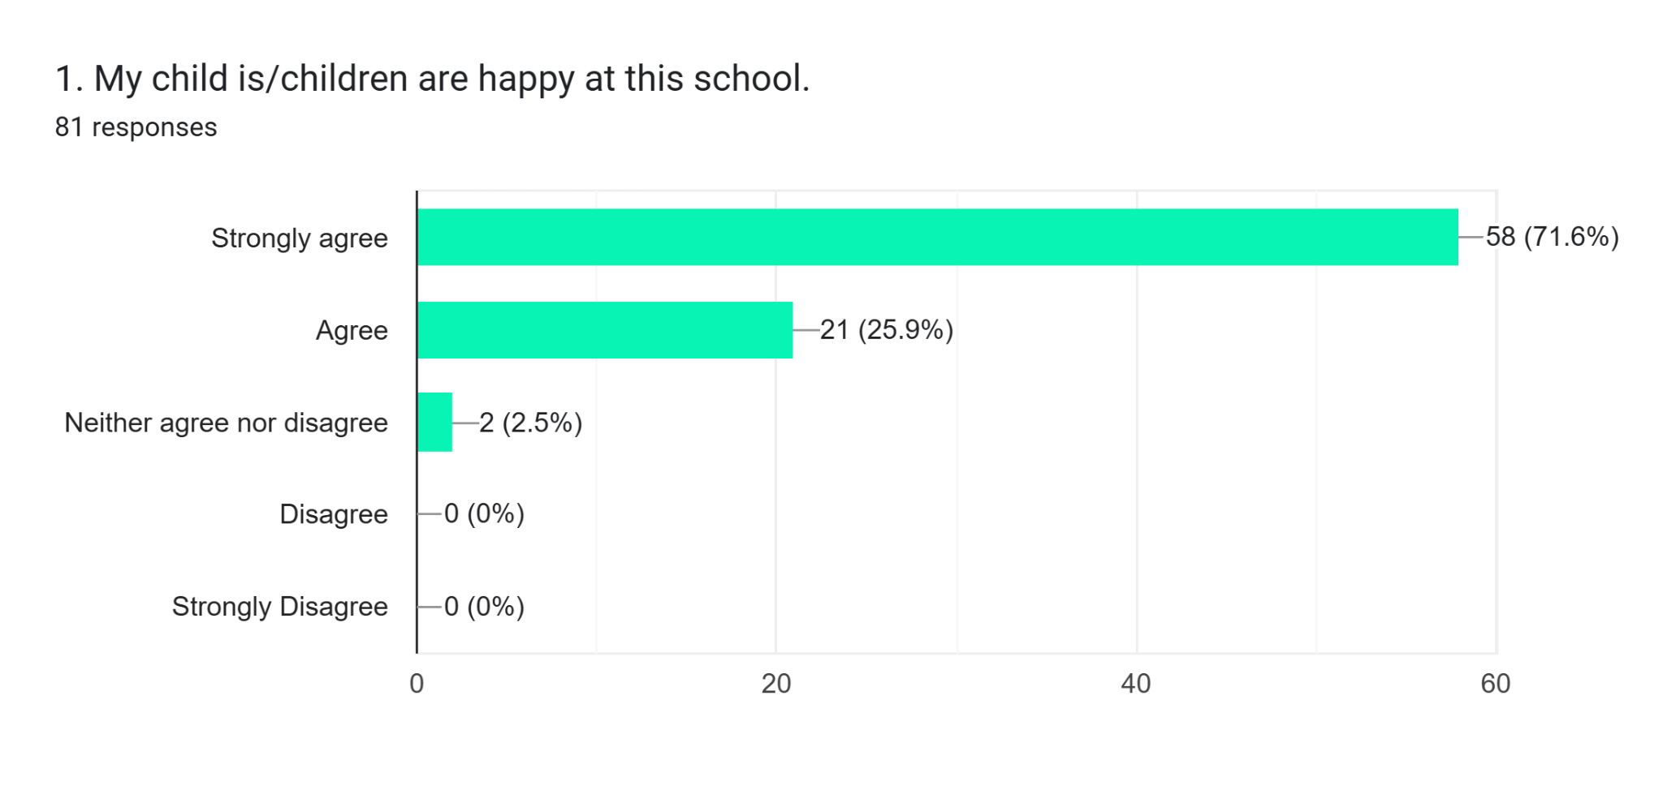

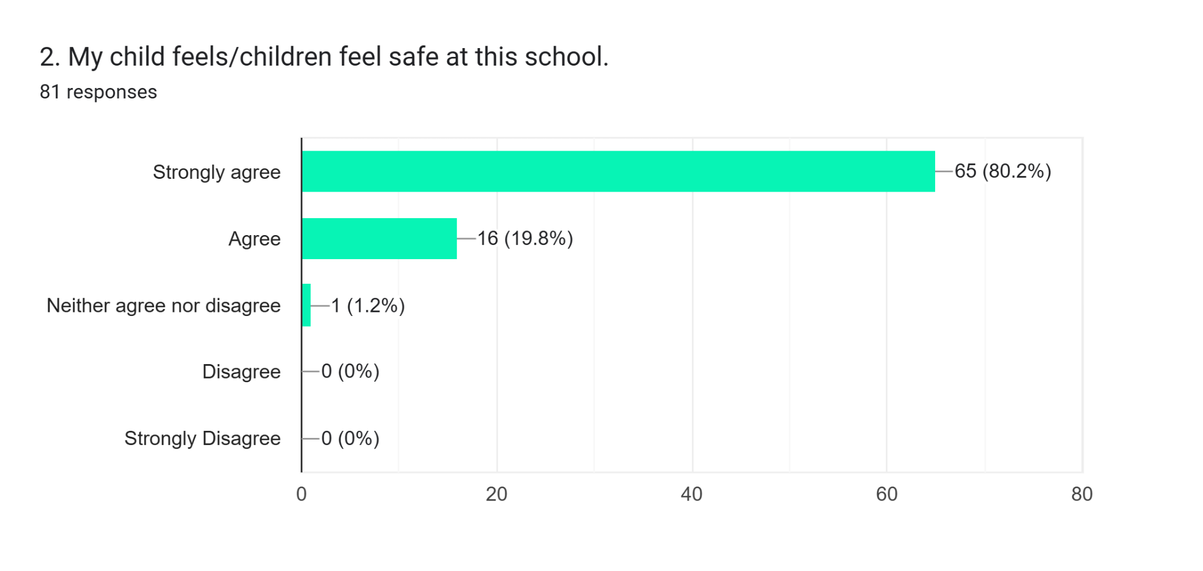

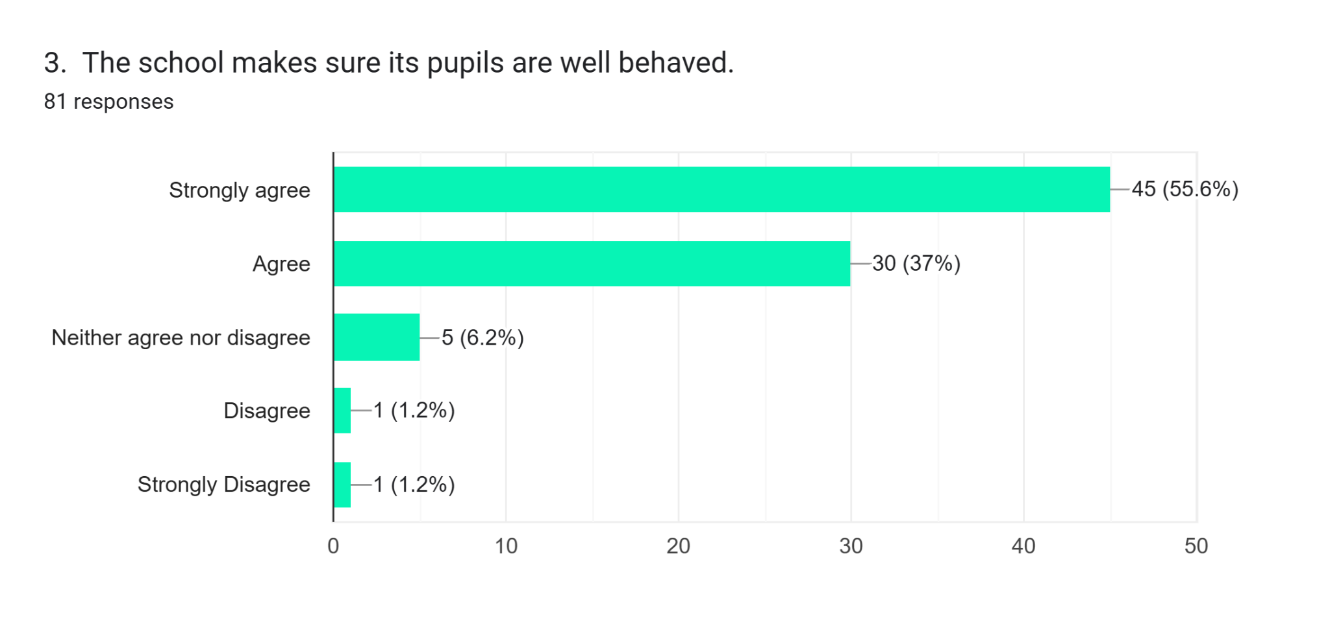
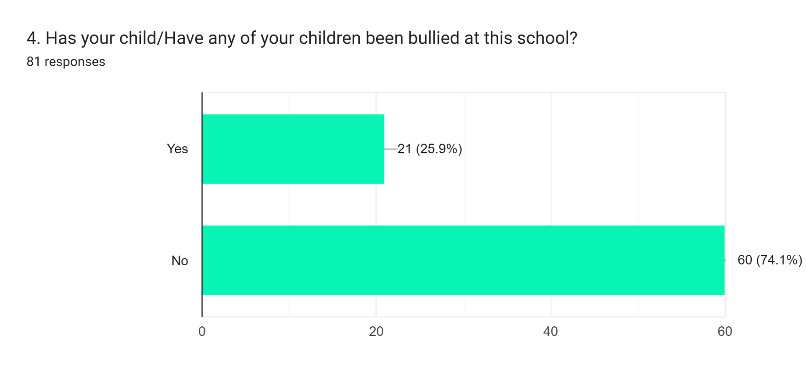

4. a) If you answer ‘Yes’ we ask your view on ‘When the bullying took place, the school dealt with it quickly and effectively’.

Yes
Dealt with
Yes they have been great
It happened in Thailand class but all resolved and she’s so happy
They handled it extremely well and it was related to a child with additional needs
Slow progress
Yes
Yes I was impressed with how the situation was dealt with
It was dealt with.
It wasn’t really bullying but one child in her classroom with behaviour problems hit her a couple of times. He was separated of her class which I very much appreciated so the situation did not repeat
Not as quickly as we’d hoped. Some issues still persist 6+months on.
Yes
It has been an ongoing issue that is continuously being dealt with. It improves and reoccurs. The school deals with it as they can
No
We have had a few incidents if name calling and racist comments all dealt with quickly
They tried but occasions still happen with one child in particular, the teacher is aware and doing what they can. My child isn’t being picked on signally it seems to be a lot of children affected by the same child
Its been happening over the last year +. Same child over this time. First instance it was physical and then emotional torment. No let up. Sometimes my child is upset and very stressed at the end of the day. I feel that the school could have stepped in earlier and apply a stronger approach to discipline in a way to curb others bullying
Italy class, has been dealt with effectively
School took care of it quickly although I did have to email in to find out if the parents where going to be contacted to sort this
Not so much bullying, but a few issues have been raised. Dealt with very swiftly and all is fine.
2 years ago, they said they had measures in place for the boy bullying him, its a lot better this year

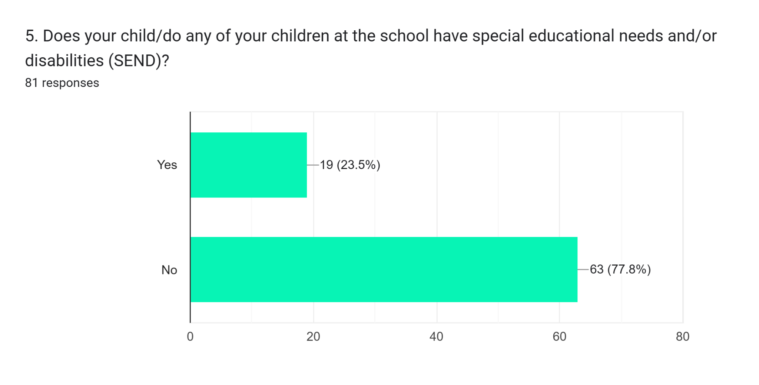

5. a) If you answered ‘Yes’ we ask your view on ‘The school gives them the support they need to succeed’.

Yes
I know they give it but I’m not sure exactly what they do other than more 1 to 1 support
In the process of getting outside help
Brilliant support
Definitely, the school has been very supportive
Lots of support on my younger child but my eldest doesn’t feel heard 100%
Now he has an isp, yes
They have been very supportive and been bought in a lot of adaptations
Yes the SEND support is exceptional
Amazing support
So far very supportive
No
Yes
Dyslexia
Yes
Alfie suffers with anxiety and a need for routine which miss Taylor is fab with
Dyslexia, learning plan
I agree, they support my child very well.
They help with her dyslexia

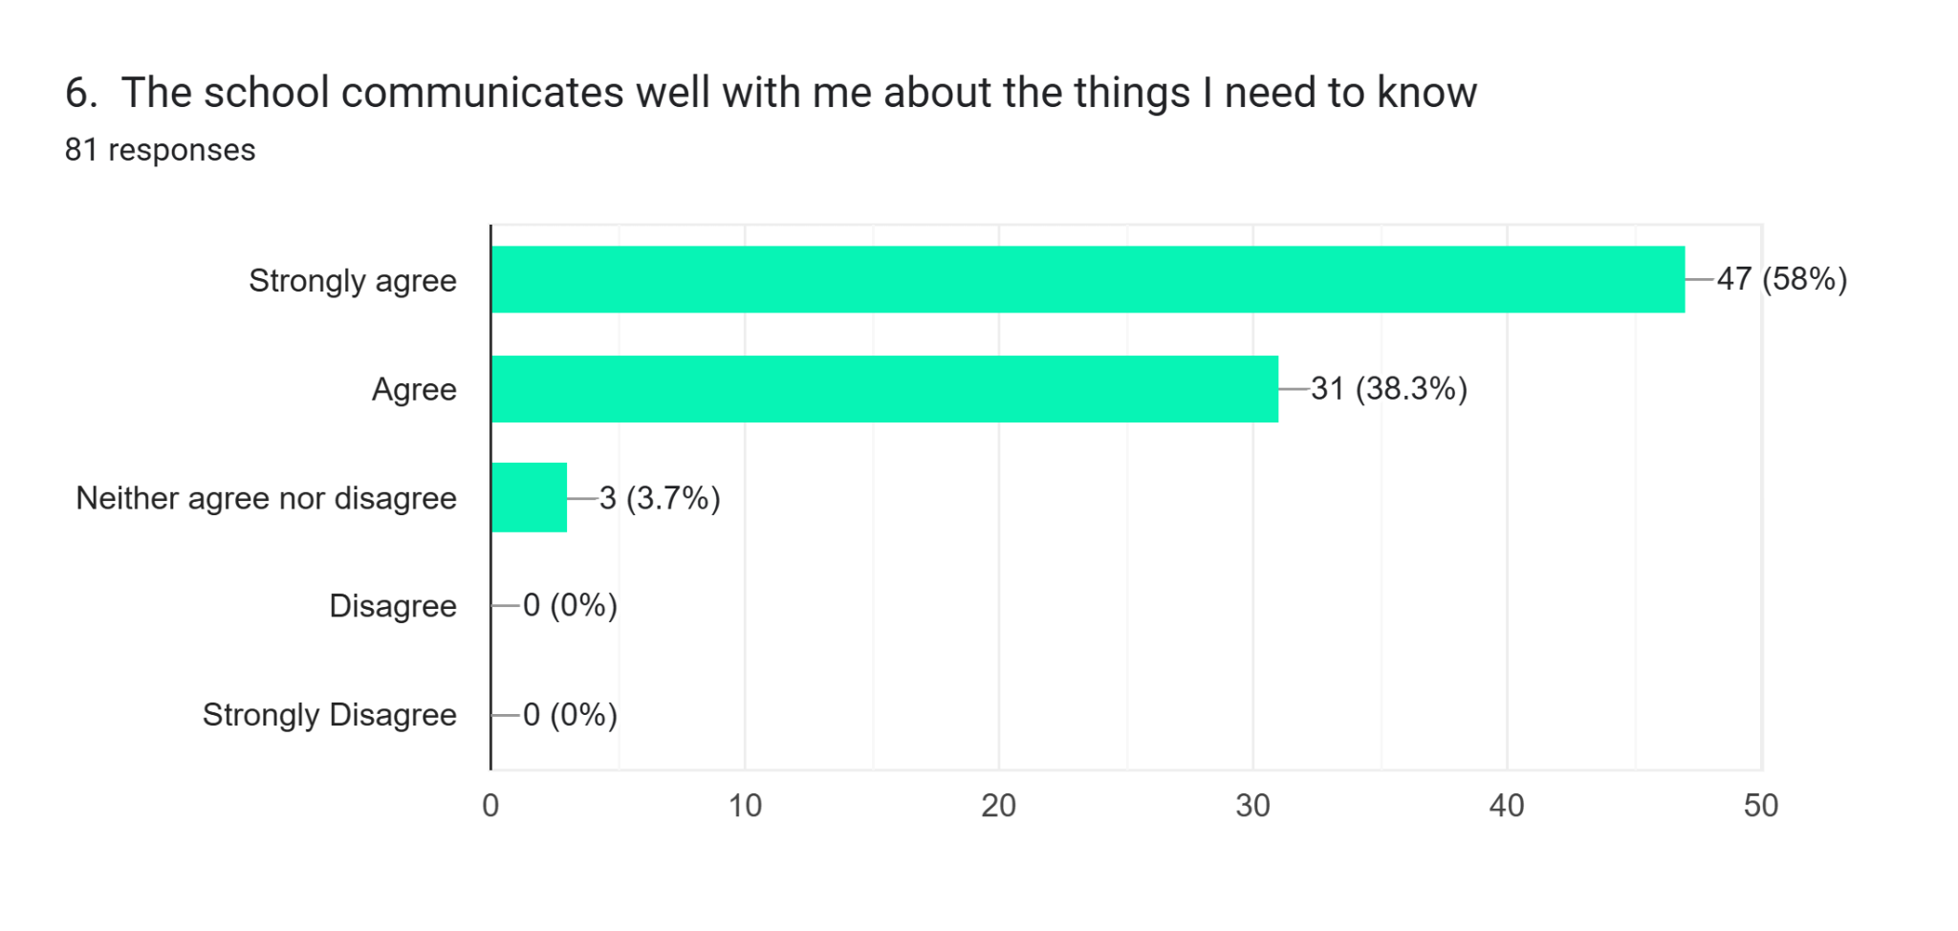
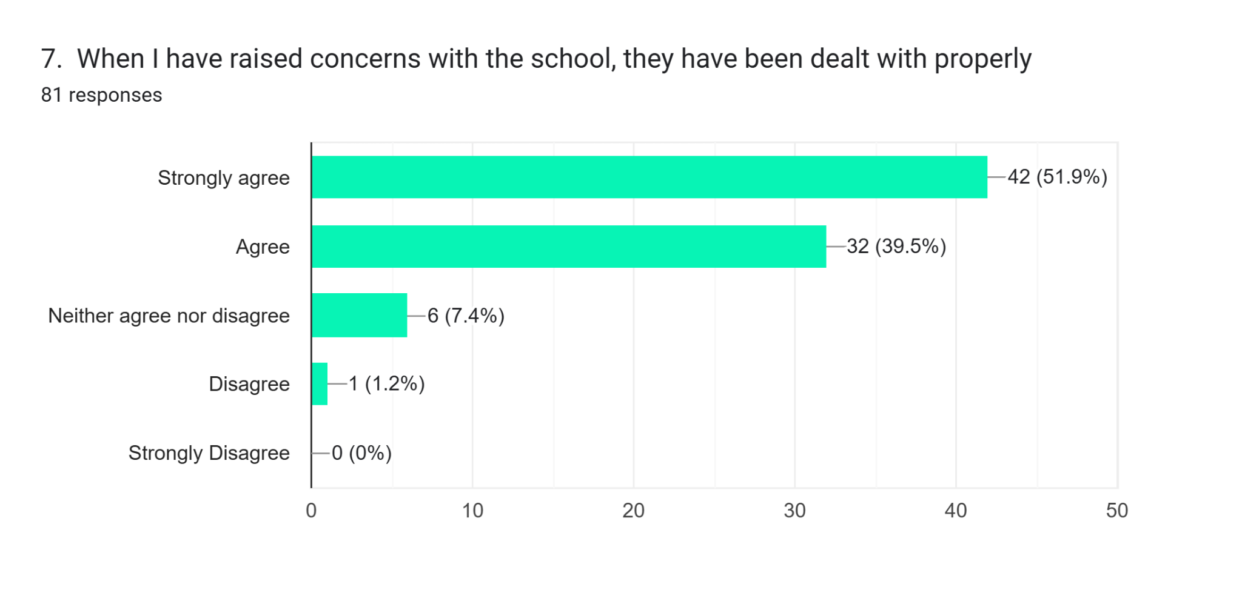

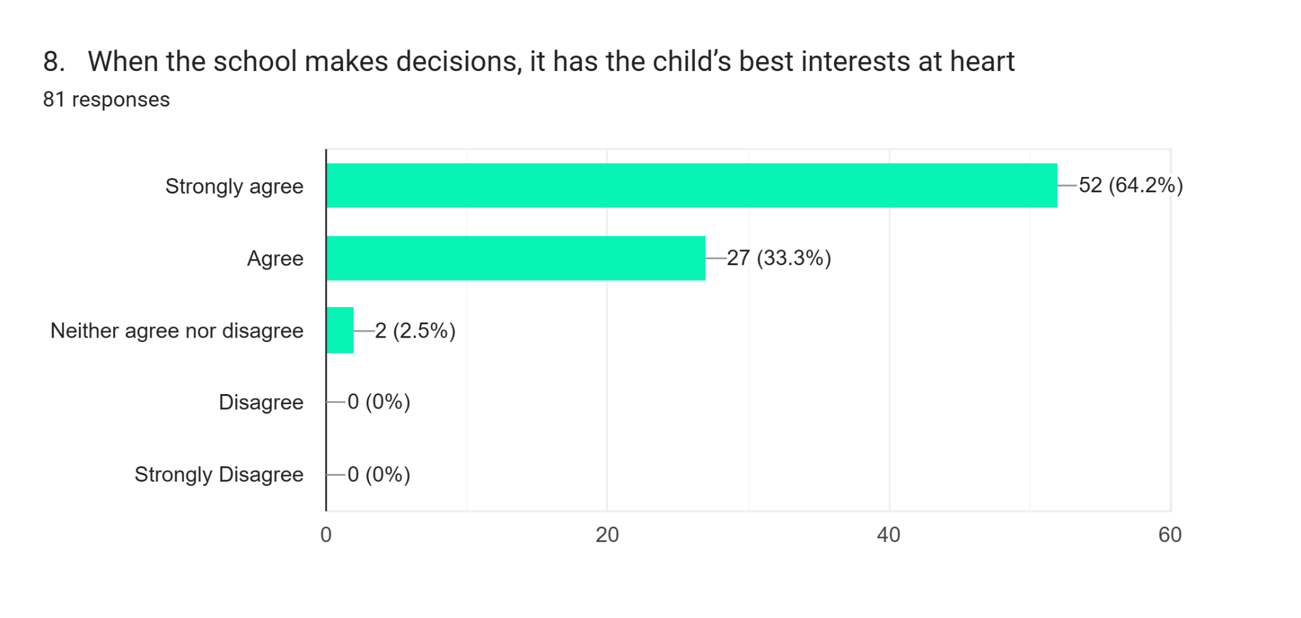

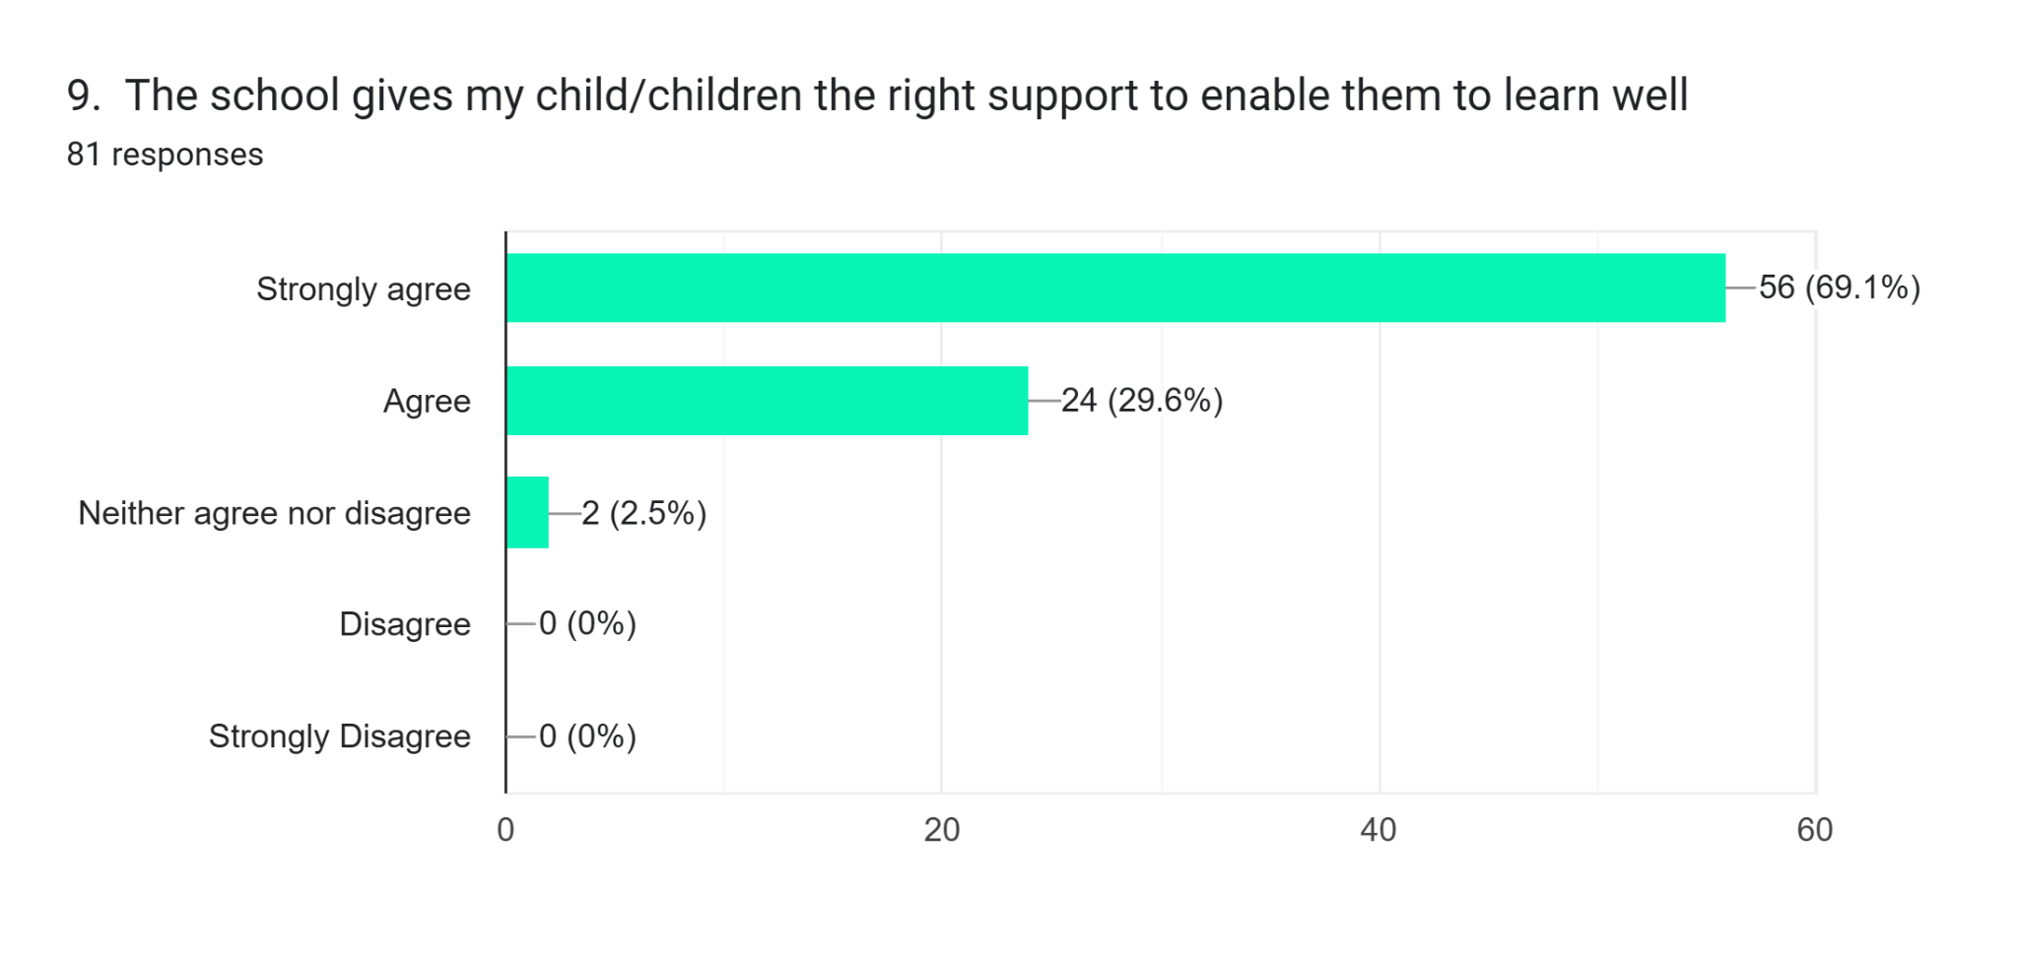
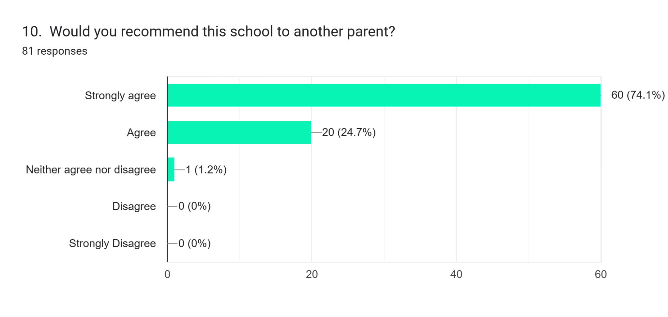

Any additional comments or feedback?

Both myself and brother went to the school when younger, love st Mary’s
The Breakfast Club 8am start is too late this has a massive effect on my family
Great headteacher
Everyone has been incredible. Thank you so much
You rock. Thanks for all you do
My children have been happy at the school, only feedback would be where additional support in subjects where they have been behind, there was limited and often no extra support available due to funding. Extra tutor outside of school enabled both children to reach expected levels in subjects they were behind in.better process for the arrangement of getting children to sporting events where parents are unable to take/pick up. Tell Mrs Copus to make the year 6 production a good one this year!!
Very good
Keep all communicatin to one platform
Thank you to all the staff for all their hard work that they do
Love this school’ the teachers and resources are fantastic

There are too many emails coming through which I can not keep up wi5h. The WhatsApp group doesn’t provide information for the week ahead so I don’t know when assembly’s are happening. Due to the volume of emails I miss things.
Our daughter is excited to come to school and loves her teacher and TA.

