
Climate Action Plan
St Marys Primary Pulborough

1 year plan Spring 2025 – 2026
Carbon baseline: 230 tCO2e Calculation: March 2025

melanie.parr@letsgozero.org

GET STARTED
ACTION | TIMEFRAME | STAKEHOLDERS | NOTES | TRACKER
Sign up to the Let’s Go Zero campaign  By joining this campaign, your school confirms that it is taking action now to reduce its own carbon impact, and that it demands the UK Government help all schools reach this goal by the end of the decade. | Start: July 2025  Review: Annually | LM/SC/Eco council/Diocese | Eco council to be set up in September with a representative from each class.  Eco council to calculate our Carbon footprint  Miss Callender to lead the Eco Council
Calculate your school’s carbon footprint using Count Your Carbon  This free digital tool allows you to calculate the carbon footprint for your educational setting. | Start:  Review: |  |  | Complete
Sign up to the Sustainability Support for Education  A DfE-funded project that enables education settings to start or progress on their sustainability journey. This includes all types of settings from Early Years to Higher Education, offering suggested actions paired with quality-assured resources. You can filter these to show suggestions relevant to your setting based on your teaching age, priorities, how far you’ve progressed already, estate, and more. | Start:  Review:
1. Decarbonisation and Energy Efficiency
Calculating and taking actions to reduce carbon emissions and becoming more energy efficient
ENERGY – BEHAVIOUR CHANGE
ACTION | TIMEFRAME | STAKEHOLDERS | NOTES | TRACKER
Implementation of Decarbonisation boilers on the school site. | Start:  Review: | Premises manager  SBM  HT | The Diocese are looking at supporting the need for new boilers for the pool, school and new buildings that may be developed on the school site.
Take part in the Switch Off campaign and have class reps to switch off lights and close doors etc | September 2025 | Eco council  PM  SBM | Monitor energy usage  Feedback at Eco council meetings  Set energy appropriately for weekends, evenings and holidays.  School to be insulated properly with ceiling and floor insulation.  Ensure all computers are turned off for weekends and holidays and this is fed to the staff
Install more solar panels | September 2025 | Eco council  SBM  PM | Site survey to be carried out for more solar panels  Look at plan for more solar panels to be added  Eco council to be involved with this and any meetings  Visit to a solar farm

ENERGY – BUILDINGS & INFRASTRUCTURE
ACTION | TIMEFRAME | STAKEHOLDERS | NOTES | TRACKER
Solar panels | Start: Sept 25  Review: Sept 26 | Premises manager  SBM  HT  Eco council | Site visit to be carried out and then discussed about the possibility of more solar panels.
Insulation to be put in as part of Decarbonisation/pumps being put in | Start: July 25  Review: Dec 25 | Premises manager  SBM  HT  Eco council | Insulation to be put into the school building to improve efficiency.  Old insulation to be removed  Wall insulation and roof insulation to ensure a better standard
Install LED lighting when replacing part of the lighting circuits |  | Premises manager | LED lighting to be considered before anything is replaced  Review lighting and the possibility of LED lighting – share findings with Eco Council

PROCUREMENT
ACTION | TIMEFRAME | STAKEHOLDERS | NOTES | TRACKER
Look at the services/agencies that we use and consider their environmental practises. | Start: Sept 25  Review: Sept 26 | SBM | Review all services and add a conversation in about the practises that they carry out.  Feedback to Eco council
Look at having more second hand uniform sales to help with uniform costs.  Use of clothing bin to recycle clothes that are not fit for purpose | Start:  Review: | PTA  HT/DHT | Half termly sales planned in to support all families and recycle uniform  Use the recycling bank to ensure that clothes that are not good enough are recycled.
Look at energy efficiency when purchasing any appliances |  | SBM | When an appliance needs replacing – economy and environment outcomes to be discussed and looked at in more detail.

FOOD
ACTION | TIMEFRAME | STAKEHOLDERS | NOTES | TRACKER
Work with Chartwells to ensure that they have a vegan/vegetarian option everyday | Start: Sept 25  Review: Sept 26 | SBM  HT | Termly meeting with Chartwells to have this as an agenda item  Review menus with Chartwells
Improve composting around the school and monitor food waste | Start: Sept 25  Review: Sept 26 | Premises manager  SBM  Eco council | Look at existing composting  Eco council to do this and liaise with SBM  Look at bins to collect food waste and use composting facilities – use of prefects to do this

TRANSPORT
ACTION | TIMEFRAME | STAKEHOLDERS | NOTES | TRACKER
Run active travel campaigns eg Walk to school week and encourage use of bicycles and scooters to come to school | Start: Sept 25  Review: Sept 26 | SBM  Eco council  HT/DHT  Teacher | Timetable this in in school diary  Look at Travel Plan initiatives  Look at improving area for bikes and scooters with posters advertising – Eco Council
Provide cycling proficiency lessons in school Eg Year 6 | Start: Oct 25  Review: Oct 26 | Y6 teachers  HT/DHT | October date for Bikeability to happen in Year 6.  Review this initiative on school newsletter and promote other initiatives

WASTE
ACTION | TIMEFRAME | STAKEHOLDERS | NOTES | TRACKER
Label bins clearly – ensure bins are labelled and placed well around the school | Start: Sept 25  Review: Sept 26 | Premises manager  SBM  Eco council | Look at ordering recycled bins to be used  Signpost children to them  Ensure good labelling
Ensure we have enough plates and cutlery to wash and reuse | Start: Sept 25  Review: Sept 26 | SBM/HT  Eco council | Check with Chartwells and staff that we have enough
Recycling assembly to take place annually to remind the children about what can be recycled | Start: Sept 25  Review: Sept 26 | Eco Council | Termly assembly organized by Eco Council  Invite visitors in to talk about this

2. Climate adaptation and resilience
Taking actions to reduce the risk of flooding and overheating and to future-proof scarce resources for potential shortages
ADAPTATION AND RESILIENCE
ACTION | TIMEFRAME | STAKEHOLDERS | NOTES | TRACKER
St Marys to subscribe to receive UK health alerts | Start: Sept 25  Review: Sept 26 | SBM/HT to set this up | This to be set up and referred to if needed  Plan in place for sprots, classes, lessons and regular drink breaks
Shades to be placed on the school field to help with heatwaves | Start: Sept 25  Review: Sept 26 | PTA  SBM | At PTA Trustee meeting talk about the need for shade.  Tesco grant to be applied for  SBM to look at planning application – if necessary

WATER
ACTION | TIMEFRAME | STAKEHOLDERS | NOTES | TRACKER
Install and use water butts for the plant watering | Start: Sept 25  Review: Sept 26 | Gardening Club  Eco Council  SBM/Premises Manager | Audit water butts  Ensure they are safe and secure  Look at water collection and Eco council to monitor this
Install half flush measures and check on water consumption to reduce wastage – taps that turn off | Start: Sept 25  Review: Sept 26  : | Premises manager  SBM | Check taps and water usage  Replace taps when needed with water reducing taps  Check flush system for water reduction methods

3. Biodiversity and Green Infrastructure
Creating habitats and adopting practices that will enhance species diversity on the school estate and beyond
NATURE
ACTION | TIMEFRAME | STAKEHOLDERS | NOTES | TRACKER
Embed the gardening club further with support from Brinsbury College | Start: Sept 25  Review: Sept 26 | Gardening Club  Eco Council | Ensure staffing of gardening club  Look at links with Brinsbury college to help with beds and watering systems etc
Use of forest schools to raise the children’s awareness of biodiversity | Start: Sept 25  Review: Sept 26 | Forest Schools  DHT/HT | Forest schools timetabled half termly  Use of biodiversity and curriculum to reflect this

4. Climate Education, Green Skills and Green Careers
Ensuring the education you provide gives knowledge-rich and comprehensive teaching about climate change, and that your teaching staff feel supported to offer this

CULTURE
ACTION | TIMEFRAME | STAKEHOLDERS | NOTES | TRACKER
Include a statement about sustainability in Governors 3 – 5 year strategic plan | Start: Sept 25  Review: Sept 26 | Governors  HT/SBM | Raise at Governor meeting – Resources and Curriculum  Implement on the strategic plan  Discuss the climate plan at Governors meeting
Add sustainability projects to the website to raise stakeholders awareness | Start: Sept 25  Review: Sept 26 | HT/FH | Update website  Add this plan and projects that we have had running or been involved in – decarbonisation boilers, shack with water butt, wind turbine etc

CURRICULUM
ACTION | TIMEFRAME | STAKEHOLDERS | NOTES | TRACKER
Set up forest schools for this academic year giving children the opportunity to look at biodiversity and sustainability | Start: Sept 25  Review: Sept 26 | MC  Teachers  Eco Council  HT/DHT | Look at planning for Forest Schools to include these things  Forest Schools to work with different year groups
Teach lessons in all curriculum areas outside as part of ‘Teach Active’ | Start: Sept 25  Review: Sept 26 | Teachers | Teachers to use and implement Teach Active  Teachers to use the school grounds to get children outdoors  Teachers to reference sustainability in lessons where it links

GREEN SKILLS & CAREERS
ACTION | TIMEFRAME | STAKEHOLDERS | NOTES | TRACKER
Eco council to invite local businesses in to talk about these issues eg recycling, insulation, water usage, heat pumps etc. | Start: Sept 25  Review: Sept 26 | Eco Council | Eco council to look at who to invite and set up a list of dates  Reenergise to come and talk
Careers Day – Ensure there are careers that look at these elements to raise the children’s awareness | Start: Sept 25  Review: Sept 26 | RHE lead  Eco council  Teachers | Careers Day to run and think of careers that link with this. Look at sustainability, insulation, green energy etc.

SUSTAINABILITY LEADERSHIP
Sustainability Lead: | Lisa Miller/Samantha Copus
Stakeholders / Sustainability Working Group: | - Eco Council  - Miss Callender  - Paul Hubbard – Premises Manager  - XXX  - XXX
DOCUMENT HISTORY
Plan Last Reviewed: | Sept 2025
Date of Next Review: | Sept 26
PROGRESS KEY
Not Started
In Progress
Stalled
Complete

Carbon Footprint
Your schools total carbon footprint is estimated to be: 230 tonnes CO2e per year
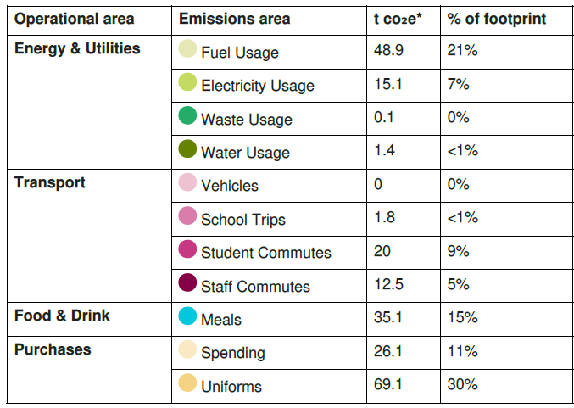
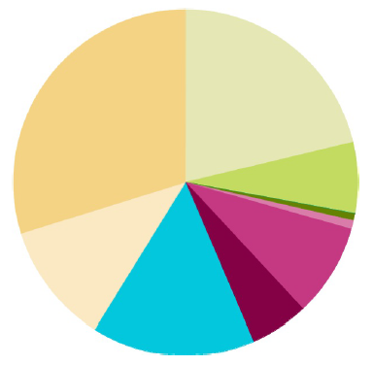



www.letsgozero.org

Ashden is registered in England and Wales as a company limited by guarantee.
Registered number: 05062574/ Charity number: 1104153
The Peak, 3rd Floor 5 Wilton Road, London, SW1V 1AP

